PART TWO – TONY IN DENMARK
It took me less than two months after my return to Denmark to make my slideshow which became an instant nationwide success. It was promoted by the intellectual newspaper Information which planned a photo book already sold to 7 countries in the Frankfurt Book Fair in September 1976. After that I sat with designer Kitte Fennestad for months working on the layout while listening mainly to our favorite records by Jimmy Cliff.
Before the book was published in April 1977 I wrote a long letter to all my friends in America about all my sudden success. Less than a week later I received a letter from Tony, who said he was crying when he heard about it. He never imagined anything would come out of my leftist hippie philosophy in my days as a vagabond (I have to find original letter to get his exact words). Next day he called me up and said: “Jacob, I am coming over to see you.” He wanted to share this moment of joy and success which he had in so many ways helped create. “Yes, come on over,” I said glad and proud that one of my friends would come all this way.
I never forget when I picked Tony up in the airport a couple of days before his 28 year birthday Mar. 27 1977. He came in a screaming green business suit in the belief that people in Denmark dressed so smart. I had never seen him dress like this before and after he saw how casually we actually dressed I never saw him in “the Superfly clown suit” again. He entertained everyone about all the warnings he had about going over here from his grandmother, “They are killing each other over there.” Typical of the American sense of geography she had gotten the civil war in Angola right then mixed up with Denmark – or else the rest of the world was just too scary – although as Tony soon concluded it was much safer than the black community at home.
I had been able to get an apartment with my American wife, black Annie, but she didn’t dare to live there since the last owner had been found dead in it after decomposing for a year after which nobody else wanted the apartment. Partly as a result of that our marriage also soon decomposed since I with my new life in show business never was home.
At my nightly sold out performances in a theater I had for 30 days in a row found red roses on my projector stand and when I found out one day they came from a beautiful red-haired woman also named Annie, I moved in with “Red Annie” instead. They decided to switch apartments since Red Annie unlike Black Annie was not superstitious about living with decomposed bodies. I made it clear that I was not right away interested in a new relationship and to win my heart the super active Red Annie provided me with the loft like studio of her former husband, an American, who at that time was Denmark’s most successful photographer economically speaking. Since he now owed so much in taxes he decided to flee to Australia and give me his studio equipment with file cabinets in which my 15.000 slides have been stored ever since. The major part of his divided studio he gave to his girlfriend, Kristin Urup, and the smaller one across the hallway about the English speaking Mermaid Theater was mine. As a result I feel asleep listening to Shakespeare’s plays every night.
I was very proud of this well equipped room – photographically speaking – and had worked hard to paint it and make it more homelike with an extra bed for Tony. But what happened? Already the same evening Tony arrived I took him with me over to visit my book designer Kitte Fennestad, whom I had told so much about Tony during our work on the book. Kitte had during our work developed a romanticized view of black men (during our later work on the movie she choose far too many pictures of black penises for American taste so that the movie soon had to be taken down in the US ). However, Kitte had after a couple of long white relationships never had a black man. And for Tony the white world had all too long been the forbidden, but desired land, so he felt that the fruits were now ready to be picked. Thus the minute he stepped inside the door he started flirting with Kitte.
“Red Annie” - my artistic companion for a year
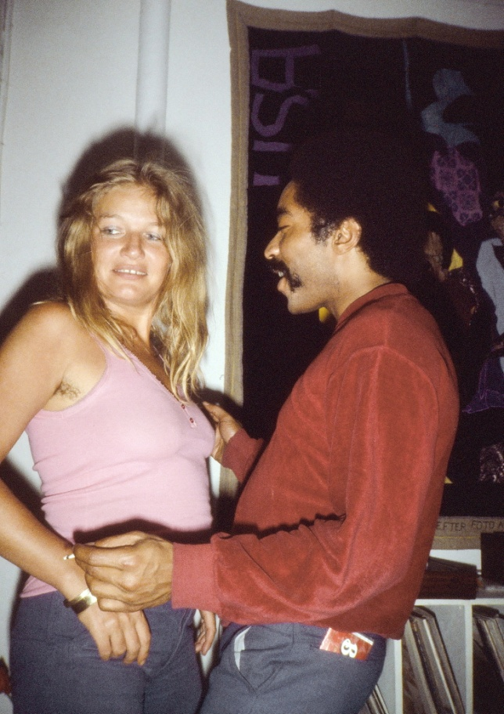
During our long absence I had somehow forgotten what a fantastic flirt Tony was. Also I had never seen it in full display since in the past it was mostly a question for him to keep black women at arm’s length. He was the one who had taught me “that a man always has to sleep on the outside of the bed so he can get away quickly”. Also I had not paid too much attention in the past just how beautiful a man Tony was, but now heard it again and again from Danish women. And how they absolutely couldn’t resist his charming and intelligent flirtatious talk such as when he tried to introduce Kitte to his “hardcore feminism”. She asked, “What does hardcore mean?” “Well, let me show you,” Tony burst out laughing and again gave her the “bedroom eyes” he should become so famous for in all over Danish bedrooms. However, since he had been so spoiled by black women who always jumped into his car and bedroom without him even asking for it or wanting them, he often forgot in the beginning that Scandinavian women prefer a little foreplay or warm up.
Kitte and Tony at a party in my new house a year later
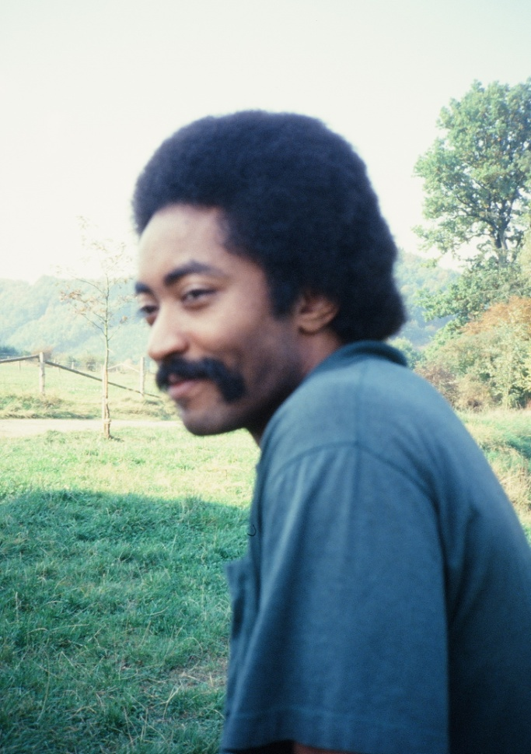
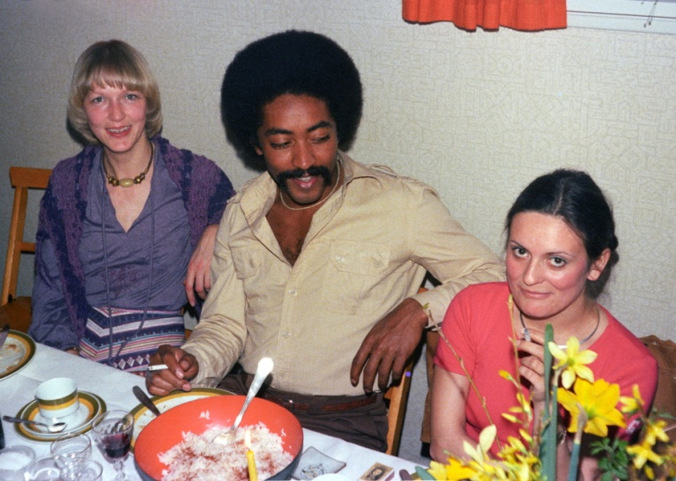
That is what I saw when we sat talking in Kitte’s new large central apartment I had only a month before helped her move into. We thought he had gone back through the long corridor to her bathroom, but a little later saw him come out naked under her house coat, laughing with self parody “Hey, babe, I am ready.” That is at least how I remember the scene. Kitte might remember it differently. And Tony might today say that he went back there to get a shower after his trip from America since I didn’t have a shower in my studio. But he never got back into his green business suit and when he a little later whispered to me “Hey, Jacob, I am staying here tonight,” I knew I had lost him. I had long ago forgotten about my feelings, but when I today called Kitte up to hear how she remembered the scene, she said she could see on my face how furious I was, boiling with anger inside. I remember more how hurt and disappointed I was since I had looked so much forward to now being a good host for Tony after those years he had been – actually a fairly bad host – for me, forgetting about feeding me with food and only giving me his leftover girls
Perhaps I also felt cheated because I somehow felt Kitte was “my girl”. Kitte and I had developed an extremely tight emotional friendship during the intense 6 months we had been working around the clock on the book. Yet, although Kitte was an extremely sexy and good looking woman and we often got drunk with my publisher Per Kofod until 4 in the morning when it would have been so much more convenient to sleep with her than walk home, the thought of us getting into a sexual relationship had never entered my mind. Partly because it has always been my principle that mixing work with love is too dangerous a cocktail, at least until the work is over, again my annoying delayed gratification principle. So again I heard for me Tony’s old annoying “Why don’t you make a move?” Even over here “in my world.”
Not even one night did Tony end up sleeping in my new studio, the best apartment I had in my life. The few times he came “home” it was not to knock at my door on the left coming up the staircase, but to knock on my neighbor, Kristin Urup’s door on the right. This former photo model I had also had an eye for during the half year we had shared the loft and often drank tea or wine in it til late in the night. Now Tony moved in with both Kristen and Kitte in their spacious flats. And to top it all he also moved in with my cousin, Anne, whom he enthusiastically told me was “the best sex I have ever had.” (I still tease my cousin, “Hard to believe today when you are 68 that you were once the best of all Tony’s millions of women!”) Like all his other women Anne complained to me that she had never been with such a messy man before. He would leave ash trays and dirty dishes everywhere in their houses which reminded me of how often I had washed dishes after Tony in his own house in Greensboro.
Tony’s sexual assault on Denmark left me both worried and with relief. Hearing and seeing how aggressive and quick he could be in his conquests I started worrying for my own responsibility and reputation for bringing such a sex monster to a country which certainly had the “sexual freedom,” which the American stereotype had so often asked me about, but where my answer always had been that “yes, it is true we have sexual freedom, but you Americans make much more use of what little freedom you have.” And relief because I knew Tony had arrived with no money, so now I could just let the burden of feeding him fall on all those women he moved in and out with. Just like he had not fed me properly in Greensboro, but let his various ex-dates take care of me
Before Tony’s arrival in 1977 the government had all summer of 1976 given me a theater to run my show in. Here I made a quick translation of the show into English, partly because I had met a KGB-agent there who at first let me to believe that they would be interested in presenting it in the Soviet Union. Wow, I was at first tempted by the idea, which instead led me to my 10 years of entanglement with the KGB. (Follow up story). I quickly narrated the show into English in the theater where I lived that summer rolled up in theater curtain since I didn’t feel like going home to Black Annie. In this first version of my show in English you could therefore hear the elevator go up and down, but that was good enough now to present to Tony who a few days after his arrival sat totally alone in my new studio apartment while I stood anxious behind him for 4 hours changing the slide trays. I was so nervous how as a black he would react to this – my world premiere in English. “Wow”, he said afterwards after the emotional ending throwing “yet another black child into the ocean”, “I am blown away.” I don’t remember anything he was critical of, but was a little disappointed that he was not as “blown away” as my Danish audiences, who were usually in such chock afterwards that they couldn’t “sleep for 3 nights after and would run red lights on their way home.” Tony of course knew the subject matter too much from the inside and his long work with black criminals and was more “blown away” by the fact that a white man could present “our oppression” so effectively. After seeing his positive response I think this was the first time we talked in length about Tony helping to present it around the world, at first as my co-speaker. Well, shortly after Tony disappeared out in his new white woman world which had “blown him away” more than my show about his old black world.
On April 22nd my book was officially published with a huge party in the same theater “Husets Teater i Magstræde”. A lot of official guests were invited including the American, the Cuban and the Vietnamese ambassadors, the bishop of Copenhagen and other famous VIP’s, but most important all my old friends and school friends. My wife Black Annie and another Afro-American woman, April Young, who had started volunteering for me, had prepared huge pots of soul food, southern style beans with smoked ham knuckles, and another black friend, Dale Smith, was playing with his jazz ban. But before the partying all the invited guests had to see my four hour show. Afterwards I had been thinking of letting Tony be my key note speaker, but I had not seen Tony’s abilities as a public speaker yet. So instead I chose a black American, Harb Lelshab, whom I had started visiting in prison where he was sentenced to a life term for a brutal murder committed in Denmark after he fled from the US army in Germany in protest against the Vietnam War. Harb had become radicalized in prison, I knew, but I had not during my visits found out how much. He was permitted to come out that night under the escort of two policemen and after just having witnessed my show for the first time, he was so fired up and nervous about standing in front of a big white audience including the US. Ambassador that he gave the most hardcore radical anti-imperialist and anti-American speech I had long heard. It was not really what I had hoped for, so I was quite embarrassed and regretted that I had not let Tony made the speech with the far more human and reconciliatory approach he shared with me.
The book became an instant bestseller selling out in just two weeks. A week after it was my 30 year birthday, which my parents celebrated for me with a second book publishing party in their big rectory in my home village in Western Denmark for all my old rural friends, teachers along with Kitte and my publisher, Per Kofod, seated at the honor table next to my old high school teacher in Danish literature, Erik Madsen, a leading Shakespeare translator. He was the only one of my teachers who had voted against expelling me from high school with the argument, “Jacob has a good head if only he learns someday to use it,” – although he had given me the lowest mark you could get for my essay “The negro problem in America” 13 years earlier. My father made an emotional, teasing but also proud speech about how hopeless and foolish I had been most of my childhood. However, the star of the evening was Tony who sat for hours with all my old school friends around fascinating them with his gangster stories.
Both I and Tony now fully understood his enormous power as a story teller in a foreign environment which obviously at that time still idolized blacks. I noticed how with his enticing voice, self ironic laughter and good looking vibrations he was able to captivate even those of my old friends whom I knew could hardly understand English and whom about 30 years later I found in the vociferous crowd wanting “foreigners out”. In the 70’es Tony was speaking to an audience which unanimously was supportive of “the black struggle” in America and South Africa. Feeling loved and understood by everyone he also in no time got out of his anti-white animosity – seeing and realizing for the first time that not all whites are like those he grew up with in the South. People loved when again and again he told the story of how “Jacob was the first white I let into my house”. Acknowledging how easily he stole the attention away from me, supposedly the main star, he was sensitive and careful enough to get back to stories which involved my life in the black community, talking especially about “Jacob’s lack of fear when walking into communities no white man would dare go into.” For the first time I now saw how Tony not only romanticized blacks, but in a free society first of all was a genuine people lover.
Tony’s understanding of the various colors of whiteness grew during the next month when it was vacation time. The book and the show had in less than a year made me into a millionaire, so we decided to go on a camping trip around Europe in the huge family tent I had enjoyed going to Italy in with my parents every summer in childhood. This time I wanted to go through the Communist countries to get a better understanding of “the enemy”.
For “American Pictures” had partly become so popular not least because the youth at that time right after the Vietnam War had become so leftist and anti-American that universities and schools were dominated by leftist thinking and left leaning teachers. Although only a minority were in support of the Stalinist countries many like Tony and me were curious to actually see if a socialist country could work. My “on and off” new girlfriend, Red Annie, demanded to come with us just as we invited a new friend, a West German fan, Wolfgang Poth, with us in the VW van I had just bought for my lectures – the first of the 17 VW vans we would wear down in the following years bringing my show around Europe.
Tony on a trip in Belgium
Tony at the party in my childhood home. On his left my cousin, Birgit, on his right my best school friend's wife Genieve, who totally fell in love with Tony and started an affair with him.
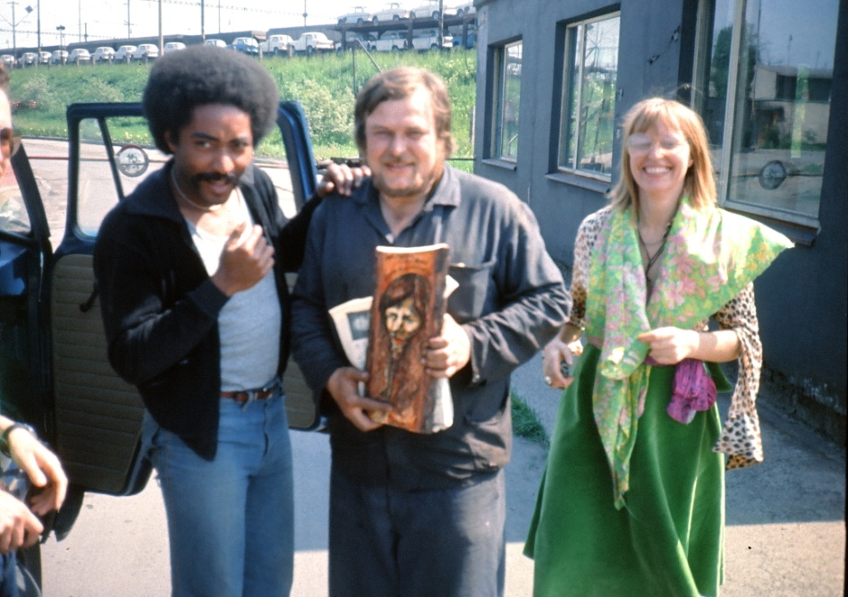
We drove off in a happy mood, playing endlessly the one and only tape we had with us, the new Abba. Annie and I would sleep in the front part of the tent and Tony and Wolfgang in the inner tent, only separated by a thin canvas through which they complained they could hear everything. I didn’t mind, for me it was payback time for all the nights I had been forced to listen to Tony’s sex activities. But what annoyed all us men far more was Annie’s constant enthusiastic outbursts, “Wow, see that fantastic yellow field!”, “See those fantastic old brown buildings!”
Annie was an artist who saw everything as art and the only reason I bore over with all her annoying outbursts even when we tried to sleep, was that she had started making truly fantastic wall size tapestries based on my photos, tapestries which ended up for years decorating our theaters both in Copenhagen and San Francisco and were eventually invited to be exhibited in the US. Congress when President Bush signed the bill to establish the African-American Museum in Wash. DC.
Since I didn’t want to disrupt our powerful artistic partnership I was with her volatile temper extremely careful not to lose her love and friendship and literally ended up as her sex slave for the whole year it took her to make the tapestries. Well, she understood that I wouldn’t bind myself too much right after coming out of the destructive marriage with Black Annie, so I had already made a deal with Red Annie that I would only come to her apartment to sleep on Sundays and Wednesdays.
Tony and Annie with a guy in Czechoslovakia, who had made a portrait of me.
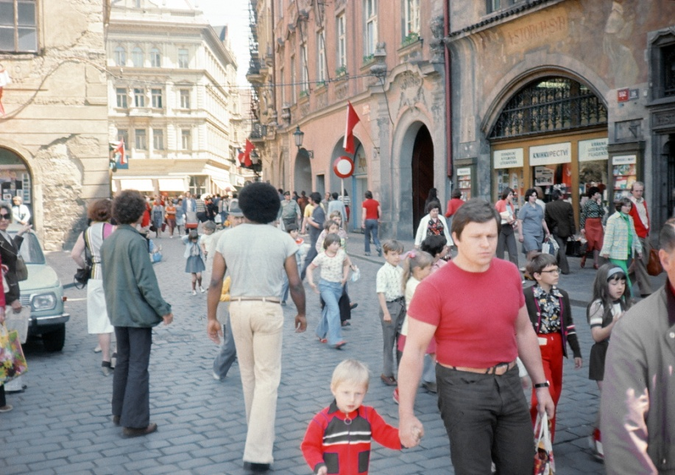
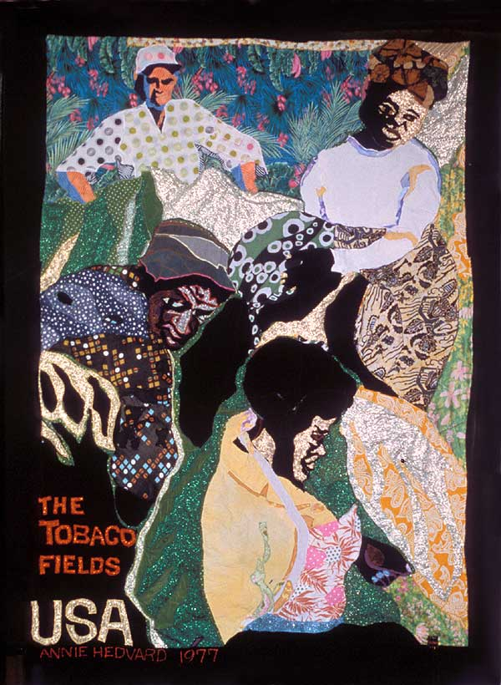
Her two daughters still thank me today because those two days were the only ones where she made good dinners for them and for me. The rest of the time she neglected them totally absorbed with her new art of tapestries filling up the entire floor of the dead man’s small apartment. Those days I relaxed in her former husband’s studio, but since I sometimes relaxed too cozily with other girlfriends – which the sensitive Annie somehow could “feel” in the other end of Copenhagen – she would often come and throw rocks through the window right into the bed when I had female visits. Another time she smashed the outside door and came bursting in and poured a bucket of ice-cold water over us during the winter. As a result I had to move my bed from the window and then built a huge double bed up under the ceiling in the far inside corner of the studio separated by bookcases so Annie couldn’t hit me from the courtyard below.
So Red Annie now enjoyed every minute of this vacation where I was forced to be with her 24 hours a day.
Exploring the whites in Eastern Europe was as interesting for us as it was for Tony. The Stalinist dictatorship laid heavily over Czechoslovakia here in the years after the Soviet invasion, but what struck us was more the street life milling with friendly trusting people shopping after all the empty fearful streets I was used to seeing in America. Tony laughed when trying to find out if people stared at us because of my breaded beard or him being black – in both cases an unusual sight here – but a good way to get invited inside people’s homes.
Tony enjoying the crowds in the red flag lined streets of Prague.
One of Annie's tapestries of the tobacco fields I had so often hitchhiked to from Tony's house in NC.

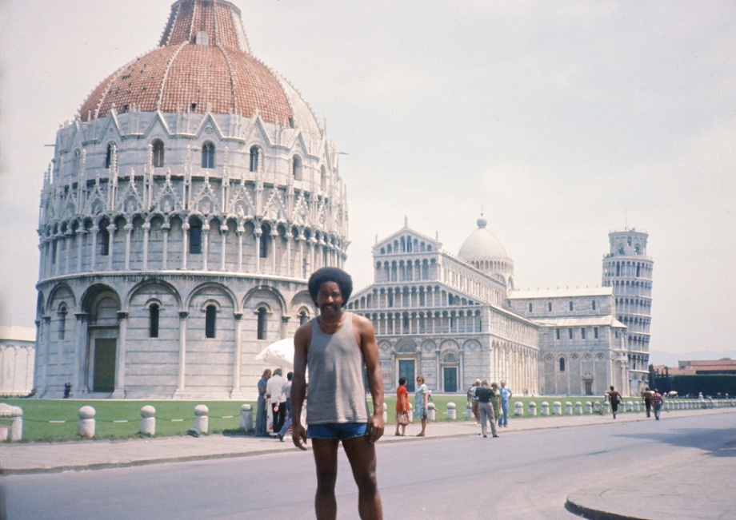
In Bruno in Slovakia we were disturbed hearing outspoken racism towards the gypsies (although their situation was much better under Communism and I hear much worse anti-Roma rhetoric in the EU today). In the same way we were disturbed by the anti-Semitism in Hungary. Perhaps that re-stimulated some old wounds in Tony, for I never forget when we were standing on the hill of the Buda side of Budapest and he shocked us suddenly pretending he was shooting bazookas down over “all those whiteys in Pest”, only again to laugh at his own childlike behavior right after. We quickly agreed that racism – contrary to what many Marxists claimed – has nothing to do with economic systems and just as we expected did not find any hopeful model in Communism.
I think it was our aim to continue through Yugoslavia, but the irritation with Annie was now so bad that Wolfgang decided to get off in West Germany. Not before Milan did we manage to talk Annie into hitchhiking home, after which Tony and I felt our real vacation could start. It was the first time we had traveled together – alone – and we liked it. On this entire vacation I didn’t see Tony with a single woman, wow! He also felt he needed a pause and during this our first pause from the disturbing presence of women our friendship had time to blossom.
I especially remember one night where we were standing at the Arno River in Florence sharing a gallon size bottle of wine talking honestly about girlfriends past and present, when Tony suddenly told me about his relationship with Edwina. He knew what a defeat she was for me, but suddenly told me the story of when he had once had sex with her, his own aunt. I was not shocked since I had long ago learned that Tony did not have any moral filter when it came to women. No, I was more jealous that he succeeded where I had failed. Many other truths not fit for writing came up in the light that night, and we were laughing and laughing as we got more and more drunk. We had started in sunshine, but when the moon came up we realized we had to get back to our tent on the camp ground far outside the city. We couldn’t even walk straight, but instead of sleeping in the VW van I insisted on driving it – now without a moral filter myself. Tony had no idea what direction our camp ground was, but was really, really impressed how I drove though a labyrinth of streets so narrow that the mirrors on both sides of the car almost touched the walls – and found the camp ground 25 km away without a scratch – not to speak of a drunk-driving ticket.
Tony in Pisa, Toscana
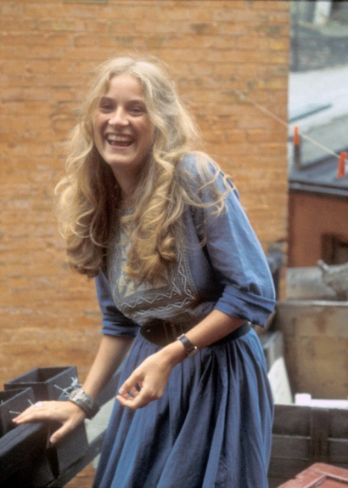
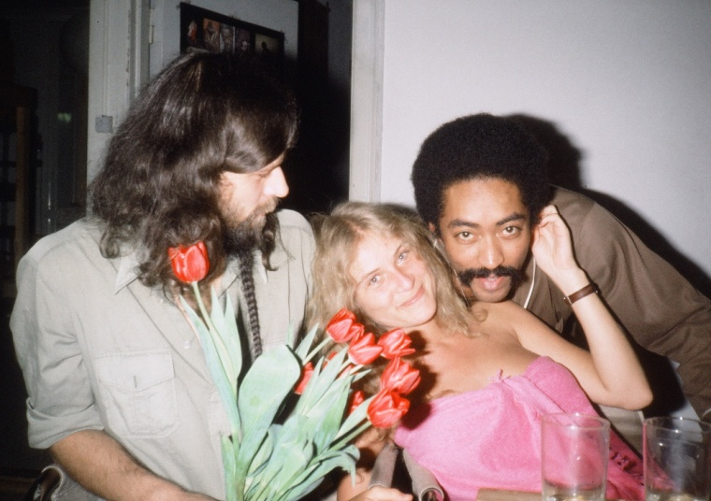
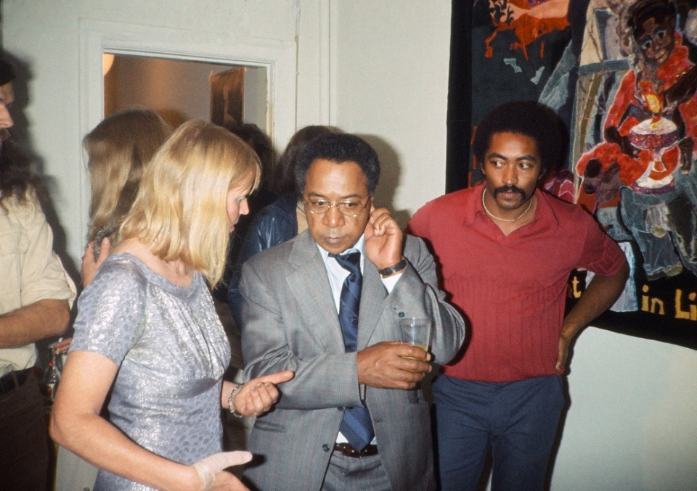
On the way home we drove through Yugoslavia. This was the only Communist country where we found an overwhelming popular support for the system and especially the leader Tito, whose portrait was hanging in every home. And the hospitality was overwhelming; people would invite us into their lives everywhere. Parents would move out of their own bedrooms and give their double beds to Tony and me. This was the first of many times Tony and I would share beds with each other during the next 30 years on the road. It was hard to understand that these open and friendly people in the aftermath of Tito’s death only a few years after would end up killing each other in a bloody civil war. Yet all my childhood I had heard the warnings “After Tito comes chaos!”
Our trip through the Communist countries was helpful for me coming to the right decision when I shortly after coming home to Denmark again had a meeting with the KGB in which I told them I needed the help of the Soviet Union to penetrate the Marxist bureaucracy in Angola, where it was my dream to built a hospital for all the money now pouring in from my book. The KGB officer Nick Gribin made two fatal mistakes here when saying that they were so happy seeing the success of my book and show that they had decided from the highest level to use me and American Pictures as their most important tool to counter President Carters annoying human rights policy and its main focus on the Communist countries. I didn’t say a word since I was a strong supporter of Carter for being the first American president ever to focus on human rights and thus break with the long sad American history of installing and supporting dictatorships throughout the Third World. I did not want to hurt Carter’s policy with my book “showing that human rights were just as bad off in the USA,” as many news paper reviews not least in West Germany had started writing and started feeling deeply troubled by my sudden role in the power politics between East and West.
And second Nick started warning me about working with blacks, “Your work is too important, but blacks are nothing but children. They are spoiled. You can’t trust them so don’t risk your chances by working too close with them.” This was absolutely the wrong thing to say to a man who had just formed a deep friendship with a black man and with him firsthand seen the disastrous human rights situation in the Communist bloc. I was thrown into a depression through which I gradually formed the ideas of how I could work against the KGB, which later in the year exploded into an open crisis with my publisher when I wanted to stop my book.
On Sep. 2nd Kitte Fennestad took me with her to the opening in an art gallery where I for the first time saw my coming wife, Vibeke Rostrup Bøyesen. As she was pouring wine for the guests we right away felt attracted by each other and started flirting, but Kitte – although we didn’t have a relationship with each other – felt so possessive of me as if I was her artistic invention that she kept pulling me away from Vibeke. I felt very depressed about leaving the place without making contact with Vibeke, since the first thought in my mind had been, “She is the mother I have always wanted for my coming children.” But later in the evening I had the luck of standing next to a guy in the bar “Summer shoe” without Kitte around just when Vibeke came in. She knew the man I talked to and used him as an excuse for starting a conversation with me; “I have just read you book and been deeply inspired by it.” I immediately hijacked her to my favorite late night club “Charlie Brown” where we danced to early morning, after which Vibeke went home with me. On the staircase I teased her saying that she was going to sleep in “my guest room” to the right where I knew my neighbor was not home, but when I saw Vibeke’s disappointed look I soon followed up with, “Ok, then, you can come into my room.” Somehow I again had wanted to practice my “delayed gratification” principle – especially since I just the day before had come home from a disastrous camping trip in Poland with my former girlfriend, May-Brit, who looked very similar to Vibeke with long light hair. My bathroom was out in the hallway, so next morning Vibeke stepped totally naked out just when Tony came up the staircase to see me after being with one of his own girlfriends. Wow, Tony was totally blown away by Vibeke’s beauty, he later said, and came into my studio laughing with some remark about, “Well, Jacob, now I see your point in delayed gratification, that the one waiting longest gets the best.”
When Vibeke realized just how many girlfriends Tony and I had at the time, she wisely used that philosophy against me by making herself “very expensive” and refusing for a whole year to move in with me permanently until she felt I was sincere about only her. She was herself in a 5 year relationship living permanently with Ole, whom everyone in her family hoped and expected she would marry. But Ole had also been so inspired by my book that he as an architect student had gone on a long vagabond trip around America like me. That cost him dearly. When he got home he had lost his girlfriend forever as a result of reading my book. I felt so bad about that that again and again I urged Vibeke to move back with him, “for if we are really meant for each other, things can wait; you know, the best will come in the end!” So in order to make myself more attractive in Vibeke’s eyes I also like her made myself more expensive. In that way we played each other’s policy against each other for a long, long time.
That was the same month I bought my enormous new apartment right on the Walking Street in which we opened the permanent theater where American Pictures was to run twice a day during the next 10 years. Behind the theater room seating 90 spectators was the office from where we could project the slides, and behind the huge sunny foyer or living room was a long hallway down to the kitchen with three big bedrooms on the side. I was really proud about giving Tony the best and lightest room “closest to the outside door so you can get out fast from your women, as you taught me in Greensboro.” I took the middle one and the last one I gave to an African refugee from Ghana, Jerry Kwakoo, who had been smuggled across the border from Germany by Jerry Justice, another black American, who joined us, but didn’t need to live with us. Jerry Kwakoo slept all day (to this very day), but studied all night. Since he had nothing to offer in terms of the knowledge about American race relations he soon ended up as a cook for Tony and me – in other words in a semi-slave position which we didn’t really enjoy – apart from his cooking being very bad. Had he not been illegal we would not have let him stay, but he ended up staying for more than a year – long enough for him to get married to a Danish woman and eventually get a beautiful brown family who 10 years later moved into my grandparents’ old house in a village outside Copenhagen.
In September the crisis with my publisher worsened. I insisted on stopping my book worldwide – “My Frankenstein monster” – while my publisher refused to give up the millions they were certain to earn. Since I felt I betrayed my former friend, Per Kofod, I felt terrible and let my lawyer handle the fight while I escaped again to Poland, this time with my new girlfriend, Vibeke. Since my previous trip with Majbrit had ended in disaster I wanted to expose Vibeke to exactly the same hardships. Vibeke passed the test and in Warsaw we signed our own Warsaw Pact about getting a child together – a pact which has now lasted longer than the original military pact. My lawyer managed to get the book stopped in all new countries where we didn’t have contracts with publishers, so without saying anything to the publisher that my reasoning was based on inside information from the KGB I felt good with myself that I did not hurt Carter’s human rights policies. I didn’t give the world rights back to my publisher until the Berlin Wall and the Warsaw Pact came down in 1989.
One reason I ended up with a deal allowing the book to continue in countries we had contracts with was also that I wanted Alex Haley to see my show. It was on my suggestion that my publisher obtained the Danish rights for his “Roots” and if I had not hurried up getting a deal with my publisher both I and Tony would have been left out of many events taking place around the publishing of “Roots”. For Tony and all my black friends he was a mega black star and to have him personally come to our new theater and see “American Pictures” with him was one of our major events of the year. Tony in his finest suit at an official dinner for Alex Haley later boasted: “Would you believe it? There I was – standing right next to my great hero – as we were pissing together shoulder to shoulder in the bathroom!”
With Tony and Vibeke in our new house
"Red Annie" telling Alex Haley about her tapestries with Tony leaning up against one of them on the wall.
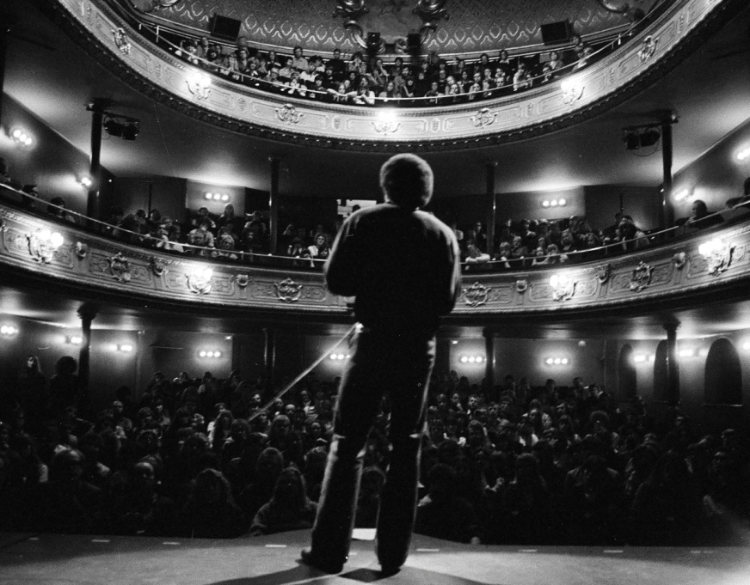
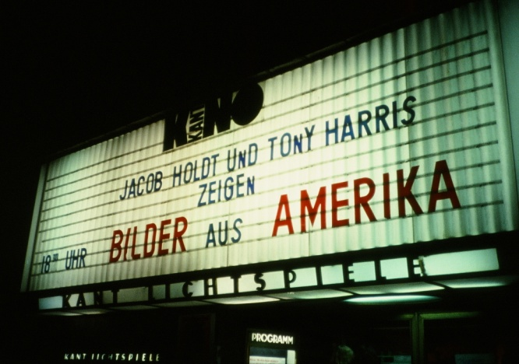
Tony and I now started touring together to promote the book in the countries it was published in where we ourselves were the stars at many official receptions. Tony quickly became a media darling and for me a great spokesman for the deeper ideas behind my book about the situation for black Americans. It was my idea to train him up to get his own set of the show, but technically speaking Tony was not the best to solve all the problems the show involved when it constantly broke down. So during all of 1978 I kept him at my side as my co-speaker especially during intermission. In Europe we found that it gave the show credibility being presented by black Americans. Later in America I was told the opposite that people listened to it because the message came from a white man – an outsider – and not from an angry black insider.
Traveling with Tony was thus both a plus and a minus. I could always feel his powerful presence at my side making me feel more secure and self-confident, when we were on stage together. And I enjoyed his wise stories coming from his deep, calm microphone. His frustration was only that the long 4 hour show gave him very little time to speak. So his greatest hour when I also found him most useful was after the show when we often hung out with some organizers or young people from the audience. If I was alone they would in their deep seriousness and reflection the show always gave people ask endless questions as if I as an authority had the answers to everything. Being tired right after the long show this could be a great burden night after night – especially in Norway and Sweden where it was politically incorrect to speak in English, but tiring to try to understand each other’s native languages. With Tony at my side it was ok to speak English and he would always start telling stories – first to answer their questions, but later he would completely take over and monopolize the entire conversation with his own funny and thoughtful stories from real American life. He could keep people captivated the whole night during which I would slowly withdraw and go to bed without anybody paying attention to my absence. So this was very, very convenient for me while Tony – normally standing in the white man’s shadow here – quite simply loved being the star of the show with his voracious appetite for being the center of attention. Certainly he was not unlike me in that respect
Tony on stage in one of Stockholm's largest theaters
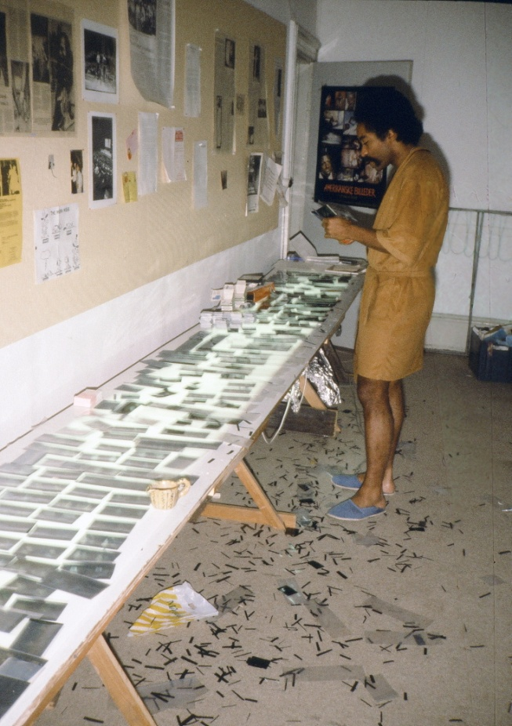
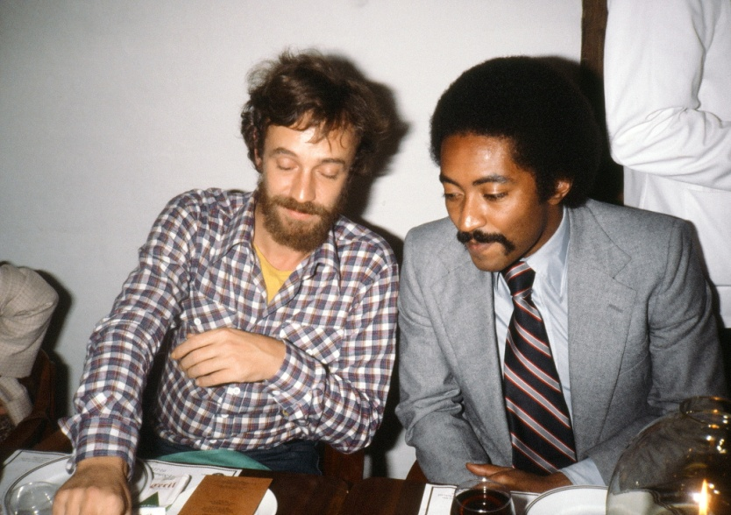
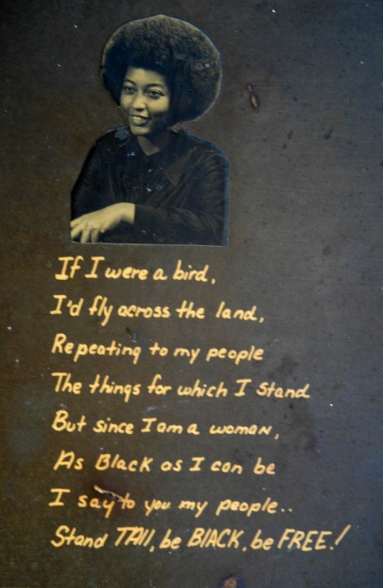
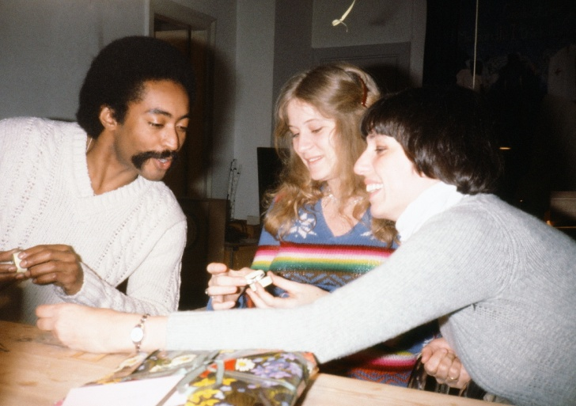
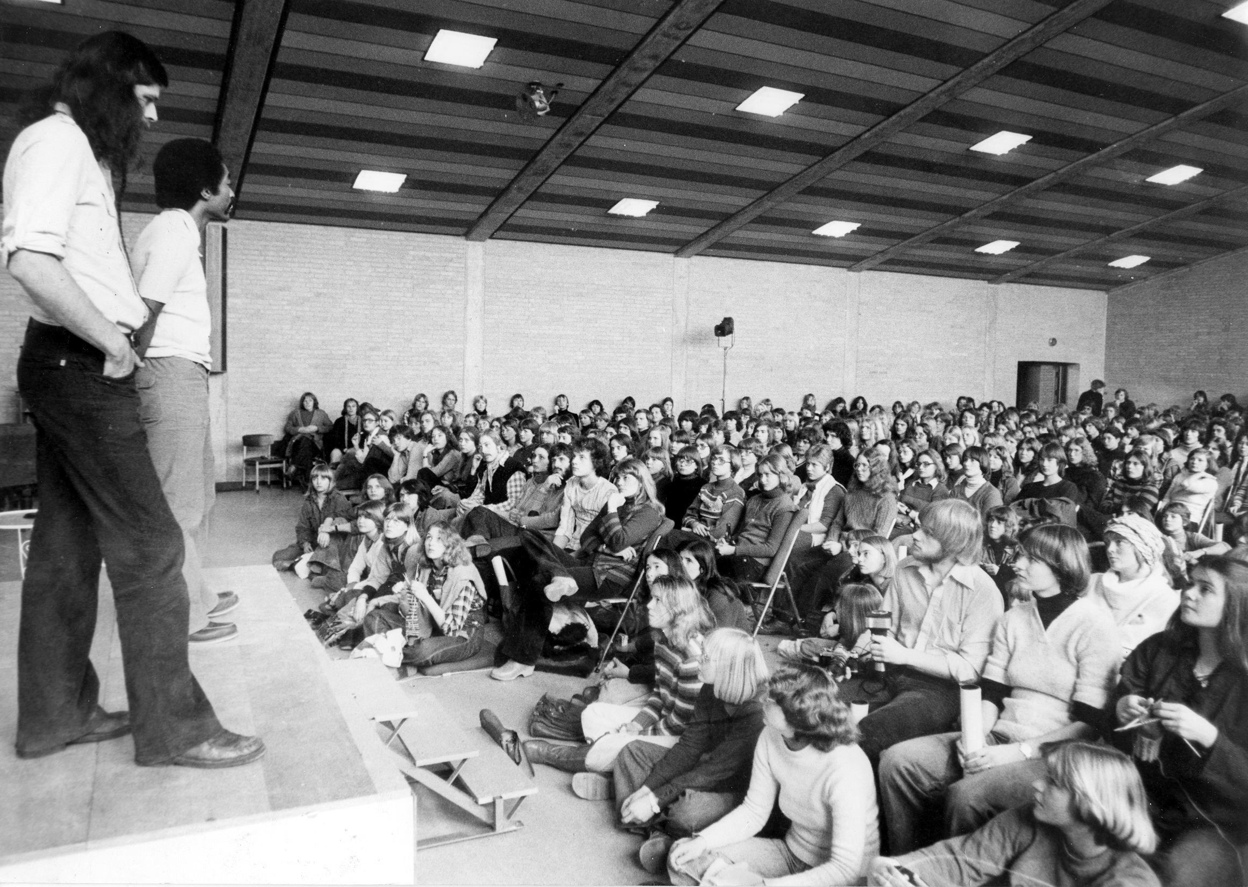
Out on the highways – first in Europe and later also America - we also had another beneficial work division. In restaurants he would always order too much since he also had a voracious appetite for food – at least with the eyes. So I would always sit patiently waiting for him to give up and say, “Oh, Jacob, that was too much, can’t you finish it up?” He knew my old vagabond habit of never saying no to free food, even when I had to dig it up from garbage cans. So in that way he helped me in the midst of our show business success to hold on to some of my old down-to-earth vagabond integrity.
More annoying was the fact that Tony would usually steal all the good looking women from me. Next day he would laughingly apologize saying that he “just wanted to give them a deeper, more meaningful introduction to black American life which they won’t soon forget.” Actually I didn’t mind it too much in all those cities where we had hit-and-run one-night-shows since it was always against my deep principle to abuse the enormous power the show gave me as a tool to go to bed with women. The possibility for that also didn’t come up very often since Scandinavian women – unlike what I later found in America – do not tend to be groupies. But when we had longer continuous runs as in several large theaters in Stockholm – or came back to previous cities – we did of course run into fans from past shows. And now when they had had time to cool off I didn’t mind having relationships with them. Years later when I met the same women again as elderly people I sometimes have asked them, “Sorry that I can’t really remember it, but were you Tony’s or my girlfriend?” That is a bit embarrassing, but not as embarrassing as when Tony came back to my 60 year birthday party in Copenhagen and I gave the guests a tour in Christiania. Every turn we took some women about the same age came running up to Tony bursting out: “Tony, you are back!” But Tony could not remember a single one of them until they started providing descriptive details. That certainly made an impression on my other birthday guests. One of my few triumphs over Tony was in Stockholm, where he since joked that “people are so inhospitable that I slept every night rolled up in the theater curtains of the theater.” Yet here I lived like a real movie star since I found a beautiful mulatto actor, Katarina Strandmark, and moved in with her in her fancy old town apartment overlooking the Royal Castle. She so identified with my message than she wanted me to throw the ashes of her recently deceased black father from Trinidad into the ocean just as seen in the end of my show. I became so infatuated with her that year, 1978, that I was seriously thinking of breaking up with my new Danish girlfriend, Vibeke. I was glad that I didn’t do it when Vibeke and I years later, on a vacation in 2004, lived with Katarina in Stockholm where they now became friends in spite of the jealousy they had nurtured for each other then.
From April to August 1978 I was back in America for the first time since my vagabond years invited as a speaker by Lewis & Clark College in Oregon. Afterwards a black TV-reporter Dick Boggle gave me his car to go around America to show my old friends the show “since you also know my friend Alex Haley, who wrote parts of “Roots” in my house.” After a show in Jane Fonda’s house in Santa Monica black Hollywood promoters wanted to set the show up in 76 major cities, but first I needed music rights and permission from all the photographed people.
On Tony’s wall in Greensboro I had often looked at a picture of his beautiful sister, Harriet, dreaming about how I could get a hold of that “educated middle class black” with her own dreams of “flying across the land” like me. I don’t think she would have paid much attention to me as a vagabond, but now she had from Tony heard about my success and suddenly one day called me up, “Jacob, I am in Memphis now, but would like to hang out with you. Let me fly out to help you negotiating with the lawyers in Hollywood.” It was a dream which had come true, next day I picked her up in the airport. She helped me with all the difficult and for me oh so boring negotiations with lawyers and at night we hung out in the coziest way I could have desired. It amused me that in all my years as a penniless vagabond Tony eagerly had helped me to get black women he had never succeeded in giving me even one, but now when I on paper had become a millionaire even his own sister would fly all over America to date me. What were black women really up to? Harriet had heard about my “yes philosophy” and was quite seductive, but now when I no longer had a deeper desire to marry the oppressed I felt relieved that we were no sexual match for each other. For good natural reasons I found out, for it didn’t surprise me at all when Harriet later announced that she had “finally come out as a lesbian.” Still, on this trip we drove all over America to her and Tony’s family in Memphis and Atlanta where she presented me pretty much as her new husband or partner – at least in business, since she had great visions for our future. Like Tony she is a dreamer, but unlike him she has a knack for setting up businesses. Right then I had to flee from both her and Hollywood since I did “not want to sell out my friends in the ghettoes,” but Harriet and her later lesbian partner, Norma, have been my good friends ever since, not least Norma, who as a result of some childhood mistreatment are so angry that she is at war with everyone in Tony’s family – even Tony. Only I can always get her to calm down even if it seems like we are still fighting. By winning Norma’s heart I of course also won Harriet’s as well as the rest of Tony’s large extended family. After Harriet I actually moved in with all his aunts on this trip.
I don’t know if it was because Tony from Harriet over the phone had gotten the idea that now she and I had hooked up or Tony just continued his usual conquests at home in Denmark. For while I had gone Vibeke had given up her game of playing expensive and had in my absence moved into my bedroom in our work collective in Købmagergade – as I had begged her to do for a whole year. Here she told me about how Tony often in my absence had come in attempting to seduce her. Vibeke knowing all too well that side of Tony laughed and said proudly that he had not been successful. So ever since I have claimed contrary to all evidence that I have proof that “there is one woman in Denmark who did not have sex with Tony in those 5 years he lived here!” If that was true love from Vibeke’s side or just stubbornness I don’t know, for she knew full well about all those girlfriends Tony and I had shared as “partners in crime” before meeting her. Vibeke could just as well have come with me to America, for our phone bill after my 4 months trip revealed that she could have flown over several times for all the money we spend calling each other.
Shortly after my homecoming, Tony and I invited Vibeke and Tony’s most recent girlfriend, a young devoted communist named Elisabeth Colding, to come up and join us on one of our lecture tours in Norway. Here we had our greatest audience ever in Oslo Concert house for 1500 spectators organized by my Norwegian publisher, but I mostly remember how Vibeke and I was having sex in the back of the steamy car most of the way while Tony drove it through the beautiful mountains. We let them off in Copenhagen, where they together started organizing our tours, while we already next day continued to shows in South Germany and Belgium. Here we heard that Kitte Fennestad had been found half dead after an attempted suicide at home. I immediately called my publisher saying, “I will take care of her. Put her on a plane to Amsterdam, I will pay.” Kitte had fallen into a depression after the tight work we had had on the book whose beautiful layout she had been responsible for, but only been paid an hourly salary. I now reaped the fruits of her labor earning millions and felt I owed her everything. Certainly she could share some of the fruits of traveling and being in the limelight with us – if only to take the attention away from her depression. So now I had both Tony and his first Danish girlfriend at my side in the VW van on our way through the Berlin wall to some of our biggest successes in West Berlin for sold out audiences night after night. However it was embarrassing to see only Tony be taken out and stripped to his socks by East German border guards only because he was black – as it happened for him and my other black employees every time in the years to come.
This publicity tour was our last European tour together, for in the new year of 1979 we decided that Tony should now travel with a copy of my show alone. I never forget how nervous and proud I was when we in a snow storm on Jan. 25th sent him off to a series of shows in Silkeborg – the other end of Denmark – for although Tony was a better driver than me he was a mess with many practical things. Already next morning we got calls from the huge Silkeborg High School inquiring about where the speaker was. In the snow storm he had made a wrong turn and ended up in Grenaa – hours away. Luckily the school gave my first black employee a bit of affirmative action and from then on we heard no more complaints – except from Tony himself when things broke down or didn’t work. Sometimes I could advice him over the phone. Other times closer to Copenhagen I would quickly drive out and solve the often simple problems like, “Oh, Tony, you just need to turn the tape. A tape recorder only accepts the side with the sound on,” I would tease him. Worse were his problems crossing borders as a black man. One time when he was in England he called me because the French border police wouldn’t let him in and had sent him back on the boat. Then the British wouldn’t let him back into England and sent him back. I can’t remember how many times he crossed the Channel before we were able to send some papers allowing him into France. Apart from the Communist borders the Swedish border police acted completely like East Germans each time stripping him to the socks where he usually had his joints. Blacks were associated with drugs and Danes with Christiania, so coming from Denmark could be hard for him since he often did travel with a joint, forgetful as he was. One time they searched the whole car and started taking my slides up from the trays. The first one the police examined happened to be of a naked black couple making love. “Ah, ha, you are smuggling pornography!” the police said with a stern voice that could have made any American feel like a criminal at the time. Luckily it was the Swedish border, so the police lightened up in a smile, “Well, at least you don’t smuggle drugs!”
Tony cutting and framing slides for the many additional sets of the slideshow needed in the 14 countries we toured in.
Tony at formal dinner with one of our much famous authors, Ebbe Reich
Traveling across America with Tony's sister, Harriet.
Tony, Vibeke and our French secretary, Dominique
Tony and I on stage together all over Europe
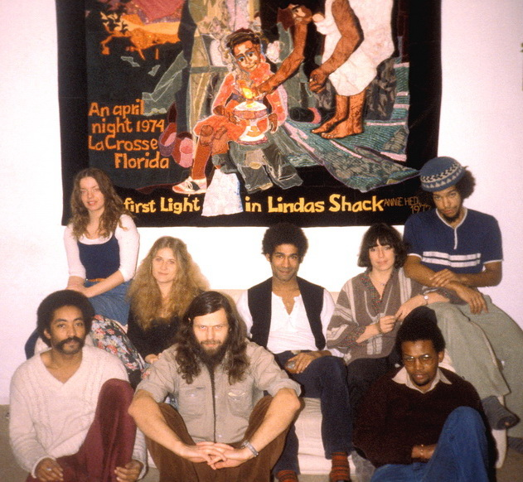
Tony was a total mess when it came to money. Unlike all the other employees who would make careful accounting for all the books and posters they sold to present to my bookkeeper, my brother Niels Jørgen, I told my brother that he couldn’t expect that from Tony. “Just put on the books the amount Tony hands over and don’t even ask about the rest.” I knew that Tony would take what he needed for himself, but nothing more. He was not out to enrich himself. One time Tony came home from a tour in Sweden to our group in Købmagergade and in front of everyone took off his big winter boots and said, “Look what I just smuggled across the Swedish border even though they stripped me down to the boots.” Then he pulled more than 120.000 Swedish kr. (20.000 $) up in small bills and scattered them all over the floor. “Why the hell did you have the money in your boots and not in our official money box?” I asked. “Well, last night after the show in Stockholm I was hanging out with some black Americans, I had met. I didn’t have time to luck the money up in the car, so since they were drug dealers I thought it was safest to hide the money from them in my boots. But as we were hopping around from bar to bar and I saw just how much drugs these gangsters were selling I did get a bit nervous suddenly seeing police everywhere around and feeling like a criminal myself,” Tony explained. “For how would the police be able to distinguish between some black criminals peddling dope and a black man peddling pictures of black criminals doing it, especially when the latter carried far more cash?” Tony laughed.
Our work group from left, Tony, me, Jerry (from USA), behind Elisabeth, Vibeke, Jean and Dominique (from France) and Howie (from USA).

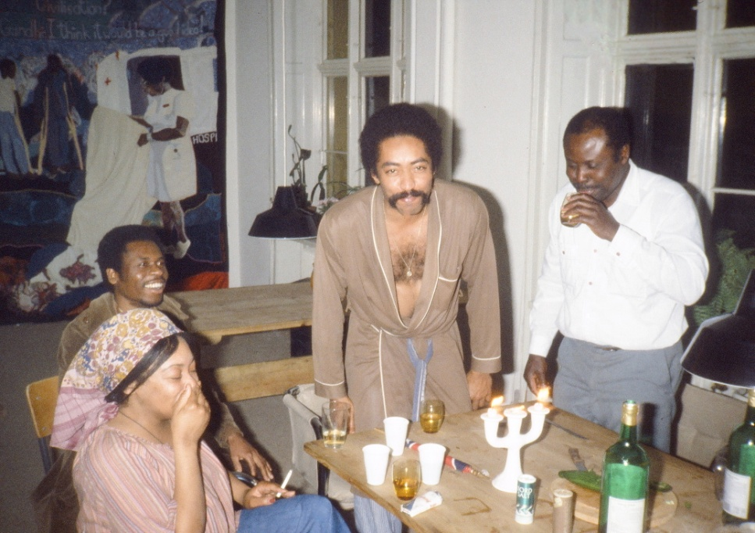
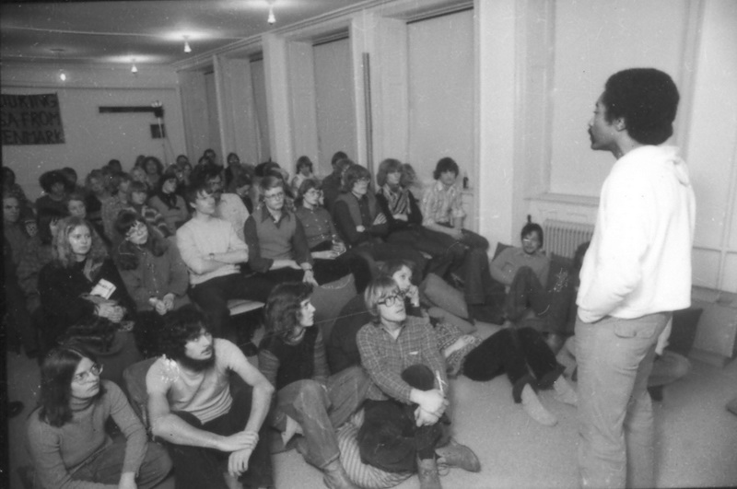
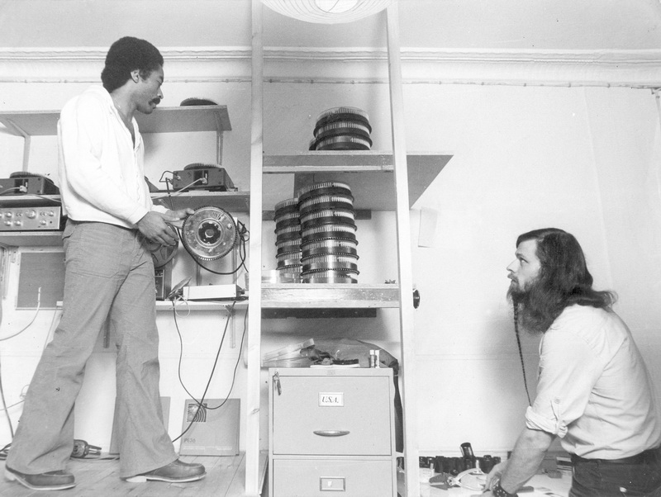
No wonder my brother, who had never any complaints about the accounting of the other blacks in our group, often threatened to quit his voluntary job as accountant for us whenever Tony handed over boots full of money for him to count, but no accounting books stating where they came from. “It is just not Tony’s style,” I always apologized for him. “You try to be open-minded, but if you can’t handle Tony then you should have seen the real ghetto people I used to live with in America.” I used this sentence in many guilt provoking variations to defend Tony with whenever there were complaints about him.
Some of these complaints I heard often in the beginning from his Danish girlfriends who would confront me about how Tony was stealing from them. I knew Tony couldn’t live without money for his modest, but compulsive consumption of cigarettes and other urgent needs. So in his mind it was just a matter of sharing or borrowing a little until later of the cash he saw laying around the houses of his girlfriends. He was too proud to ask me for money and for a long time I was forgetful of the fact that he had not brought money with him to Denmark and myself so used to live without money that I didn’t even think about it during the first year when Tony didn’t officially work for me. When I started hearing such complaints the solution was very simple; just start giving Tony so much money than I didn’t hear complaints any more. That was unfair to the others in the group since they had a fixed income of 300 kr. for each slideshow they presented no matter how many books and posters they sold. Tony’s needs were greater than that, so I just made an unwritten deal with him that he had to adjust his income himself out of his loose poster sale. This was harder for the accounting to discover a loss in than the book sales.
For the most part everyone was happy about this deal since Tony was too important an asset to let go for something which in the eyes of ordinary companies probably would have made him “unemployable”, that horrible stamp so much business in America puts on ghetto blacks. Besides he was my friend and experiencing in him here in Denmark so much of the ghetto pathology – even though Tony like the others were not really from the ghetto – helped constantly sharpen my own awareness and inspiration about the problems we whites have with the people we shun and ghettoize. So I would staunchly defend even the darker sides I saw in Tony which was easy then since the Europeans we dealt with at that time were so guilt ridden in their relationships towards blacks. Today when so many of our immigrants develop similar ghetto pathologies the Danes have hardened into some of the most reactionary racists I presented in my show.
How that guilt played out in different “white” countries we exposed to the same slideshow was interesting for Tony to observe. One time he came home from Sweden in chock after he twice had seen people in the audience try to commit suicide as a result of seeing the show. The second time was when he presented it on the 5th floor of a building and he saw a man during the show throw himself out and down through the glass windows. As Tony said, “At home in America we blacks kill each other because of the conditions we have to live in. In Sweden they kill themselves just from seeing how we have to live. The Swedes internalize all the crimes in the world and feel personally responsible for them” However, in Denmark the reaction was just opposite. In the Nikolai Church Suicide Prevention close to us downtown the volunteers usually advised their suicide prone clients to go and see “American Pictures” because afterwards they said that “the show had given them new hope for humanity”. Twice they later came and told us that the show had saved them from committing suicide.
In Germany the reaction was completely different formed not only by guilt, but also anger towards the parents for their complicity during Nazism. When I said things in the show about trying to understand the Ku Klux Klan and see the hurt human being within, this was like a red piece of cloth before a bull for the young Germans who wanted to hold people accountable for their crimes. They would night after night attack the messenger and if I was not present, they would hold Tony or one of my other black messengers responsible for “defending the Ku Klux Klan.” We talked a lot about how the rightwing hate of their parents had carried over into a leftwing hate of their children. Tony especially was a good observer of the unhappy anger in their homes sometimes counting the many times they would hit their own children. Today when I come back with my show in today’s united Germany I find a completely healthy population, but at that time it caused first Tony and since Jerry Justice to eventually pull out of Germany because they as blacks couldn’t stand the reactions – even though the show and the book was more popular there than in any other European country.
Our house soon became a hangout for Copenhagen's blacks. Here is Tony with my ex-wife "black Annie" at left.
Tony entertaing the audience in the theater in our house.
Tony presenting the show in our theater in the house.
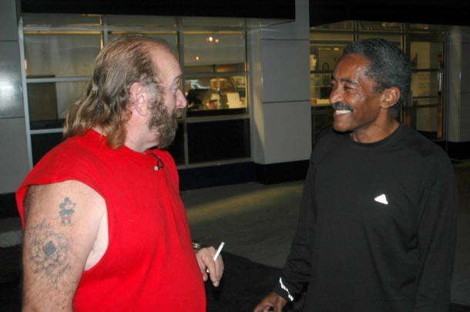
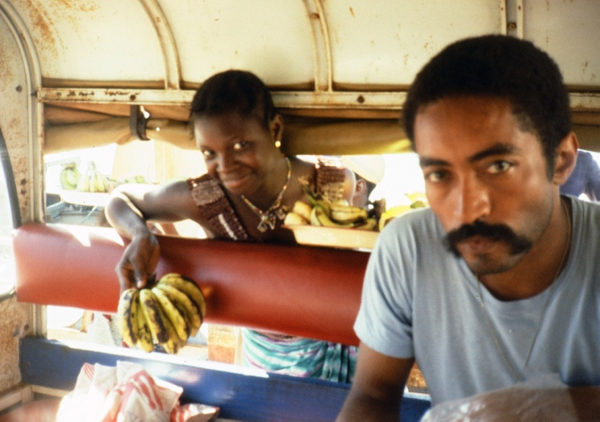
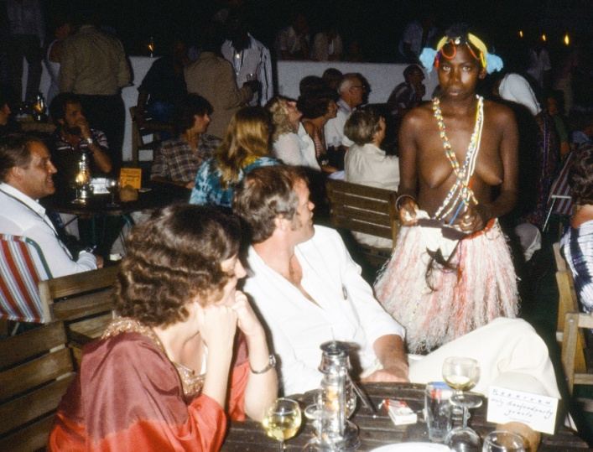
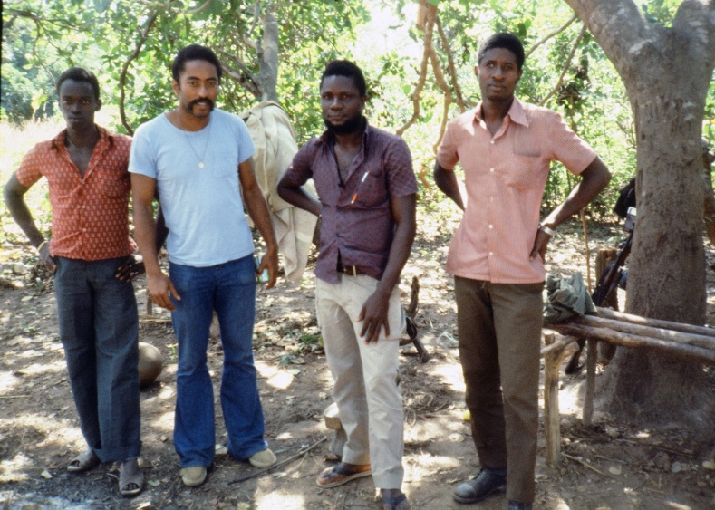
Jerry lasted longest because we always felt he had a “German mind” himself having lived there for some years, speaking the language and having a lot of the anger himself being a two time Vietnam veteran. But Tony was with his love of humanity and deep insight into its psychology and pain far better dealing with them at the time. Since he was such a fantastic entertainer and always in the center of attention he never learned the local languages like the others. Thus he felt better understood in Scandinavia (where people are used to listen to English since we unlike Germany subtitle movies), not least by the women.
Well, our working collective had grown to 12 members with a very sexist structure with 5 blacks having all the fun presenting the show for up to 2000 people every day in various countries and 3 white women doing the more boring homework of organizing all these shows and dealing with the less boring crisis situations they constantly brought up. I and a couple of others were busy working on the cinema version of the show along with a growing number of volunteers after we had formed the Foundation to support the anti-apartheid struggle in Southern Africa. That will all be too much to write about here where I will mainly focus on the stories involving Tony.
One such crisis occurred when Tony was touring Norway where he on the evening TV on Nov. 4th 1979 saw the images of the Ku Klux Klan come into his hometown Greensboro, unwrapping their guns, kneel down and start shooting into a “Death to the Klan” demonstration. Of the 5 dead demonstrators he saw his old girlfriend, Sandy Smith. Tony was in such shock that we talked about flying him home to Copenhagen and cancel the rest of the 3 week tour. As I remember it we did fly him home, but my database over past lectures says that he did complete the 21 shows with long difficult driving up and down the slippery Norwegian mountains. In those years Norway didn’t have all today’s tunnels.
I have since worked with this particular Klan group (still active until the leader behind the massacre, Virgil Griffin, after my last visit with him dissolved the group in 2003). But at the time his massacre had an interesting effect on my show. I had on my US tour in 1978 been to my first Klan meeting where I in a hood recorded a horrifying Klan speech in the dark woods of Alabama among with 70 armed KKK members (of whom one knew I was an anti-racist, but more about that in my later lecture). I wanted along with the photos to include that in the show as a substitute for my ex-wife’s speech about the KKK when she grew up “across the tracks” with the poor white “roper boys.” They later joined the KKK and committed the famous murders of the 3 civil rights workers in her hometown, Philadelphia, MS, as shown in “Mississippi Burning.” One reason was that the black Hollywood promoters had warned me to “take out your black wife, so you don’t look like another white liberal. That will make your message stronger.”
However, coming back to Denmark with my own self-experienced KKK-meeting Tony and the other blacks in our group all voted down including it into the show, “for this will make your show old-fashioned. Everybody knows that the KKK was in the 60’es. Your show has to be about the black oppression today.” Well, after the Greensboro massacre with the KKK murdering Tony’s old girlfriend and wounding of one of my old black friends, Willina Cannon, they all changed their minds and said: “Jacob, will you please hurry up putting your modern KKK pictures into the show.” And that became one of the most powerful sections of the show right up until 1991, when I had an even worse story of a family of mass murderers killing numerous blacks to put into the show – and thus had to shorten the KKK-section which now seemed old-fashioned.
During our work on the cinema movie, which Kitte Fennestad made the layout for, she one day suggested that we all went to Africa since a friend of hers could give us cheap airplane tickets. So 6 of us flew off to Denmark’s new popular tourist destination Gambia for two weeks on a charter trip. It was Kitte, her 14- year old daughter Kathinka, Tony, my ex-wife Annie, my later wife Vibeke and I. None of us had been in Africa before so it was interesting to explore our different black/white perceptions of it. And none of us liked being ordinary charter tourists - fenced inside an area since there were frequent burglaries into the hotel rooms - in this dirt poor country with only one dentist to 500.000 inhabitants. Tony especially hated to see the servile attitude of many black unemployed men waiting outside the hotel to talk white women into taking them out of the misery. And we all hated the “pig feasts” performances with native dancers rolling themselves out for white tourists. So we decided to leave and take a trip on our own into the country on small trucks to get away from the tourist scene. However, for Tony and Annie that turned out to be even worse. As we drove day and night on bumpy roads going through rivers and villages and only saw black faces all around us – endless black faces in crowds surrounding us in the darkness at night in towns with no electricity - Tony and Annie felt more and more uncomfortable. They had internalized American racism about “the dark continent” and black people spelling danger. They more and more stiffened up while we four white Europeans absolutely enjoyed every moment of the trip and felt totally secure. Not least Kitte who after her relationship with Tony was now totally hooked on black men. I never forget one long night when after having traveled for hours with seemingly thousands of black faces around us wherever we went we started approaching the town Ziguinchor in the more developed South Senegal. Suddenly Tony could see lights in the distance and burst out loud in enormous relief, “Europeans!” Ever since then I have teased Tony - with all his anti-white feelings when I first met him – for that loud longing-to-see-whites eruption.
Senegal was important for all of us to see, for here was a functioning black society with blacks in all positions in real banks and businesses contrary to the failed state of Gambia. The few Europeans we saw there were actually Portuguese colonizers who had just fled the war of liberation which we had supported from home in neighboring Guinea-Bissau. This was the reason we had taken the trip south from Gambia. We wanted to see a country in the midst of a guerrilla war, but we were both in Denmark and here unable to get visas since most of the country was under the control of the freedom fighters. Instead we decided to hitchhike and sneak across the border. However, we couldn’t see exactly where the border was in the jungle and just kept walking and walking deeper and deeper until all of a sudden we were surrounded by a hostile group of guerrilla fighters armed with AK 47’s pointing right at us. We were at first absolutely terrified fearing that they would think we were Portuguese and again I especially saw how nervous Tony and Annie were. They had seen too many blacks with guns in America and had no faith in them. Yet Vibeke and Kitte quickly eased up and started saying something in French which is somewhat similar to Portuguese which the fighters understood. They started joking, but we didn’t really win the soldiers out of their mistrust before they offered them cigarettes. Then they were suddenly all smiles since – as we later saw when they allowed us to continue into a local city – there was absolutely nothing to buy in their ripped stores still run by a handful of remaining Portuguese. Kitte got the guerrillas to look at my book and explained them about the suffering of blacks in America. They were so moved by my photos that they repeatedly said; “Why do they have to suffer like that in America? Why don’t they come home?” This moved us all deeply. That was their reaction to my book in the midst of a bloody liberation struggle in this dirt poor ripped African country, “Why don’t they come home?” Now also the contact between Annie and Tony as Afro-Americans was established with Africa which had been almost impossible for them to do in Gambia where everybody were laughing at and imitating the superficial way Alex Haley had come to find his “roots” while displaying a similar discomfort about traveling among so many dark-skinned people into the interior to find his ancestor’s village.
Years later in 2005 I had started working with the KKK and brought America's biggest Klan leader with me to Tony's house in Atlanta for him to counsel.
Someone sneaking inside trying to sell bananas to Tony hiding in his carriage from the crowds :-)
Tony and the guerrillas with their AK47's behind them
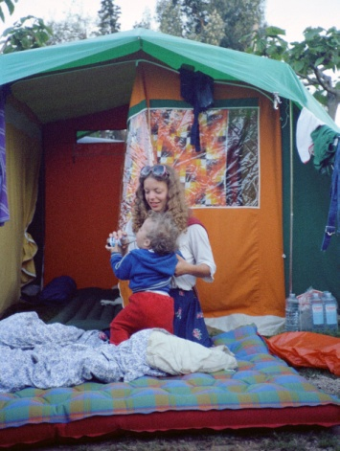
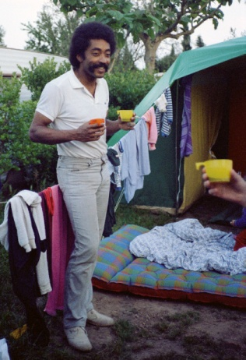
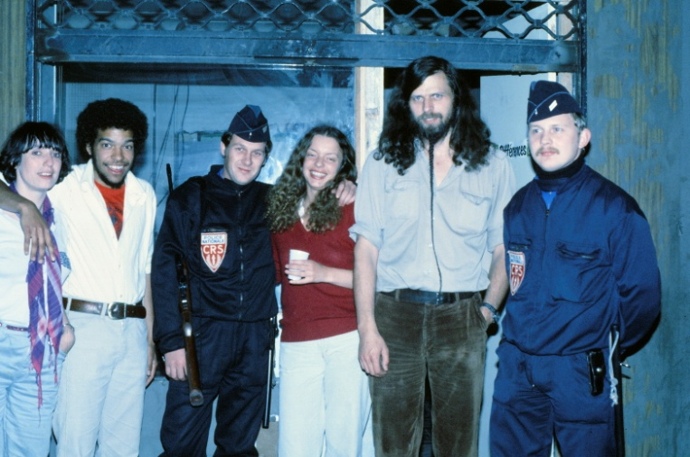
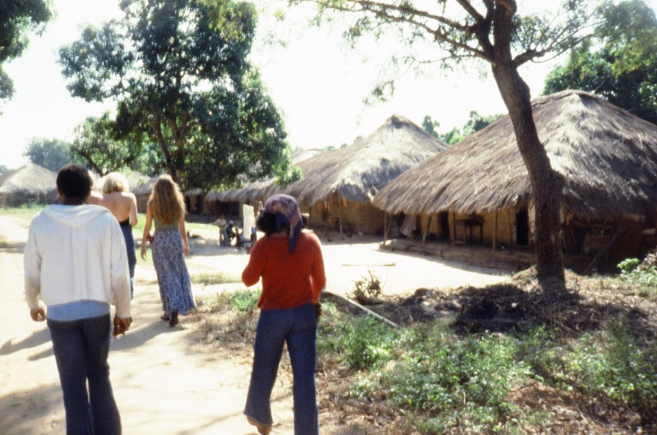
“If Haley had even been there,” as many openly doubted he had. The meeting with these determined guerrillas helped us shortly after to agree that all our money from American Pictures, the book, the show, the movie, should go to the far more difficult struggle against apartheid in Southern Africa.
The cost of the movie, however, for long swallowed most of the earmarked money, but in May 1981 the movie was finished and we all drove off in two VW-vans to present it in the Cannes Festival. On the way we made a stop in Paris where some of Tony’s friends had helped organize a show for us. We were very anxious, since that was Melvin and Jean McNair, the former Black Panthers and hijackers, who helped organize it. They were still very controversial at that time, so we had to have two heavily armed policemen to protect us against the bomb threats throughout the 5 hour show, as seen in this photo, which made us a bit nervous since we had both Tony’s and my two year old sons inside. Previously the anti-racist group hosting it had 14 bomb and machine gun attacks on their building.
So it was quite a contrast for us right after to stroll around on the marble floors among the world’s leading actors in The Carlton Hotel in Cannes. We are probably the only ones ever to bring babies to the Cannes Festival and our two one year old boys were soon irritating other guests with the result that we were thrown out of Carlton. We were probably also the only ones to stay in tents on a camp ground outside the city since our principle always was to sleep cheap in order to maximize the money for our African projects. Unfortunately I was chosen to take care of the babies alone on the camp ground that night my own movie was presented along with the entire partying taking place afterwards. Tony, Vibeke and the others had so much fun that they didn’t come “home” to sleep until next day.
Afterwards the movie was invited to Film Festivals in London, Berlin, Dublin, Los Angeles, San Francisco and even Durban in South Africa. Tony took it to the Dublin and London festivals where it was named “Outstanding Film of the Year by the London Film Festival” and he sold it to Channel Four for a huge amount which we right away sent to a former guerrilla group in Batsiranai in Zimbabwe which had now been liberated.
Whether or not we should go to South Africa with the movie was debated for long. We supported eagerly the boycott of SA – always avoided tanking in Shell stations etc – but the festival was run by very liberal people who felt the movie could help change attitudes among SA whites. I let Tony and the other blacks alone make the decision. At first they came with up with all kinds of demands such as how the movie should be shown for a totally integrated black/white audience. To their surprise the Durban organizers agreed to all their demands, which made us suspicious using arguments parallel to those I had used against the KGB “They just want to show South Africans that things are not better in the US. They try to discourage the blacks in SA from struggling by showing them what true freedom for blacks looks like.” In the end Tony and the other blacks voted not to go to Durban also from fear that our cultural breaking of the boycott could be used against us later in the US where we were about to start up. These liberal South Africans were actually very idealistic and tried for several years after to obtain the movie. Not surprisingly, for of all the spectators we had from around the world in our theater in Copenhagen, the ones who always reacted strongest and most positively to the show were blacks and whites from South Africa, who said that “it reminded them so much about home.”
I should remember this chapter since it leads up to Tony’s later formidable career in American campuses as a powerful anti-sexist counselor often drawing on examples from his own life.
Before Tony in 1980 had his son and Elisabeth moved in with us in Copenhagen and helped make him more responsible (the same effect Vibeke had on me), his womanizing in our otherwise devoted work collective (with its sexist work division) had continued to get worse and annoyed the rest of us. Often he would have a woman in his own room when another arrived whom we could then hear him making love with in the elevated bed in the combined office and projection room. Two in one night! So when Tony’s beloved grandfather died and he went home to Greensboro for the funeral we decided that I should call him and tell him that he couldn’t come back unless he changed his behavior. I made several calls about how we simply couldn’t take it any longer and how his attitude threatened to destroy our reputation. Tony put all his charm in use and promised again and again over the phone that he had changed. For at his grandfather’s funeral he had seen almost only unknown old black women standing around the grave silently weeping under their big hats. It was embarrassing for his grandmother and family for everyone knew that these women were his grandfather’s girlfriends and “I don’t want to end up like him,” Tony said. Finally I was convinced that Tony really meant it when he claimed to have had a change of heart, and allowed him to come back to Denmark.
Elisabeth and their son
Tony at his tent in Cannes
Dominique, Howie, Tony's girlfriend Elisabeth and me with police outside the building while Tony is presenting the show inside
Tony and "Black Annie" in rear, Kitte and Vibeke in front
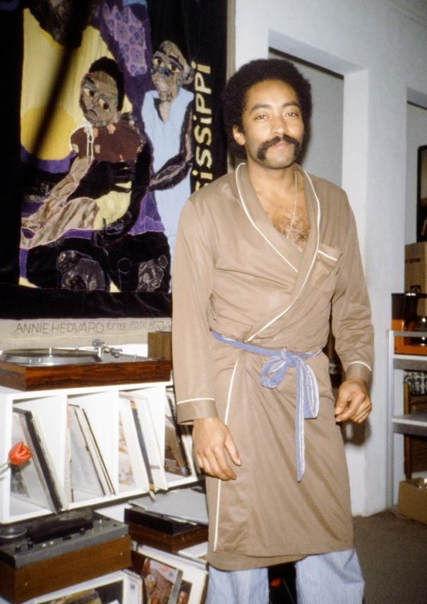
But never will I forget the day when he after a two month’s absence arrived in our house in Købmagergade. I had my parents on a visit – the pastor’s family – and Kitte, Vibeke and some of the others were politely sitting drinking tea with them at the big table just inside the front door. Suddenly Tony arrived and threw his bags just inside the door and everything was joy and laughter for a short while, but only a few minutes after the first of his many girlfriends arrived and they quickly went into his bedroom. A little later we heard loud penetrating screams from his room and Kitte and Vibeke started speaking louder and louder in an attempt to deafen the background sounds. My father knew very well what the sounds were all about and put on his most disapproving forehead in folders, but my confused naïve mother started asking; “What is this sound? Have you got a dog?” And then Kitte started as loud as she could to get into a long story about how we were taking care of a sick dog for some friends, so sick that we couldn’t let it come into the living room to us.
A little later another one of Tony’s girlfriends arrived and soon the dog screams now came from inside the office, if I don’t remember wrong. Not until late next day did Tony come out to reclaim his traveling bags still spread around inside the front door. So before he had even unpacked his luggage he had broken all his promises about changing
It may sound from this description that Tony was using all these women – and certainly this was the truth – but there is no doubt that they were also using him as their archetypical dream of a black prince. They were not naïve; they knew what they were getting into. Most of them were well educated and very attractive and grounded teachers, librarians (like my cousin), architects etc. and when I and the others talked with them – usually when they came around and sat in line to get access to Tony’s bedroom – we didn’t have to warn them about “Tony’s non-committing nature”, for that side of him they had long ago looked through. Some of them already had stable relationships with Danish men and just wanted to “live out their black dream” before making a final commitment to their own man. I can’t recall any of them claiming to have been deeply hurt by Tony, only disappointed about him not living up to all their dreams, about him “being too messy, leaving full ash trays and dirty cups in every room”, or in the worst cases “borrowing (or taking) too much of my money” and such petty complaints. When over the years I have later met them with Tony – many now happily married to other men – they have always shown great joy about seeing him again. It was as if he just as smooth as he could charm or talk himself into relationships with them (within minutes), just as smooth and elegant could he get out of their relationships (within a few days).
Tony as we usually saw him in a bathrobe - ready for the next date
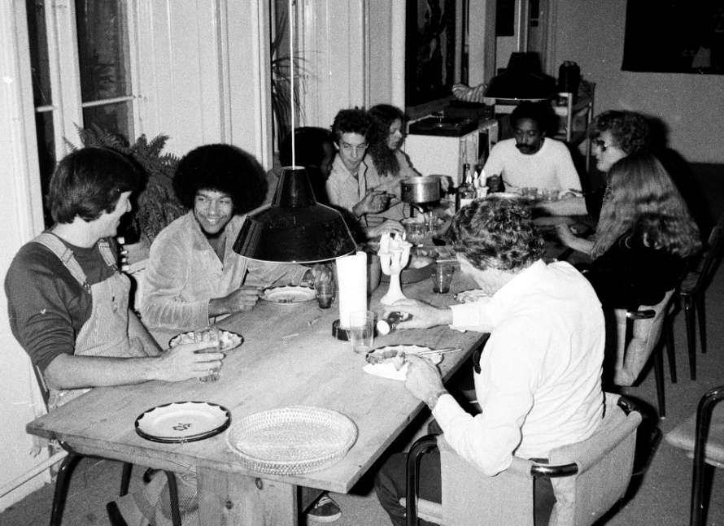
That this was not only a problem between Tony and Danish women we saw close up in our own house, where a lot of the Gambian men were gathering – Gambians brought home by Danish women and married into culturally lopsided misalliances. Most of these men with no education soon ended up on the Danish streets and got into selling drugs. One of them was Mohammed – a beautiful guy who like most of them had married a beautiful, but hardworking Danish woman. Mohammed loved to hang out with the fast speaking cultured Afro-Americans in my house sitting around reading their Time Magazines etc, but Mohammed was the first to pay our attention to what happened to the other Gambians, warning us to watch our wallets whenever they were around. We loved Mohammed because he for long seemed to be above this sad trend and would make it, but eventually he too was kicked out by his wife and ended up on heroin and in prison.
The lawyer for our Africa foundation, later director of the Danish Employers Association, Søren B. Henriksen, for a long time defended many of our black friends who ended up in prison. As a womanizer himself he saw the advantages since some of these beautiful Danish wives during the court cases would form so strong relationships with him that he later ended up in relationships with them. Since I and my Afro-American friends in America were used to seeing blacks always “marry down” – getting the most unattractive, impoverished white women who had problems finding boyfriends at all – we were astonished seeing how they in Denmark always “married up” with the most beautiful, educated women. This worshipping of blackness in the 1980’es (before the onset of today’s racism toward foreigners) also explained a lot of the enormous appeal of American Pictures in Denmark, while it flopped in the ex-colonial societies of England, France and Holland.
Seeing this blaxploitation of African men also gave Tony some bad feelings which made him to some degree adjust his own behavior towards Danish women and gradually learn to appreciate their enormous sense of independence and “liberation” in terms of demanding equal division of responsibilities – totally unlike the servile black women Tony mostly knew from America. When I often invited black American women to Denmark “where the men just loves black women and you can get quickly married to a responsible man”, these women were often disappointed and confused when they were invited out by men earning far more than themselves - such as my lawyer - and these Danish men then refused to pay for their drinks and insisted on splitting the bill in half. “How can I fall in love with a man who won’t do anything for me?” I heard them whine.
Meal in our living room, Tony at the end of the table. My parents visiting on his right with Vibeke.
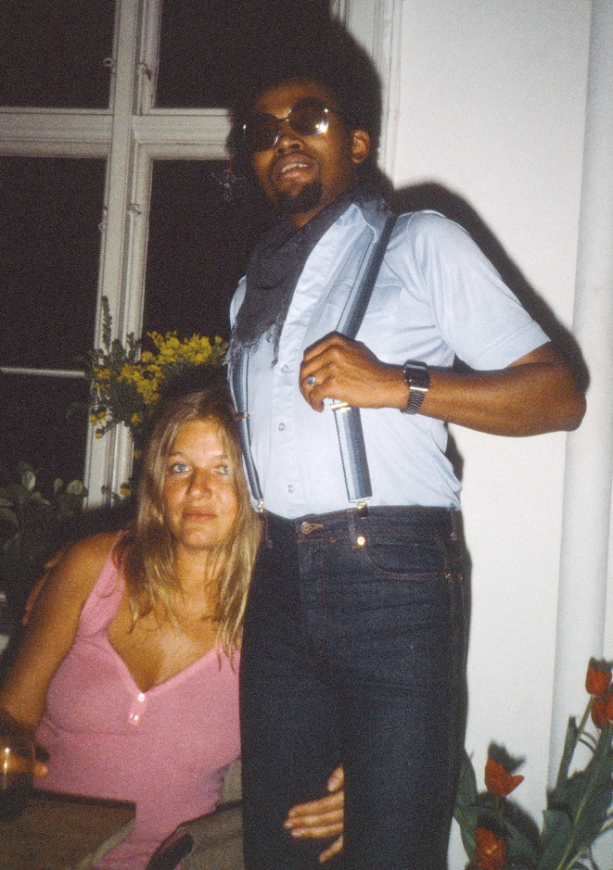
The worst case Tony saw of blaxploitation he experienced in our own house. For Kitte Fennestad had after her short initial relationship with Tony gotten so hooked on blacks that she imported a man home during our trip to Gambia. We installed them in one of our rooms since Kitte was now working on our film, but as a successful businesswoman often she would have meetings out in town. However, Ibo, her Gambian boyfriend absolutely refused to see her just take off to meetings with mostly men every day. When she was out I saw him pull her underwear down from the shelves and walk around in circles and stomp on it, swearing and yelling something about “keeping his woman down.” Sometimes he would find out where her meetings took place and walk right into the office where Kitte sat surrounded with lots of men around a table and walk right up to her and spit her in the face in front of them. Sexist patterns so deeply ingrained in a culture from birth do off course not understand western logic and my many lectures for him about how wrong his behavior was. The only thing that worked for a while was when I put on Jimmy Cliff, who was enormously popular in Africa, and played endlessly his “Foolish pride” for at the highest volume. But finally we had to kick him out – like all the other Danish women had kicked their Gambian men out. It was a great defeat for us, for with all our understanding and tolerance from American Pictures we had expected we could handle the culture gab better than the other Danish women whom we had in more diplomatic words often called variations of “racists”. Then Ibo started coming around to break our bicycles and destroy our cars – anything associated with Kitte and American Pictures. One day he suddenly appeared inside our house kicking and destroying everything while the show was running, and the women had to call the police. And just when the audience came out from the theater in the intermission they saw in shock how Danish police led a black man in handcuffs through our living room/foyer and all thought that it was part of the show with all the guilt towards the show raised in them. Eventually Ibo was shipped back to Gambia, but we got nervous when we heard he had managed to escape into Europe again. By then Kitte was living with another black man – one of my American guests and spectators of the show – whom she also fired after a while. Finally one day she found her “black prince” – actually a prince from a royal family in Nigeria – with whom she has lived happily ever after to this very day.
All this helped to change Tony’s attitude in a more responsible direction, which however only made him so much more attractive for Danish women – “a black man who very eloquently could talk about women’s liberation.” So his sexism just found a more disguised and alluring level
I don't have any picture of Kitte and Ibo, but this photo of her with another of our employees Jerry Justice illustrates her love for black men very well.
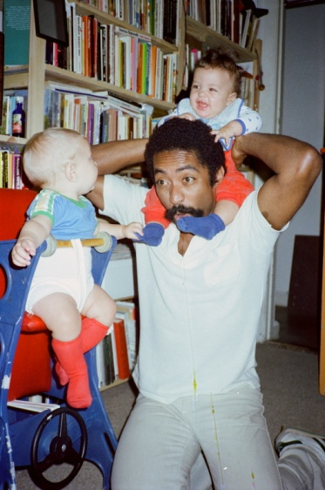
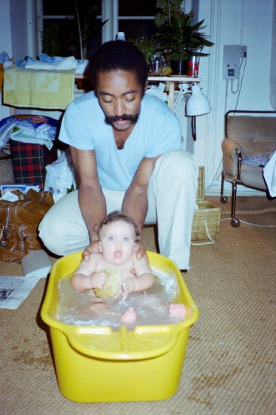
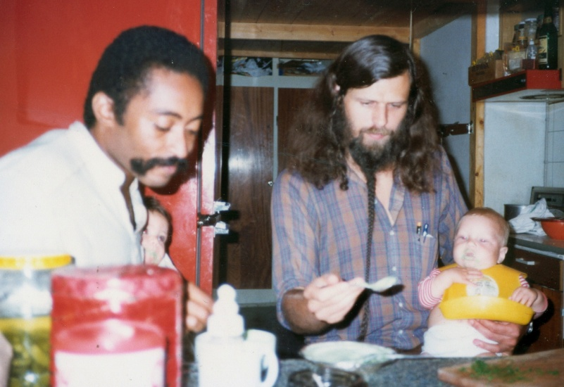
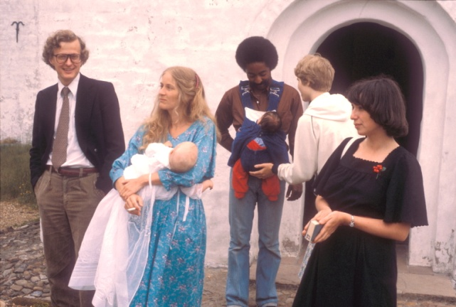
Finally one day we found an effective way to stop all Tony’s swing door womanizing. We got one of his girls pregnant with him. Well, it wasn’t really our planned conspiracy and it certainly was very much against Tony’s will. But it happened with Elisabeth and she insisted on having the baby. So she moved in with Tony and us in the months before her birth and became a stable part of the collective. I don’t recall how faithful Tony was during her early pregnancy, but since Vibeke and I expected a baby at the same time he wanted to show that he was just as responsible an expectant father as me – not indicating in any way that I was a good role model myself We both went to birth training courses exercising the correct breathing techniques.
Vibeke and Elisabeth got very close in that period and even Kitte started having milk in her breasts in some kind of female solidarity against an otherwise male dominated house. In February 1980 they both gave birth to sons one week apart. Elisabeth got a cesarean, so Tony did not use all his learned techniques. And I was so busy photographing the birth that I forgot all about helping in the decisive moment. From now on there was an unspoken competition between Tony and me about being good fathers, feeding our babies together and proudly walking around with them in snugly baby carriers on the chest in public. Tony clearly enjoyed the role of the liberated father in those years where the feminist Redstockings movement still ruled in the minds of the youth and he could score high points among the women.
The next two years were probably the happiest in our lives for both Tony and I and the only period in his life where I have seen him live a regular family life – as regular as it could be within the framework of our work collective. So square and regular was it that we both enjoyed being home with our families and watch TV – especially the TV-series Dallas with all its conservative American values – with all of the collective sitting around in the huge couch at the end of the living room with the show playing in the background in the theater.
Two fathers feeding their babies
The baptism in my father's church. Tony with Nanook in snugly. At left our lawyer Søren B. Henriksen
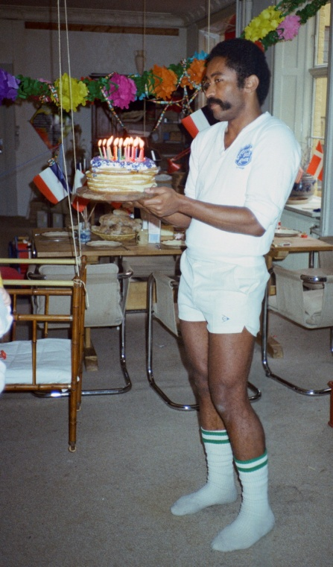
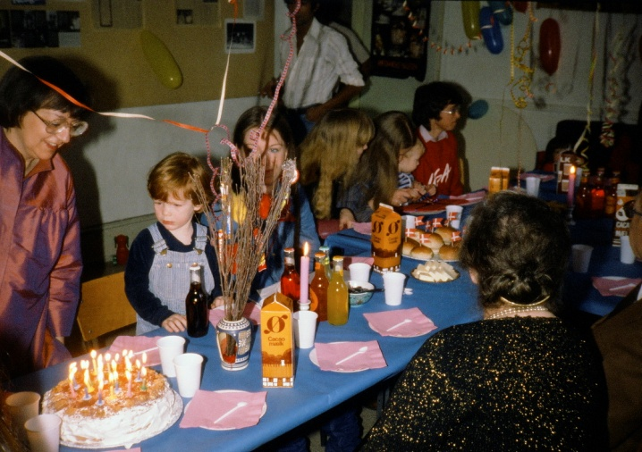
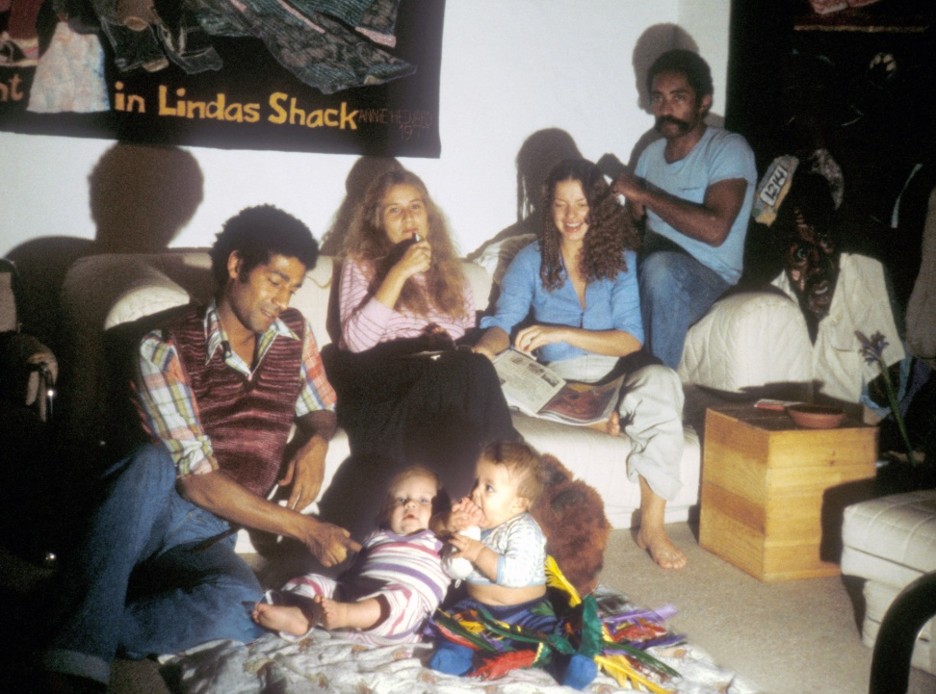
Only in the intermission when the audience came out would we jump up and hide the TV away and act busy serving coffee from Nicaragua in support of the Sandinistas against Reagan’s Contra war and playing Victor Jara’s revolutionary music from Chile or “Earth, Wind and Fire” quietly in the background while conversing with the audience. At the ticket selling place at the entrance to the theater the children were hanging in a child’s crib from the ceiling so that no one could get into the theater without giving a little push to the children and thus keep them asleep. With Annie Hedvard’s enormous guilt-provoking tapestries of suffering black faces staring down on us all many spectators later told us that the experience of seeing our harmonious black/white/international happy family life was just as overwhelming as the show itself.
The result was that many came again and again to see the show – or usually the second or third time to just hang out with us or to volunteer for us cutting and framing the special enlarged 40x40mm copy slides to allow more light on my pictures for the larger and larger audiences we had around Europe. Some came as far as from Ireland and Algeria to work on the movie, which we slowly produced on sophisticated equipment in my bedroom. Some worked hard as cleaning ladies to earn money to give to our Africa Foundation and discreetly come and place bags with more than a thousand dollars in our bath room.
Tony with our famous hanging crip at the entrance to the theater
One of our large birthday parties with Tony's mother in law seen at left
Jean from Guadalupe, Vibeke, Elisabeth and Tony with the babies playing
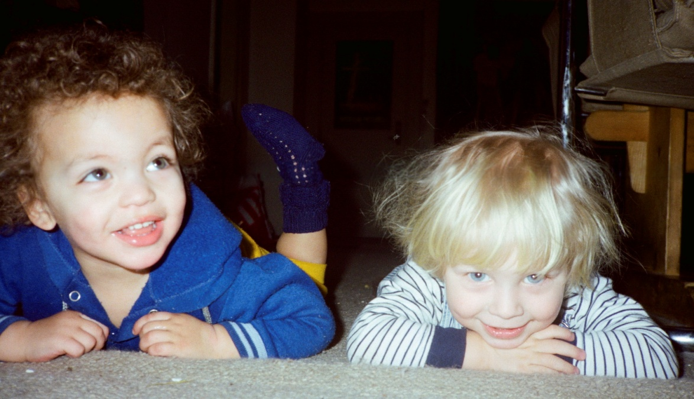
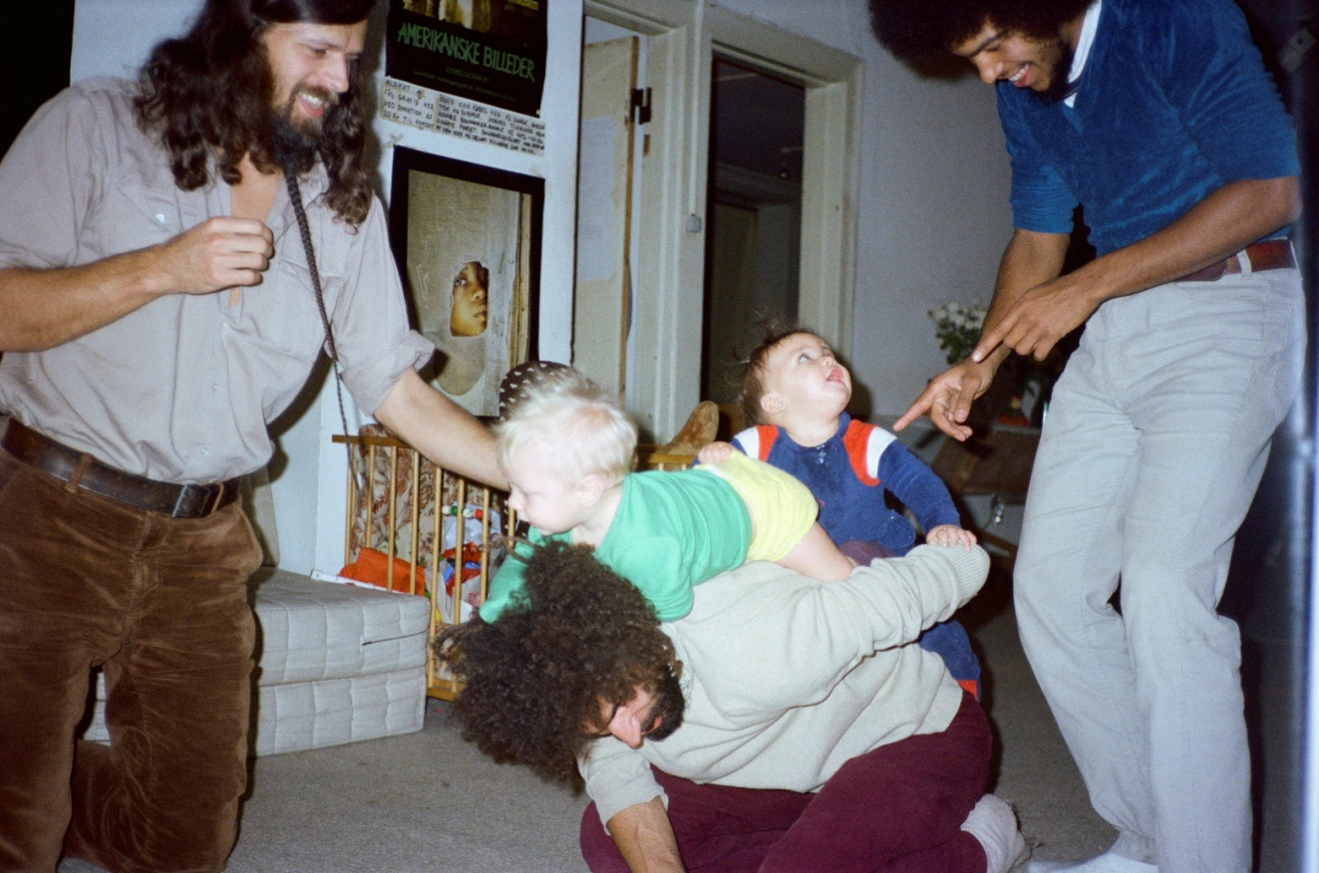
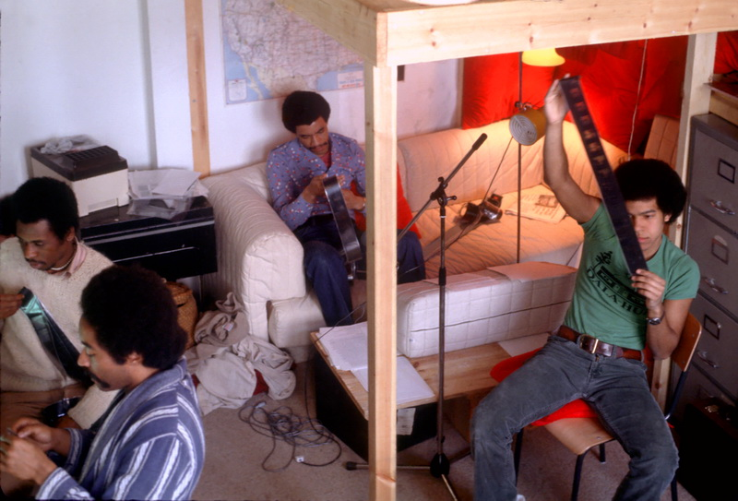
It was a period when the whole world came to us and we consequently felt we were the center of the world. And Tony enjoyed that only period in his life where he didn’t have to go out hunting. If he was not out presenting the show he would often walk around all day in his house coat. We would eat big dinners together often all 10-15 members of the collective – soon with our two sons, Nanook and Daniel, crawling and playing under the table. They bonded so close with each other that for years after they were like blood brothers. Many more would come for their big birthday parties.
It was a period of tremendous optimism. Everything was going right for us – schools and organizations all over Europe were calling for us to get the show – and we were working hard on the movie through which we felt we really could conquer the world – including the United States.
Finally in 1982 the group split up in two with half of us moving to America – and the rest staying in Europe expanding into new countries such as Finland, England and Ireland.
For the children it was a fantastic multicultural playground. Here Daniel and Nanook are with Sebastian and Howie.
Everybody was preparing for our entry into America. Here from left Jerry Kwako, Tony, Harb Lelshab and Howie.
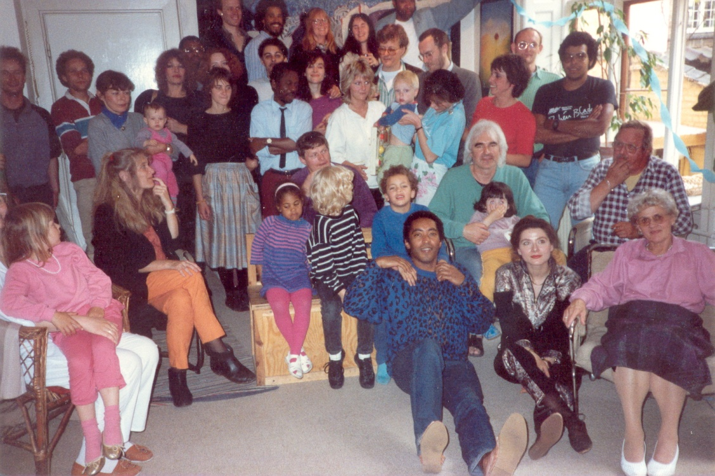
In 1986 we had a 10 year reunion for all of us who had worked in the Købmagergade collective.
At that time 6 children had been born as a result of the relationships formed. Tony is seen in front of Nanook and Daniel.

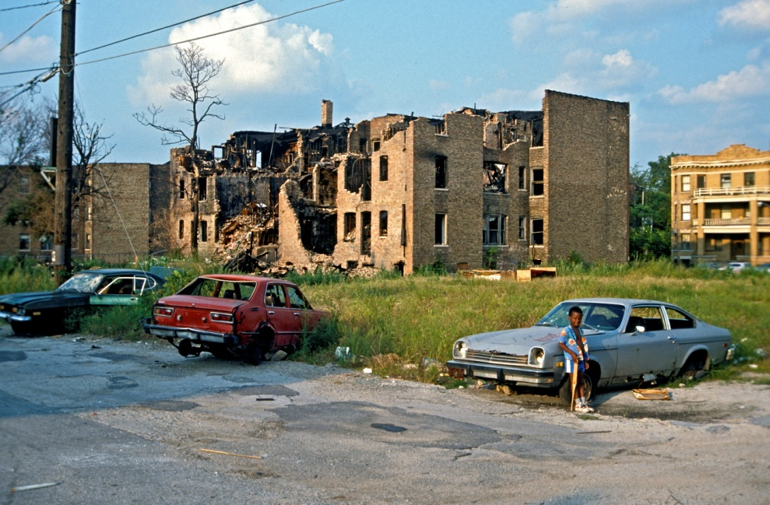
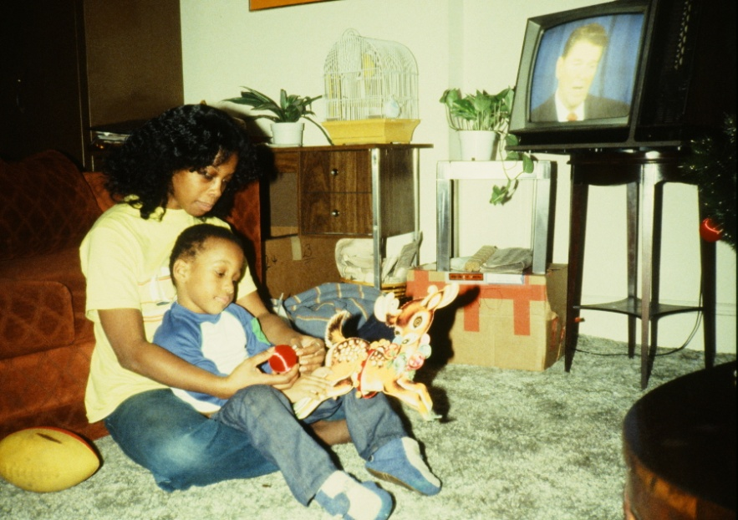
Tony in America – his greatest success
I was the first to go to America invited to the Film Festival in San Francisco in the fall of 1981. It was a tremendous success with standing ovation from the 1600 strong audience in the Castro Cinema in the Castro Gay District. But that was also our only success for a while. Afterwards I bought a cheap second hand VW bus and drove to my old farm outside Toronto to pick up my projector equipment left there after my car crash on the tour in 1978. On the way I stayed with a black/white couple on the South Side of Chicago, David and Julie Less, who wanted to help set the show up there in Univ. of Chicago. I rushed back from Canada and called Tony and Howie over from Denmark to help run the show there. It ran nightly for a month there in The Court Theater and received probably the best reviews we had ever had – both in the University Media and in The Chicago Reader uptown. But we did not get many spectators from the white north side of Chicago since they don’t dare go down through the ghetto on the south side after dark. And the blacks on the south side did not like to cross over the wide DMZ divide (the Midway Plaisance) between the affluent university in Hyde Park, where they were feared by the white students. Also they had a lot of anger because the university was slowly buying up more and more buildings in the ghetto to expand.
Tony, Howie and I lived in the dark slummy and barred ghetto apartment with David and Julie right in the worst section on the 62th hundred block of S. Woodlawn. We had no money since we had just given all the 120.000 dollars from Tony’s film sale to Channel Four to our apartheid projects in Africa, so now we were forced to live in the center of this ultimate apartheid in Chicago “on the wrong side of the tracks”. After all the security we had had in Europe and all our dreams about “making it in America” it was quite a chock for Tony and Howie to be dumped in this most vicious ghetto where they did not even dare to walk the few hundred yards over the DMZ to the theater at night. For my own part I kind of enjoyed again being back in the ghetto. For when seeing the shock and disbelief our audience was in after seeing my pictures often I often in Europe had started getting a feeling that perhaps I somehow had exaggerated conditions in the show. This section of South Chicago with huge empty lots between our buildings looking like bombed out Germany after the war was no doubt worse than anything I had presented.
There were endless burglaries. One night the criminals broke into our van and stole 3 of my most treasured cameras. It is not to brag that I say this, but I really felt so much “at home again” that I said to the others that I would walk around in the shooting galleries in the neighborhood to try to see if I could buy back the cameras from the junkies. The others stared at me in absolute disbelief as if I had gone insane. David was a tall, strong and crazy three-time Vietnam veteran who had been so wounded that he could show us how all his bones were screwed together with bolts and screws. He had been in the firing line quite a few times in Vietnam, “but nothing ever scared me so much as this neighborhood,” he shouted with his deep voice. “You are not going out there in those shooting galleries, Jacob!” Howie had grown up in a ghetto since his father as a psychiatrist and expert on black oppression psychology had refused to move out of Boston’s Roxbury ghetto to join the white flight to suburbia, “but Roxbury is virtual suburbia compared to this hell, you have brought us into, Jacob.” And Tony had seen nothing like this in the entire south ….and probably just dreamed about moving our show to Chicago’s north side with all its white women
So none of them offered to join me during the next two days when I walked around and knocked on buildings with no lights or windows and asked if I could buy my camera back making sure not to carry too much cash on me. Tony for years after used this episode in our workshops and interviews to point out that “Jacob has no fear”, but this is far from the truth. I had lots of fear the first two years in America when blacks mugged me all the time, but like David in Vietnam I had just lived in a war zone for so long that I had unlearned my fear. However, I was amused here again – like in Africa – to see an example of how Tony had internalized the prevailing fear of blacks in America (I say it only to tease him). That fear we now heard about from our white students in “Fort U of Chicago” every night. Somehow it seemed like we two whites in the apartment were suffering least from this fear. David’s wife Julie was a bleeding-heart-do-gooder-liberal minister, who seemed above it all wrapped in some divine Teflon – probably the same naivety the others saw in me. She had taken this deeply wounded soul David with all his violent psychological problems under her wings as if this was her ultimate mission in life. I was not surprised when some years after she told me she had to divorce him as a result of his violence.
There was another woman in the house as a result of violence. On my way back from Canada I had driven through Detroit’s worst ghetto to reconnect with old friends. Ten years earlier I had photographed a family bitten by rats in a rundown neighborhood when I suddenly saw the most beautiful black woman my own age in the house next door. Lynaise Dobbins had long hair all the way down her waist and a self-assured intelligent face. I had to talk with her and she seemed very interested in my pictures, but a little apprehensive as to what a white man was doing “in my neighborhood”. In spite of all my flirting she didn’t really open up to me and was as a student still living with her mother. I told her that I would write her a letter explaining better what I was doing – although I hardly knew in 1971 what I was actually doing apart from looking for such a beautiful black girlfriend to travel with. She quickly indicated that she was only interested in “a beautiful black man” – as was the case for most of the black women at the time. Since I was absolutely taken by her beauty and certain that she was the right woman for me I from somewhere else in America wrote her a 20 page long tightly typewritten letter (which I still have a copy of), but to my great disappointment never got an answer from her. Over the vagabond years I was often in Detroit, but never dared look her up – afraid that I would again get a negative response from her – or rather so busy with my project that I preferred as usual to “postpone the good things in life.” As I always said to Tony; “If you wait long enough even the best women will come to you.”
And I was right. After 10 years Lynaise was now ready for me. Now I found her sitting as if beaten up with a sad face in a rundown shack. She remembered my long letter, but had now lost it. She had first married a “beautiful black man” and had a child with him, but he turned out to be an addict and very violent. Later she married another black man, a Jamaican I think, but he had turned out even more violent and even beaten her while she was pregnant with their child. Now she was finished with black men and just waiting for a prince to take her out of this misery. “Please, Jacob, take me with you!” she begged again and again. However, my own desire for a beautiful black woman had over those ten years with my own destructive marriage to a black woman long ago evaporated. And still, how could I possibly say no? So she ended up with no hesitation going with me in my VW camper – in her attempt to escape from one violent ghetto (Detroit) only to end up with me in another violent ghetto (Chicago) only with some vague idea about working with me and American Pictures. Perhaps that could have worked out, but Tony and Howie felt we were more than enough people stuck in that small ghetto apartment and did not swing very well with her. So that ……
Temporary interruption……
Lynaise Dobbins after 10 years now with Reagan on TV
Well, I have now so many lectures here in Denmark in the fall of 2014 that I will have for the time being to stop writing about my long friendship with Tony. Also I don’t know to what extent Steve McQueen will tell the story about what later came out of American Pictures.
For everything I could possibly have dreamt about in my vagabond years as a messenger between blacks and whites now came true. After a difficult start in Chicago and in our own theater in San Francisco Tony and I finally conquered the American university system and ended up with the longest track record ever of any speakers on the lecture circuit. Here Tony - drawing honestly on his own deep pain and darker reservoirs - ended up as a formidable workshop leader often holding 300 students captive for up to 12 hours - in tears. Often colleges invited my show back again and again if only to get Tony back. After Tony got me into his co-counseling ideas my show became enormously popular without the European tendency of finger pointing. The image of a black and a white man working so closely together was itself moving for our audiences, they reported. These next 25 years where we created lasting change in the thinking of students – who still meet 10-15 years after to evaluate the impact on their later lives – I will write about later. But that story of how two uneducated men could rise and form such a powerful team should be told, I feel – especially if Steve McQueen wants to present a positive black male figure in his movie. With love Jacob Holdt

