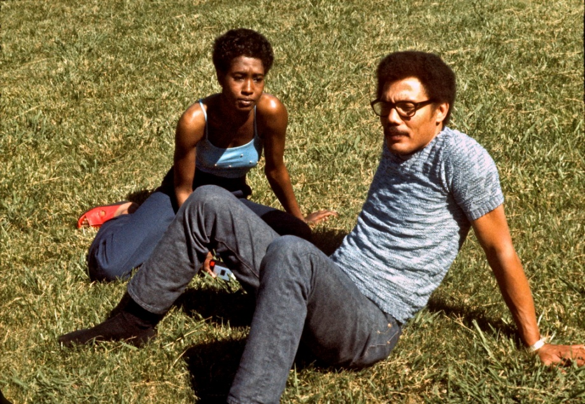
My long friendship with Tony Harris
In 1973 I was increasingly aware that I was working on some kind of photographic project on black-white racism and in the fall I wanted to go to North Carolina to photograph the tobacco picking. I sat in Library of Congress for a couple of days doing research while staying in Georgetown with a girlfriend, Eveleen Henry, who stored my slides. Both on October 1st and 2nd I tried to hitchhike south from Washington, but kept getting picked up by Virginia police who gave me tickets. With my usual joyful national pride encouragements a la “Wow, American police is so nice. They always come to give me help when I am stranded” they luckily each time drove me to better places rather than to prison which was the norm for hitchhikers in Virginia. After a lift with a “Born to lose” speeder I finally in Petersburg got a lift with a long haired anthropologist in a VW camper, who took me all the way to Myrtle Beach where I slept in his camper. Neither he nor I knew where the tobacco crops were – it later turned out we had passed them – so next day on Oct. 3rd I ended up in the other, more urbanized end of North Carolina in Greensboro where my lift took me to the university UNCG. Here in the coffee bar I met Tailor who said that perhaps I could stay with his black friend, “Mack” or Ernest McCoy. That was my luck.
Mack was a devoted social worker in the daytime, but equally devoted womanizer at night. So life was never boring in his house where he usually entertained his latest dates playing saxophone for us. He introduced me to many well educated black women such as Gwen Sneed, an incredible intelligent daughter of a tobacco farmer, but unfortunately like most other educated black women at the time totally opposed to black/white marriages ….even though we spent a whole night together in lovely conversation. As we drank whisky Mack tried to signal to me, “Do you want to spend the night with her?” For then I knew he would continue out in the city to find another woman for himself. I laughed and signaled to him that I would like to stay even though I sensed that it was a hopeless case, but after so much time in the underclass I felt it was important for me to be challenged by educated black women. Not least to fight the ever-threatening creeping racism of seeing blacks as inferior which you so easily develop if you are only around uneducated and in the south often incredibly ignorant rural blacks.
Ernest McCoy with a date
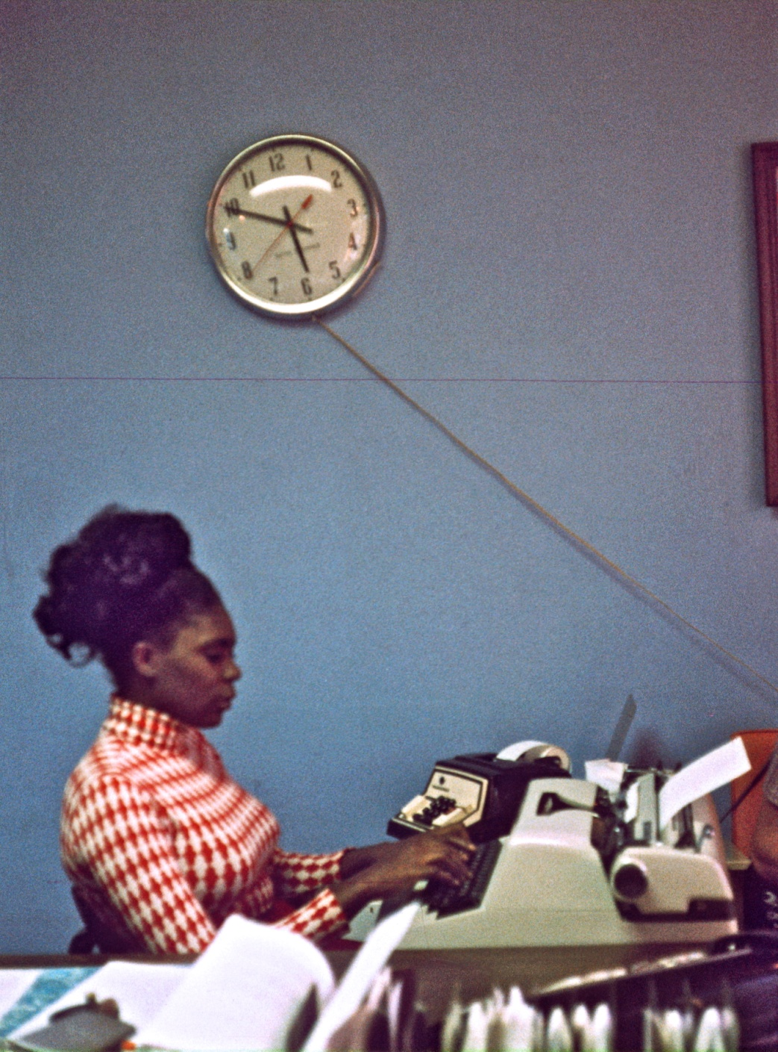
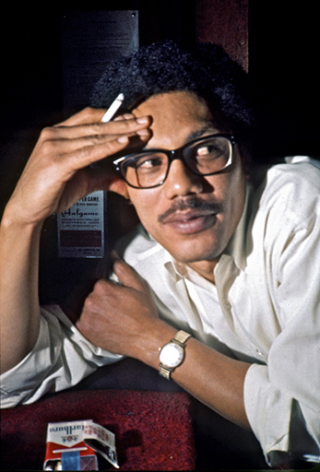
Well, next day Mack took me to his workplace in the Drug Action Council, where I met the secretary Geegurtha Pennix, who became one of the named key figures in my later book on page 244. Here I was definitely back in the underclass, for this was a center for drug rehabilitation of prisoners. Geegurtha had as a former prostitute been one of them, but was now trying to proceed into a normal work life after getting help here in the clinic. Somehow I right away hooked up with Gee, as we called her, but in one of their breaks all the other co-workers came upstairs from a session with convicts downstairs. And one of those was Tony Harris, who was skeptical since Mack had brought me there. I got into a hectic discussion with them about my work. My diary says that I explained my pet theory to them about how blacks up in the North in one sense had become more defeated since they like Vietnamese peasants right then had been bombed into strategic hamlets or concentration camps so that the white oppressor better could exercise mind control over them. After all a great way to ass lick these southern blacks, I can see today. Counselor Dorris was wildly enthusiastic about the pictures in the book and soon Mack – sensing that his white guest had won them all over – suggested that I come with them downstairs and give a rap session for their convicts. So I went down and spoke to 20 hardened criminals and all Mack’s coworkers, who eagerly asked about everything. It was like I lifted a veil for them, some of the coworkers said, and Tony has often repeated the story about how I made the prisoners totally quiet and feeling embarrassed because I – a white foreigner – somehow knew more about their lives and psychology than they did themselves. Dorris afterwards came upstairs and said, “Gee, it was like Jesus walked through my house and told me everything which was wrong with it!” That sentence made Mack completely freak out in laughter since I had just the night before told him about the Jesus image many blacks had of me – especially in the South. So that was the day – Monday Oct. 7th, 1973 – where I first meet Tony, whom I had no idea would end up as my lifelong friend. Especially since I was sensing that he like so many other blacks at the time was pretty anti-white.
However, already the next day, while Mack was at work, Tony came by Mack’s house to pick me up and to take me to a very fancy “black restaurant for the bourgeoisie” as I write in my diary, to eat all the free lunch I could eat. I can’t remember if this was his own idea, but the other coworkers had at least agreed that he should bring me back to do “more counseling for our clients, for you can tell them very uplifting things they have never heard before, and coming from a honkey (white man) they listen far more intensively”. Before we drove back to Drug Action Council Tony said that he himself had been convinced by my talk “that not all whites are bad. And believe me, that is not easy to admit here in the South,” he laughed in his characteristic self ironic and liberating laughter. “Therefore I would also like tonight to invite you to my house to introduce you to two of my black women friends. You have to understand, that this is a strange step for me. For I have never before allowed any white to enter my door.” To introduce the guest to “dates” I had already learned among southern whites was a very southern trait, and Tony just as Mack had very soon correctly analyzed that the fastest way to my heart went through black women or as many psychologists would later conclude - since it had nothing to do with race, but the guilt of the oppressor - through oppressed women. For only the impossible beyond your reach counted in my mind as truly attractive.
Geegurtha Pennix in Drug Action Council. At a huge French photo festival in 2006 this photo was the official poster and is today hanging all over in museums as “art”.
Ernest McCoy who today is a clinical social worker and psychologist in Greensboro
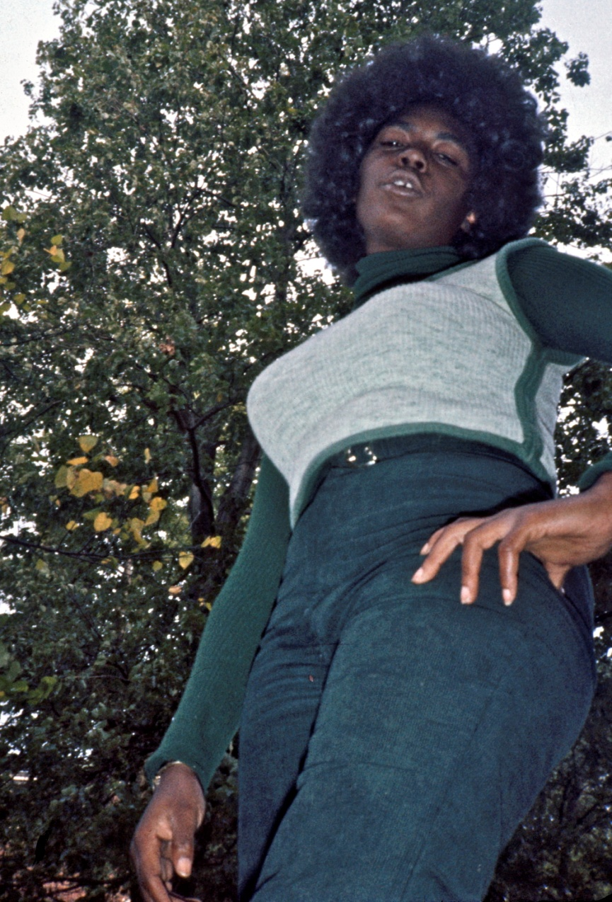
That hostility towards whites was nothing new for me, for this was the prevailing attitude among most blacks at that time where it was almost impossible for me to be accepted into black homes – especially by more educated and aware blacks. I had myself explained it to Tony’s clients as the end result of whites forcing millions of blacks into ghettos against their will right at that particular time shortly after the Civil Rights Struggle when blacks felt they were closer than ever before to reach the ladder up to “the American Dream”. However, when they everywhere found whites moving that ladder further and further away from (social contact with) them, then of course the counter reaction comes, “You must not fraternize with the oppressor.”
So anti-white had Tony become that I don’t think he would have invited me home had it not been for another fact which I was not right then aware of; namely his long power struggle in Drug Action Council with Mack. Not only was Mack “selling out” and being resented for going with white women – one of whom Mack and I had already shared, Sis Thomas – but moreover for their deep personality differences, their different approach to things in counseling, and for Mack having a formal education while Tony like myself was mostly a self-taught, but nonetheless an equally brilliant counselor. Tony had the advantage from personal experience of having himself been a former light drug user. How much is debatable since the norm was that practically everyone I met in those days at least smoked pot. First of all they were equally popular, handsome and competitors among women. So when Mack now scored extra points in the community for daring to bring a white Scandinavian hitchhiker onto this anti-white scene, that was probably more than enough reason for Tony to try to overcome his prejudice of whites in an attempt to somehow wrestle me away from Mack. In other words it was initially probably more to win over Mack than to win me.
What had also impressed him and all the others was that when in my talk to the inmates I had mentioned how it was almost impossible for me as a white to get to stay with blacks, Geegurtha had suddenly burst out, “Well, Jacob, you are always welcome to come and stay with me.” I never forget the shock of disbelief that went through the room. Nobody – and I say NOBODY including myself – had ever seen or even heard of a black woman openly inviting a white man home in the presence of other blacks, most of them men. Not until I years later traveled in Africa did I experience such an unusual phenomenon. And in this case it was not at all the disgusting thought of black-white sex which drove their surprise. For everyone knew that Gee had been an addicted prostitute for years with mainly white customers up in the far North in Buffalo and that she was now after several years of counseling in the clinic “clean” and healthy, a fact which in turn was probably the only reason Gee even dared to publicly invite a white man – if only to demonstrate just HOW “clean” or pure she was now.
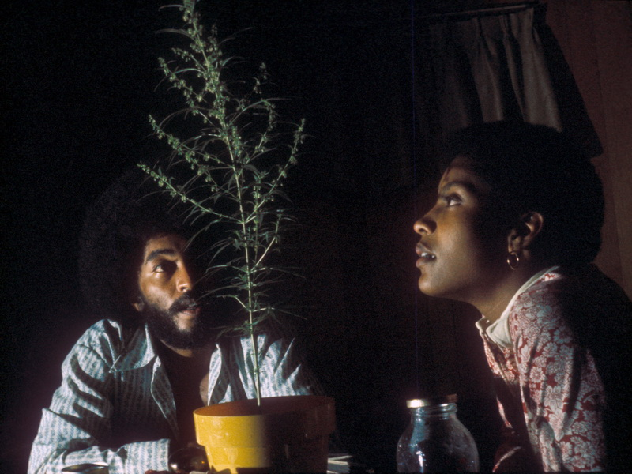
Geegurtha posing for me as the prostitute she had recently been

Staying with Tony and Piere, his favorite date for a long time
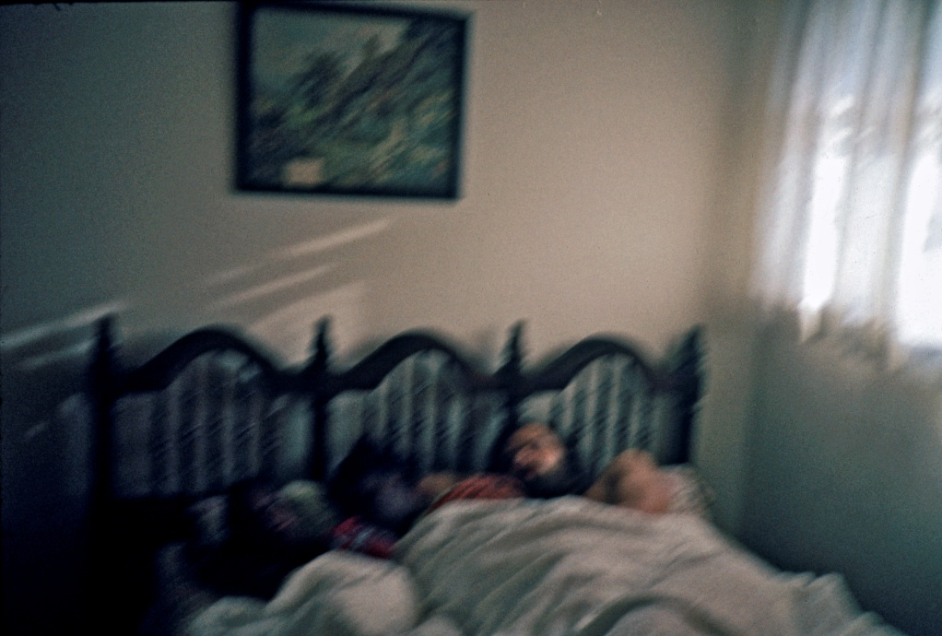
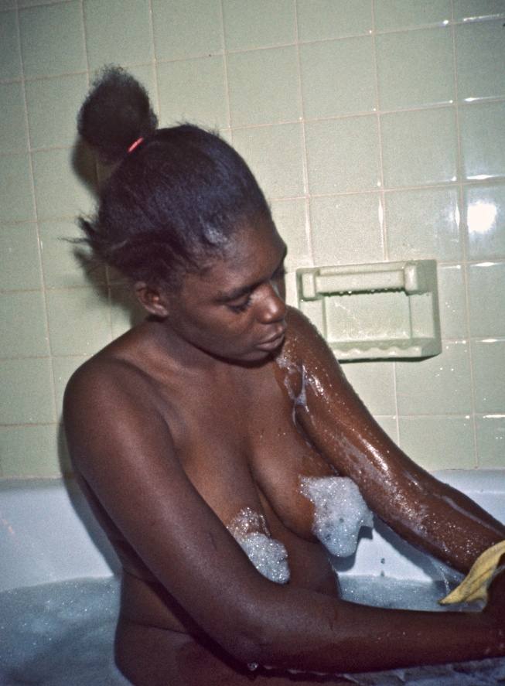
So that night after my second successful session with the inmates I was rewarded by Tony being taken to his off-limit-for-whites-home on Lutheran Street and even promised a date with the best friend of his girlfriend, Angela. Her name was Alfrida, but she never showed up. I can today see for me her repulsive negative reaction when Angela said that she had a white date for her. I was relieved, for somehow I felt it was a test by Tony and I also had my own pride. If I displayed too much eagerness when being set up with a black date, Tony and the others would probably conclude that I was just another white liberal who had invented a sophisticated black liberation theory just as another way to score black chicks. That cynical suspicion always hung over me in the black community and made it equally stifling and difficult for both me and my rare black dates to open up emotionally towards each other.
From the beginning I really liked Tony and felt at home with him, so in order not to lose him I tried not to make myself too cheap by showing interest in the sexual opportunities I soon sensed in the slipstream following a handsome, popular man like him. My conservative son-of-a-minister nature also always made me feel embarrassed when people tried to set up relationships for me with women and made me escape into even more political commitment which in turn fascinated more attractive types of women than just the cheap dates. For me this was a more intelligent way of dating or – as another result of my Christian upbringing – for searching for the right marriage partner.
So instead of going home with Tony the next day I decided to go for a “clean” and oh-so-Christian date by moving in with a prostitute. By staying with Geegurtha for almost a week I proved to Tony that I was really devoted to the cause and not just interested in cheap sex. For just as Tony and the other counselors would be fired for having sex with their clients I had already told Tony that I had never had sex with a prostitute and was totally opposed to it since this was their business and I always tried to relate to people’s deeper humanity beneath their oppression. That gives tremendous freedom for both partners and exactly as a result I could move in with Geegurtha and share her double bed in the house she shared with her extremely devoted Christian sisters as the most natural thing.
We shared bath tubs and tossed pillows in the nude and Gee enjoyed the intimacy we had exactly because she had never been able to develop such intimacy in the destructive relationships she had had with her customers in the past. I loved her jet black skin and big breasts and covered them with the contrasting white foam – photos I later had to take out of my slideshow in America where people saw totally black skin as ugly and the photos as sexism – even though they were the result of the very opposite, joy over the sudden freedom from sexual exploitation.
Sleeping with Geegurtha at my side for a week as a result of my “foolish pride”
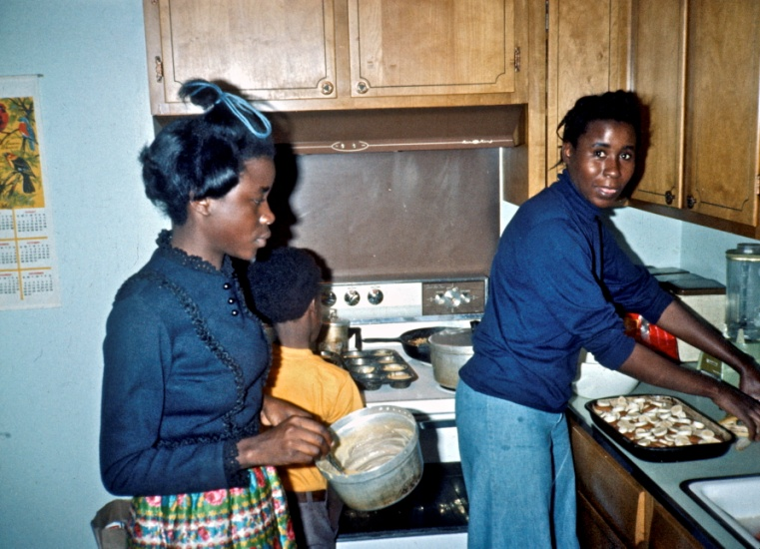
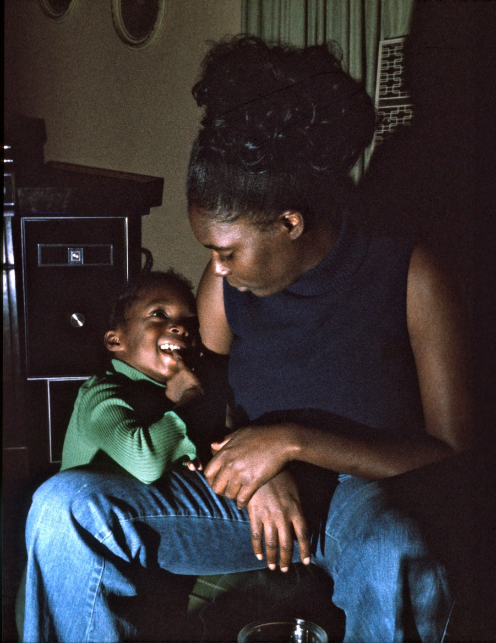
When Gee went to work in Drug Action Council in the morning her most conservative church going sister, Georgia, would take me to lunch in the YMCA where she worked and tell me how they enjoyed seeing Gee loosen up like this and even being able to spend time with a man again for the first time. Just the thought of a man had repulsed Gee after her many years as a prostitute and drug addict during which time she had struggled to save her daughter Tania, who was born an addict, but saved through blood transfusions. I was moved to tears when I now saw and photographed the motherly love between Gee and Tania after their long separation during which the sisters had taken care of Tania.
While her Christian sisters appreciated my role in her long gradual healing process her brother certainly did not. When he came over in the evening of home coming and walked in finding us sleeping in the same bed together, he saw it as a sexual thing and immediately called home and protested to their parents. They came over and scolded us right after church on Sunday morning although Gee could not take them serious since her mother had herself just thrown their hopeless father out and now appeared with her enormous church going hat and her new outrageously small and ridiculous man radiating absolutely no authority. So we just laughed at all their hollering about how it was not right for blacks and whites to be or “sleep together”.
Geegurtha’s religious sister Gergia
My favorite photo of Geegurtha with daughter Tania
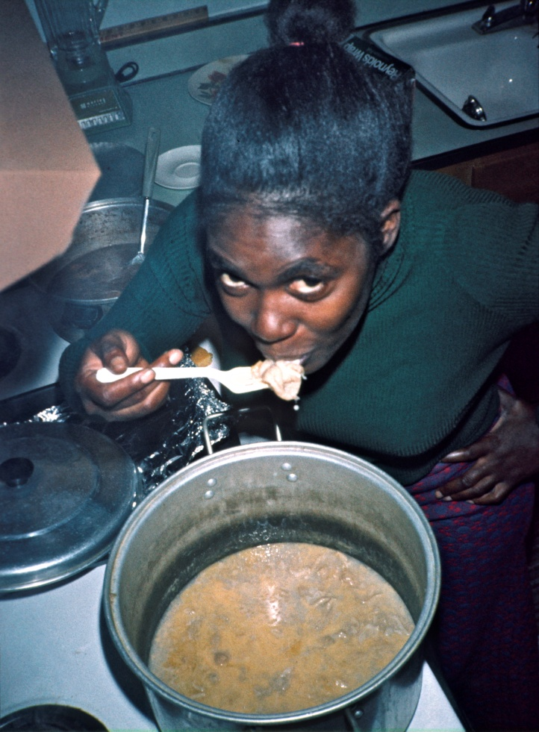
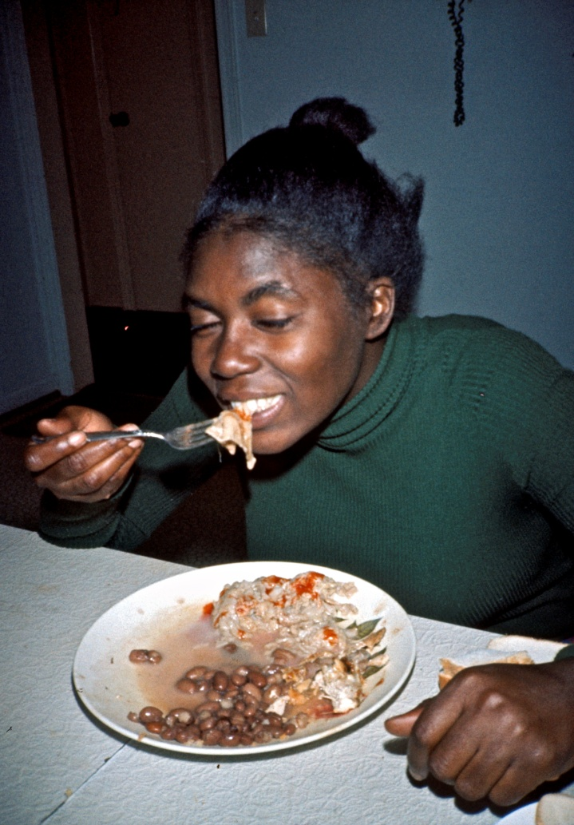
By then it had been “homecoming”, where most black students in the North come home to their families in the South and vice verse. I helped Gee all day to boil a huge pot of chitterlings gradually transforming it into a small disgusting slimy mass so bad-smelling that the whole town could smell it. Chitterlings are the only southern soul food I absolutely can’t get down (with joy, but sometimes with closed nose to avoid hurting people’s feelings).
So since Mack had gone “home” to homecoming in Wash. DC. I had picked up my packsack in his house and now officially moved in with Geegurtha or ultimately Tony. This was very convenient since I could now in small steps move from Mack into the house of his worst competitor without hurting Mack’s feelings. It was a strong principle I always had to respect people’s hospitality by not – especially in my relationships with women – hurting their feelings by moving in with other women in the same town.
So a week after I had met Tony I could finally move in with him on Oct. 13th and start our long friendship. I had with Gee been visiting a grandmother taking care of her 2 year old grandson (page 135 b.l.). He had also been born an addict in the absence of his mother who was still active as a prostitute and since it was close to Tony’s house I asked Gee afterwards to drop me off there. I walked right into a scene, which would repeat itself all the time I knew Tony, in bed with a woman. This time it was Angela, but “no problem” Tony said half naked, “you are welcome as long as you can keep the others girls away,” and went back to bed. A little later Pierre knocked on the door and since I knew that this beautiful, calm thoughtful student with a very short afro was Tony’s favorite
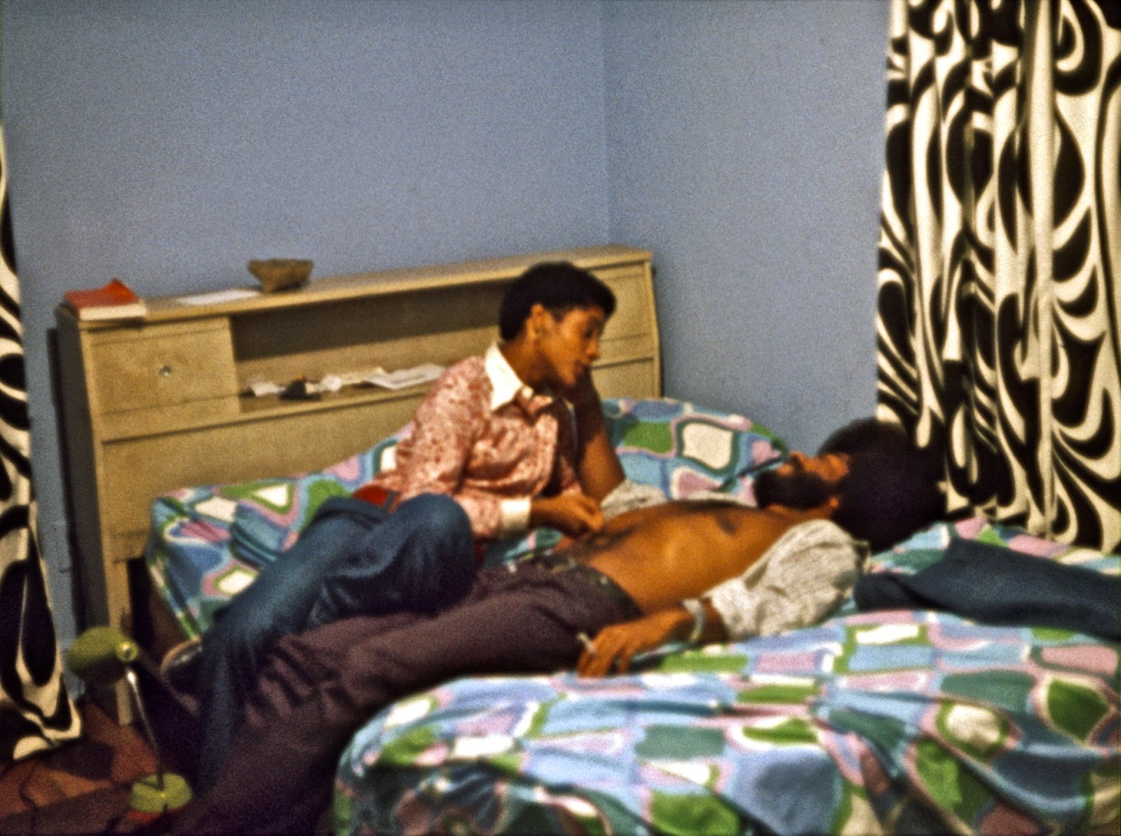
Tony in his bedroom with Piere
girlfriend I tried to play my new role as his doorman as well as I could, coming up with a lie about Tony not being home. But Tony’s car was parked outside and she knew Tony well enough and started a scene and got Tony out of bed. After a long argument she left in anger and when we were left alone I apologized for not having stopped her, but Tony just laughed and said: “Don’t worry, she will be back tomorrow. Then you have to keep Angela away. That is a much harder job!” I felt relieved, for I could feel that my job as a white doorman in a house which had not previously accepted whites was secure for a long, long time ….and no doubt with some fringe benefits in the form of leftovers from this rich man’s overconsumption. Since I right away felt that Tony willingly would sacrifice Angela to me and I had a good eye for her, I felt embarrassed that white Sis Thomas, whom I had shared with Mack, soon tracked me down to Tony’s house on 1907 Lutheran Street. Every day she would drive by in her flower delivery truck and hang flowers on the door knob for me if I was not home, “To my Danish pastry”. So one of the first days I decided to go and spend the night with her in her hippie apartment with walls decorated with long bearded guru pictures looking like me, mainly to let her know that if she wanted to see me I only wanted to see her there since I did not – without using those words - want my black and my white worlds to be integrated in Tony’s house. That would have been difficult to understand for this peace loving young hippie girl who felt “we should be colorblind since we’re all brothers and sisters”.

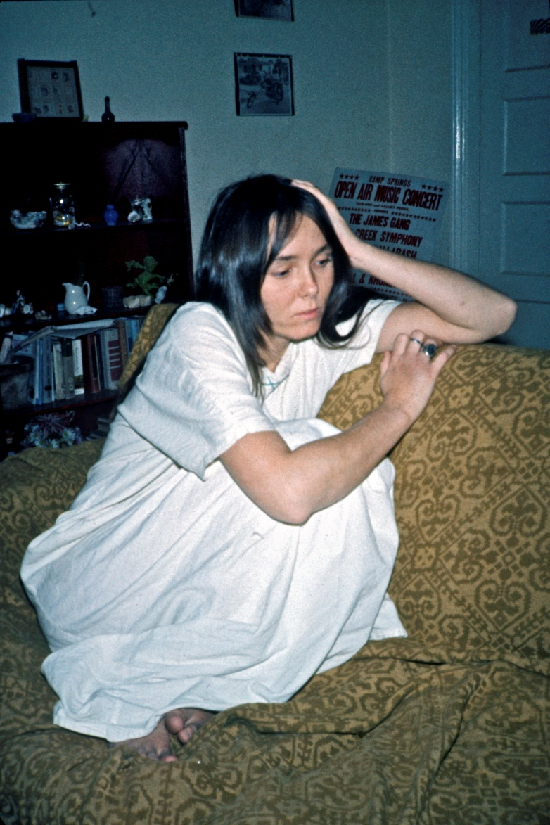
Sis Thomas kept pursuing me throughout her gradually worsening life in which she ending up as a junkie in a destructive relationship with an abusive racist man in Saratoga, Florida. Over the years I got many cries of help from her. When I was traveling in 2011 with my present Danish wife to visit our daughter in U. of North Carolina, Sis flew up to meet me in Greensboro “to spend our last night together” in her brother’s house. I drove up from my wife in Charlotte into a worsening tornado with lots of warnings about not going into the center of the storm. Sis’ brother thanked me for coming, “for Sis has talked about you for almost 40 years.” Sis was now so week that she was in a wheel chair almost unable to speak and I had to lift her up in our elevated canopied bed after first seeing her eat a ton of pain killers. I knew she would not have long to live and hugged and kissed her while thanking her for her “invaluable contribution to my life and to “American Pictures”.
However I could not fall asleep with her Florida habit of having a noisy fan next to the bed. Also the same night the worst tornado swept over our house killing lots of people around us. When I left next morning through fallen threes spread all over and one donkey which according to N.Y. Times had been seen swept away up in the air and found alive miles away a couple of days after, Sis’ brother stood tearful and thanked me for having given his dying sister this last moment of peace and joy. I felt both relieved and guilty – guilty for not having been able to do more for her over these intervening 38 years during which I felt I had done much more to help my black friends who had helped make my life a success.
With Sis Thomas in 2011
Sis Thomas in her apartment 1973
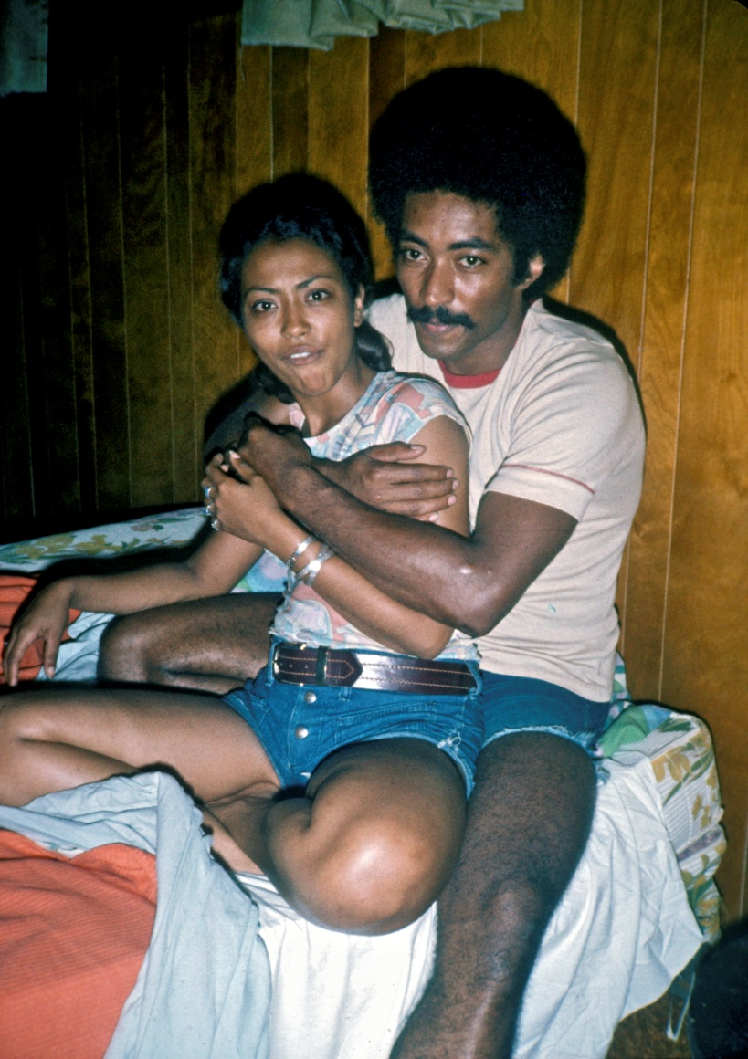
The most important contribution Sis gave to my vagabond life on the road in the 70’es was to come and pick me up in her flower delivery truck whenever I was stuck on highways around Greensboro where I couldn’t hitchhike. Nobody had cell phones then, so it was difficult to call Tony who was only home when he was in bed with a girlfriend in which case I did not want to disturb – unless it was absolutely urgent which of course it never is for a vagabond who per definition has plenty of time.
For the same reason I never stayed for more than a couple of days with Tony. Partly I did not want to overstay his hospitality (if I stayed longer with any other people it was usually with a girlfriend), partly there was not much to photograph for me in highly developed Greensboro and partly I often fell in love with Tony’s girlfriends and therefore felt it was better to cool off and go away for awhile and wait patiently until he had used them up Although Tony’s and my thinking in so many ways was very alike there was one clear difference when it came to women. While he suffered from an instant gratification syndrome I always practiced delayed gratification in my firm belief that the best things in life will come in the end. Thus I can see in my diary that already two days after moving in with Tony I decide to leave on the 15th “planning to go West. Yet I ended up going to Washington DC” to stay two days there two see my latest of my slides which I stored with a white girlfriend, Eveleen Henry.
Afterwards I spent a week in Norfolk, where I took many of the photos in the book and almost got married to Teresa Knock – mainly I believe because she convinced me that then we could inherit her father’s store – a small “Seven Eleven” – which for me in those days sounded like an incredible amount of money which could possibly finance my photography. I even wrote a letter from there to my adoptive family in Canada, the Godfreys, that now I was considering getting married. Well, after two days it turned out that our sexual relationship was so horrible that also Teresa gave up on our marriage plans. Also she was afraid that her racist father would end up seeing the photos I carried around in my book and deny her the inheritance. So I gave up my failed instant-gratification-to-richness-attempt and again walked out the back roads to a productive week among poor blacks and returned to Tony 1004 miles (1600 km) later on Oct 27^{th.}
Tony with another woman called Sis (as far as I recall)
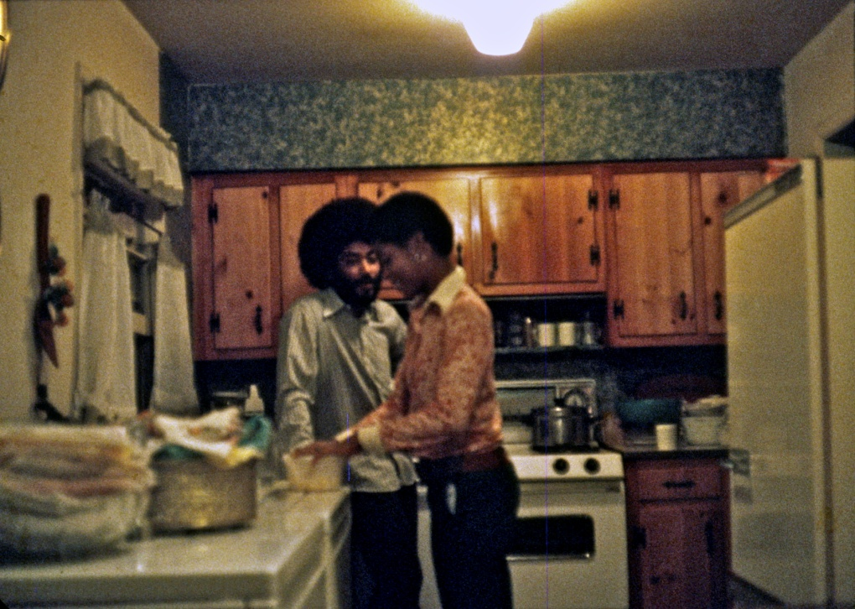
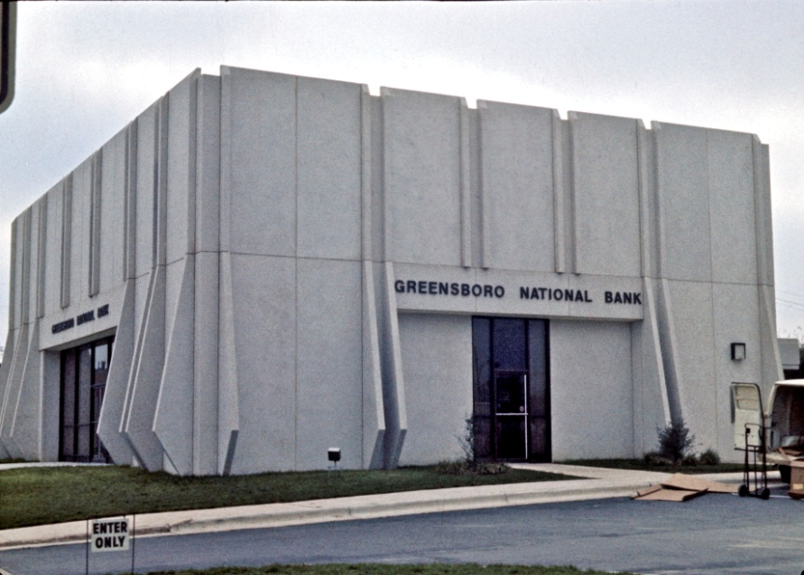
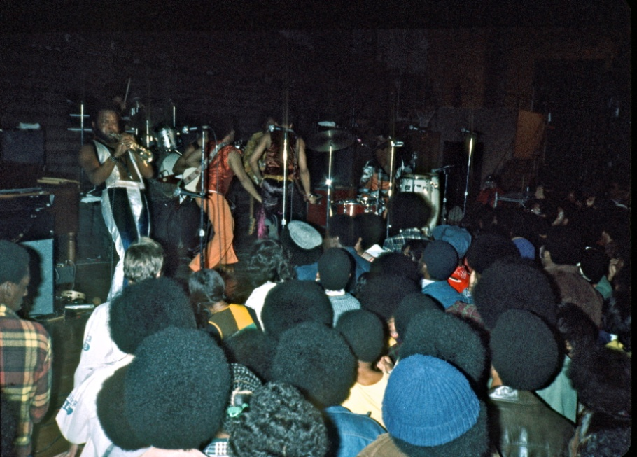
Here Tony enthusiastically told me that he had now broken up with Angela, “So she is all yours now!” he laughed. Wow, that was really tempting, but after two nights with long intellectual conversations with Tony during which we were amazed how similar our thinking was, to his great astonishment I two days after my arrival asked at noon on Oct. 29th to drive me out to where E. Lee St intersects with Interstate 40. This is where either he or Sis Thomas would end up dropping me off so many times during the next year. “What? It is pouring rain today. Why don’t you wait until tomorrow and see Angela tonight?” Tony asked in utter disbelief. He never understood my priorities and often in the years after entertained people in Europe: “When the sun was shining Jacob would sit home writing, when it stormed and rained outside, he would take off hitchhiking.”
He teased me for being “driven by some higher forces”, but admired me for that since he shared my higher leftist ideals, yet constantly gave after for some “lower forces” himself. On this particular day I didn’t feel I had a choice. I wanted to go to the tobacco fields out in eastern North Carolina while there still was some harvest or tobacco drying or auctions that fall. And “I want to put off getting laid with Angela since I think she needs a cooling off period after you, Tony!”
In that sense the crossroad E. Lee St and I40 became symptomatic for my constant choice in Greensboro. For although Tony’s house was right next to the big black university North Carolina A&T State University (which years later tore down his house to expand campus there), neither Tony nor I ever tried to get a date with any of the female students there. Today, when I know the ranking system of American universities so well, I understand why. For this was a “lesser competitive school” and though I normally wouldn’t accuse Tony of discriminating against any type or class of women when it came to sex, we both – although having no university education ourselves – were shaped so much by our middleclass backgrounds with educated parents that we had nothing to talk about with these students. No, somehow we felt far more at home in another black college across town, Bennett College, not least me as a white man. For this was an all women’s college where I had no competition from black men and where these better educated students somehow seemed more like my equals. Without the peer pressure from black males with all their internalized racism about “not letting your race down by going with a white man” my long range chances were far bigger in Bennett since I was ultimately more interested in marrying a black woman than in just having sex. Thus it felt strange from Tony’s house often to walk through the completely open campus of A&T next door all the 2 km over to the completely closed campus of Bennett on E. Lee St. - closed by door bells and security to give these sheltered middle class women protection. For historical Bennett College was laying in an area right next to the ghetto and the worst night club in the ghetto was “The grill” owned by Tony’s father.
That was another reason to walk over there, for Tony never had any food in his house. He would usually eat out – especially in his father’s restaurant – usually with his grandmother Honey cooking in the daytime. Tony loved his grandmother, so when he remembered to feed me he would always drive me over there for food. But since Tony was very forgetful, he often left me starving in his house for days, thinking that I walked over to be fed by his father or grandmother by myself. Which of course I did, but I liked better to drive over there with him.
For driving with Tony was always an event in Greensboro – especially on the dividing Lee Street with Bennett College on the nicer side and the slummy “grill” on the other side. Good looking and charming as Tony was the black women would simply jump into his car, the attractive educated women from the left side and the ghetto girls from the right side (when we drove in eastern direction on Lee St.) When there was more than one, the spare one would jump into the back seat with me. On the way home to Tony’s house he would again and again signal to me in the mirror, “Why don’t you move, Jacob? It is time to send her a message that you are interested in her.” But I felt far too embarrassed about a situation in which I knew the only reason the women had ended in my lap was because they were interested in Tony. The fast “get-it-over-with-quick” underclass ghetto women I was not interested in and the sophisticated Bennett students I felt demanded a longer, yes, “sophisticated” conversation with me before I could even think of “making a move” – a move which was so contrary to my whole vagabond philosophy of letting the women themselves making the move if - and only if usually after some days – they turned out to be interested in me. So again and again when Tony was in bed with his date in his bedroom I was sitting in the living room with my “date” waiting for him to come out and drive her home. After just a couple of frustrating E. Lee St. nights I was usually ready to escape out into the freedom of the highways, which Interstate 40 came to symbolize for me in Greensboro.
This is how Tony’s house became a convenient home base for my cross travels between duty and lust. For I always felt rewarded when as in the rain on Oct. 29th I took off from his security going into the unknown. It was during the next 4 days out in rural Wendell I ended up taking many of the best tobacco pictures in my book and met lifelong friends among the poor pickers such as Lefus Whitley and his son Lep. Lep took me around in the poor shacks in the wooded areas around Zebulon into an unknown world of poverty completely apart from the one in Greensboro – although it was only 160 km away. Yet after living in their shacks with no indoor plumbing for some days it was good to come back to Tony to get a shower and with his help to put things into perspective. For although I had no problems intellectually understanding and explaining how blacks in such poverty were oppressed, nevertheless you cannot help in your deeper guts developing a feeling of people being inferior when you are only surrounded by people in inferior conditions and lesser development.
Tony’s middle class upbringing and early participation in the civil rights struggle such as in the Greensboro Sit-ins in 1960 – started by 4 next door A&T students and next day joined by Bennett students and later hundreds like then 13 year old Tony (probably encouraged by his visionary mother Dot, who was a very politically aware teacher) – had helped give Tony a deeper historical perspective of the situation. And with Tony’s unbound optimism and romanticism of blacks he rarely fell into my periodic gut despair beginning to doubt blacks. In his house I confronted the idolized version of successful blacks portrayed in Johnson’s magazines “Jet” and “Ebony” – images which stood in utter contrast to those I saw and captured on the back roads of America. It was not that Tony from his work with poor underclass prisoners in Drug Action Council was not aware of “my world”, but living in the more successful black community in Greensboro he was not dragged down by it.
Often he was more realistic than me with my belief in people’s inner goodness and warned me about his own psychopathic friends. On the same night I came back from the tobacco fields in the East he invited me to come with three of his friends to an “Earth, Wind and Fire” concert in Chapel Hill. (I am not sure I at the time even knew about that famous group since in my diary I just call it “a rock festival”).
Tony and Piere in kitchen where I only rarely could find food
Tony was always proud to point out “our black achievements” such as Greensboro’s black bank founded two years before in 1971.
It existed until 1995.
Earth, wind and fire concert i Chapell Hill
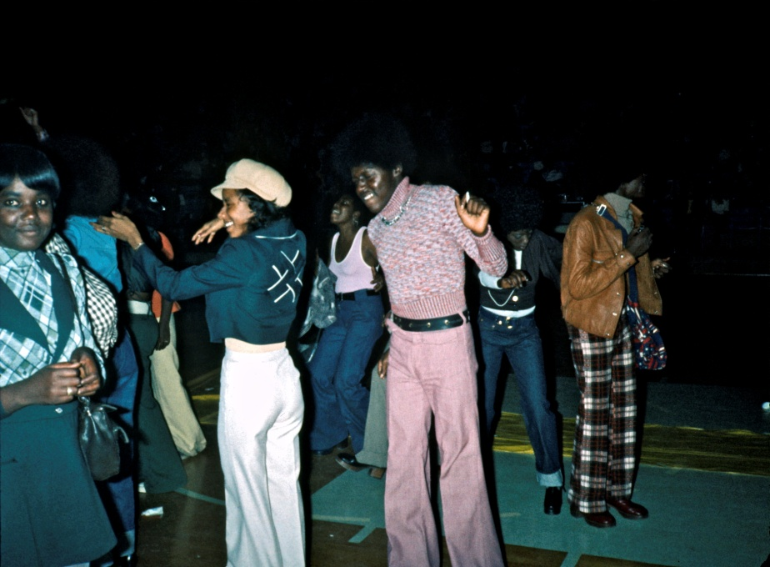
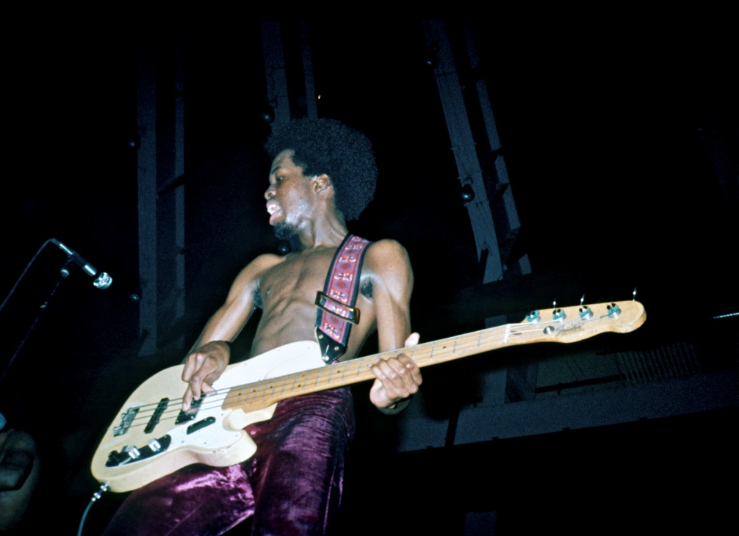
Forgetful as Tony was he had not been thinking of how I had no money for the entrance ticket, but I surprised his friends by “exploiting my white privilege” to somehow “cun” my way in for free.
Not only did they suddenly see me inside, but they even saw me photograph backstage and being surrounded by black women at some point at this almost all black concert. This irritated the three black
men so much that on the way home Bob, the driver, after sitting quiet for a long time suddenly stopped in the middle of nowhere and turned around and said to me, “Hey, whitey, you’ve got to get out.” Tony turned around and shook his shoulders with a resigned look as if to say, “I guess you gotta get out.” He apologetically later told me that Bob was a pathological double murderer, so he was not going to interfere in my behalf. I said to Tony that he shouldn’t feel bad about it since I had that night myself become a “double killer”. I walked back in the cold night to Chapel Hill and found two wonderful white women, Laurie and Jennie, to stay with. “White women are so easy that they are no challenge,” I said. “You should try them one day.” The idea appealed to Tony, so in order not to break his wow about not letting whites into his house next day he drove with me the 80 km back to Chappell Hill to be introduced to my two female students. However, to get into the white female dormitories for a black man is not as easy as for a white. I don’t remember much from that night except that Tony drove home and I ended up late in the night falling asleep on the floor with one of them. After all his successful attempts to set me up with black women I was glad that I could now pay him back trying to set him up with white women. Although we were equally unsuccessful in our cross-the-lines dating I have to confess that over the years Tony succeeded bursting through the white wall to such a degree that I sometimes regretted I had ever helped him.
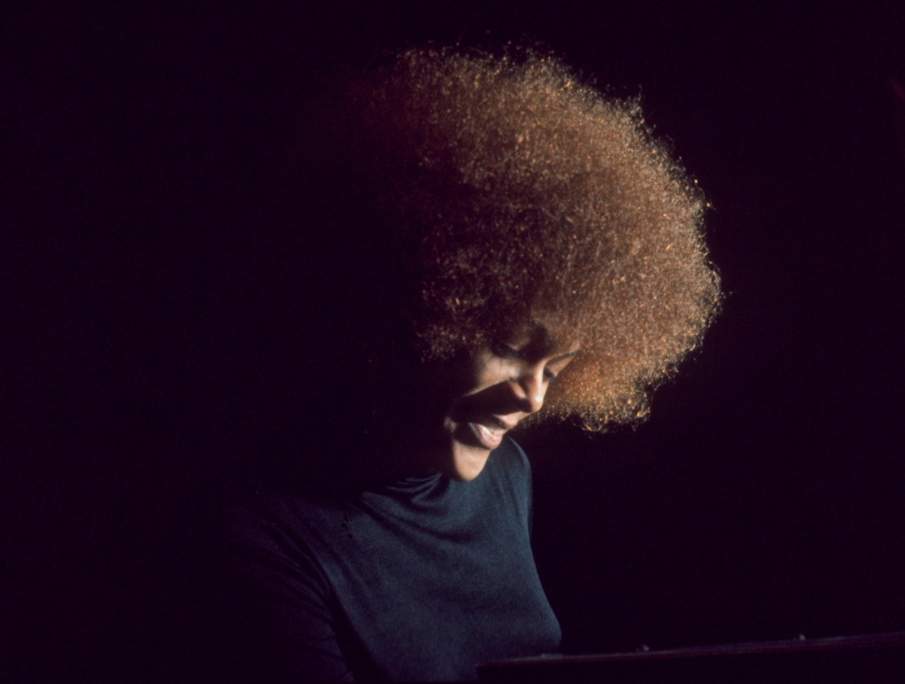
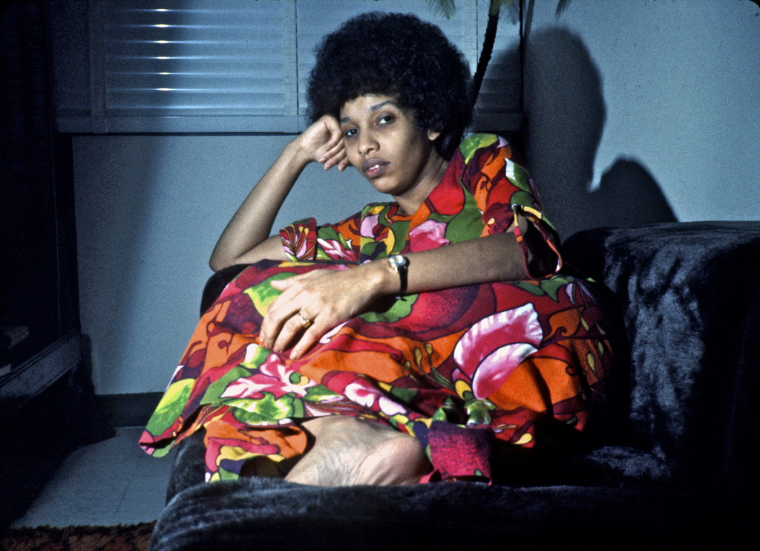
Next day I again wanted to leave Tony to go south, but his favorite girlfriend Piere in Bennett talked me out of it since she wanted to introduce me to her friend Edwina (not the Edwina in “Credo” in my book). We hooked up well and talked for a whole day in the dormitories. However, I got confused when Piere’s other friend, Alfrida walked in with her huge reddish afro. I was so taken by afros as a liberation symbol that Alfrida during the next year became my favorite to hang out with – although only photographically since I still couldn’t get myself to “make a move” when alone with her. In my embarrassment about not being able to neither choose between the two nor “make a move” I finally gave up and went to Sis that night – not to get easy white sex for I had to reluctantly agree with Mack that she was “a dry fuck” – but because I knew she could drive me out to the highway early in the morning in her flower truck while it usually took Tony half a day to wake up from some late night date. And just the thought of sex with Sis was out of the question for me when I saw her shooting heroin and her deep frustration because she couldn’t feel it. But after my last complaint of her having lice as the reason I didn’t spend time with her, she had at least now sprayed her whole house against lice in honor of her “Danish pastry”. I always wondered why I only got lice when staying with white hippies and never with poor blacks who had no indoor plumbing.
Again I am glad I quickly gave up my bourgeois-black-women-hunting with Tony when Sis drove me to my usual cross road in life on Lee St and I40 next morning on Nov. 6th, for after a black/white car accident in Fayetteville of one of my many drivers that day, I got picked up in Denmark, South Carolina by Jane Bowen. She was from one of the old slave owning plantation families and couldn’t believe I was standing there with my “Touring USA from Denmark” sign next to the town sign of Denmark. And after a hot sexual night with my white owning class date I had the luck next day of driving by a cotton field full of some of the pickers her family probably once had owned. It always took a lot of debate in my head whether to stop a car when I had a good ride not knowing how long I would have to wait for the next ride on such deserted roads, but here I knew immediately that this was a historic moment since so little cotton in the 70’es was still handpicked. That day I describe on page 23 in my book and if ever I found it hard to swallow the anti-white sentiment I was up against in Greensboro here I saw the roots of it when affluent whites from up North hour after hour drove by us in the cotton fields in their huge motor homes. I managed with backbreaking pain to pick my way in and get to stay with these initially fearful and hostile pickers with no electricity and indoor water, but in my sweaty dirtiness the next day I decided with guilt feelings of again exploiting my white privilege to go with Jane Bowen to Charleston to explore her plantation owning family’s wealth – if only just to see a shower. They absolutely spoiled me and showed me for the first time original slave huts around one of their old estates outside Charleston off highway 17 North, along which black women still sat making handmade breaded baskets. It was like white supremacy images popped up in front of my eyes everywhere with Jane’s family, the “Independent Life” sign on page 131, the black nannies taking care of rich white children on page 204 and finally – after I left her to go south to see the lift off of a moon rocket in Cape Kennedy, the image of the rocket shooting up over the poor black man’s shack on page 148 after spending the night in the ghetto of Daytona in a small bed with a black junkie, who was shooting up “the white stuff” as the first thing in the morning on page 245 t.r. After spending the night in a bar in the ghetto of Titusville partying with the local blacks I managed to spend the night with one of them right next to the old starving man’s shack and got up at 6 am Friday Nov. 16th to see the liftoff of the rocket. I was so happy when I – in spite of my wide angle lens – managed to get these ultimate white supremacy shots that I spent all morning in a coffee bar writing to Tony and Pierre as well as friends in Denmark about my small “victory over the system”. I felt I enjoyed a reward and went out to Interstate 95 and hitchhiked overnight the 1800 km first up to Eveleen Henry in Washington to sleep a few hours and then next day all the way up to my old girlfriend Marly Sockol in New York. She made a huge steak for me next evening to congratulate me for my “small photographic victory over the master-slave system” and bought me some new pants after the others had been torn in the cotton fields. After which I returned to the South and arrived back in Greensboro Nov. 26th after spending a day comforting the wife of my gangster friend Alphonso in Baltimore (page 200) since he had just been sentenced to 6 years in prison. (His later interesting story I will tell in my lecture for Stephen McQueen).
This time I had been away from Tony for 20 days and hitchhiked 4331 km. We were really glad to see each other, so to celebrate my “small victories over white supremacy” Tony told Pierre to bring Alfrida over that night. But again it seemed like it was easier for me to conquer affluent white plantation daughters than the proud black bourgeoisie, for Alfrida ended up walking home already at midnight and Tony again complained about my lack of aggressiveness, “I really don’t understand how you make it around America so easy with your passive attitude to things. With such an attitude whites could never have subdued blacks for so many centuries! You’re really different.” he said while bursting out in laughter.
I haven’t recorded our further discussions in my diaries, but again Tony helped to raise my understanding of many of the black-white reactions I had met on the trip and not always understood. Tony had a deep intuitive psychological insight and could often see the faults in my Danish interpretations of people’s interactions in America which in turn gradually helped to make me into a better traveler. Also he could see the shortcomings of my saying yes to everything and passively observing and accepting people’s hurtful behavior - even when their aggressions hurt me. His advice “You have to interfere sometimes and take responsibility!” could make me feel quite guilty since it resonated so much with my father’s admonitions in childhood. I believe it was his attempt this night to instill a little responsibility in me which ultimately saved Tony’s grandfather next evening, Wednesday Nov. 28th. That night “I had met two strange women in “the Grill”, Dorothy and another,” as I write about it in my diary in very few words since I so often experienced such violence. “We decided to go home to Dorothy so they dropped into a taxi outside. On the way we stopped at a store in which they stole some booze and food and brought out to me in the waiting taxi. I knew they had no money to pay for the taxi. “Don’t worry, we will use this one”, said Dorothy’s friend and showed me the gun in her hand back. I can’t remember what went through my head then, if it was only because I had in the meantime discovered that the taxi driver was Tony’s grandfather. He was married to grandma Honey who always fed me in “The Grill” and scolded violent types who couldn’t stand the sight of a “honkey” like me in there with, “Don’t you act up. He is a nice white boy.” Nevertheless, Tony’s warning the night before that sometimes there were situations where you have to take responsibility no doubt helped in my quick decision to knock the gun out of their hands and push the two girls out of the taxi. That Tony’s warning had a great impact can be seen on the fact that I next day proudly told the story to Tony, “See, I can sometimes take action. I just saved your grandfather last night.” But Tony was unimpressed and just shrugged it off as if it was nothing, just another instance of all the violent interactions we both experienced daily in the ghetto. He didn’t even tell his family about it. Only when he 4 years later saw my story about it in my book on page 209 did he react with shock. Now he was at a great distance from the violence in Denmark and reacted with great emotion to the story – now on print - and thanked me for saving his beloved grandpa and mailed the story to everyone in his family.
My own initial reaction was very similar to his, I can see with the few words I use about it in my diary. For after getting the girls out of the taxi I certainly did not want to miss out on the buzz and food they had just robbed, “We ended up walking to another joint where we spent the evening among extremely wrecked types. Afterwards we knocked a sleeping man out of his house with a shotgun and I spent the night in Dorothy’s house with a wasted guy she tried to get rid of.”
So much in my diary for my later story “Luke 7: 36-50” which shocked much of the world and was printed in both German “Der Spiegel” and the Soviet paper “Pravda” for millions of readers. Yet neither Tony nor I were impressed by it when we experienced it in our ghetto life and I mostly told it to Tony to prove to him that sometimes I could take decisive action out of my inaction.
Emboldened by this victory I decided to stay in Greensboro for a few days to prove to Tony that I could also now take decisive action toward all the bourgeois black women he presented for me Perhaps my new self assuredness could already be felt, for the next day Alfrida came up to me on campus and said that now we should try to be serious about each other and asked if we couldn’t be together over the weekend. There was no doubt that she meant sexually.
But the same evening Tony took me over to present me for his aunt Edwina who had asked to be introduced to me. I was completely knocked out by that meeting for Edwina was the most brilliant well educated black woman I had yet met and our thinking was so much in harmony that we ended up talking until 3 in the morning. I was so seduced by her whole presence that I was convinced she would be the black woman I would end up getting married to. After a sleepless night Edwina next morning called me up and said she had been able to feel my vibes “call me, call me” about how deeply I wanted her to call me. She asked if I would drive with her up to New Jersey, where she had to go back to her job in ATT in which she held a high executive position. I was really torn and twisted in my mind whether to go with her since in my mind it was obvious that this was an invitation to move in with her and start a relationship – the ultimate security and black wife at once which so much was a deeper drive in me at the time. However, since she had been so impressed exactly with my devotion to “the black cause” I ended up saying no to go with her. Partly because I had so many projects in my mind I had to finish in the warmer south before again heading up in the now cold north, partly probably to impress her with this very devotion and how it made me deselect any “lowered gratification threshold” cheap desires, partly because I already had a date lined up with Alfrida this weekend and didn’t want to disappoint her and partly out of my usual belief that the best will always come in the end when through trials and hardship you have finally proven that you deserve it. And if Edwina and I really were meant for each other, for sure then our relationship could be put on the back burner for a while. Oh, how I came to regret this delayed-gratification decision when a month and a half I finally came and moved in with her after thousands of miles of hitchhiking and she now had cooled off her warm emotions for me. That story I need not to tell here since it was so much elaborated on in the letter I wrote to Edwina from Greensboro on Feb. 20th published as “Credo” on page 77 in my book. In this story I also focus quite a bit on how I can’t seem to integrate the two worlds I travel between, the black underclass I have lost my heart to and the black educated middleclass I want to marry, but constantly crushes my heart with its rejection.
After tormenting myself for a whole day about how I could possibly let Edwina drive alone up to her new job and life in New Jersey, the same evening Alfrida burned me off by not showing up for our Friday night date. So I ended up as usual hanging out with the underclass in The Grill that weekend and even gave my bed in Tony’s house to one of his friends crashing on the floor with a date, “You can have it, I don’t need it anymore.” With no success in ghetto love myself I could at least help others to a little ghetto love.
Next day Sunday Dec. 2nd I never forget. For at 2 pm a white woman, Susan, came over. She was a close friend of my beloved Edwina, who had an eye on Tony. So Edwina had talked Tony into “dating my very good friend ….although she is white.” Now the first white I had seen in Tony’s house sat there with us and I could see how Tony got fired up with all his incredible charm to impress her, entertaining her with stories about how he had been on TV in Memphis and the like. I had long ago learned not to believe EVERYTHING in Tony’s incredible stories when he wanted to win someone over – especially when I had heard them several times. But there was no doubt about it, they were incredibly seductive. Combined with Tony’s unbound optimism and romantic outlook they worked every time. However, with my own disastrous interracial dating having just been burned off by Alfrida I somehow stayed true to the anti-white Tony I had come to love and felt his behavior that day was tantamount to “race betrayal”. That was of course not my words, but I left his house with a teasing remark “I think it has become too white in here, Tony,” which according to my diary made Tony crack up in laughter.
Alfrida with her wonderful afro
Edwina in her apartment in New Jersey when she had cooled off
And what did I do myself? I walked straight up to Tony’s former dark-skinned girlfriend Angela on Bennett College. She was sitting in their living room making Christmas decorations of popcorn with friends, all light-skinned women as I note in my diary showing how I had myself internalized the racism of the time. I had proposed it for Angela before, but now when I had given up my bed in Tony’s house and could not take her there I again proposed it to her. “Why don’t you come with me on a hitchhiking trip and I will show you America?” After all, without the essential tools in American dating – a car and a bed – why not invite her for the only thing I knew I was good at, hitchhiking? And having just seen Tony unfold his charm and been influenced by his “affirmative action when it comes to women” I apparently rolled out so much charm that Angela’s friends all encouraged her, “Yea, Angela, why don’t you go off with Jacob?” So Angela to my surprise went up to her room and changed into her finest checkered suit as if we were going to a ball. I was about to come with a critical remark about finding some more casual clothes for hitchhiking, but was afraid this would scare her away and concluded that dressing up for a party might give us faster rides.
Then we took off with the other girls wishing us good luck, giggling and laughing since they had never seen a black woman go off hitchhiking with a white man. But this time I felt no inclination to call up neither Tony (her former girlfriend) nor Sis (my sometimes white girlfriend) to drive us out to Lee and I40. So we walked a long way out of E. Lee Street before a fancy car suddenly hit the brakes to pick us up. That was a black psychologist who took us as far as Durham. Fine enough and at first it was an interesting conversation in which he as a psychologist got deep inside the “deeper motives behind your black project.” I had no particular end destination in mind except taking Angela as far away as I could seduce her to go in a few days – preferably to New York which she had never seen – but the enormously intelligent and charming psychologist convinced us first to come around and visit some of his friends in Durham. I had not very much been in such black upper-class homes before and was as impressed as was Angela. Then he convinced Angela that we should also come home to himself in Chappell Hill. I was not much for much for the idea since this

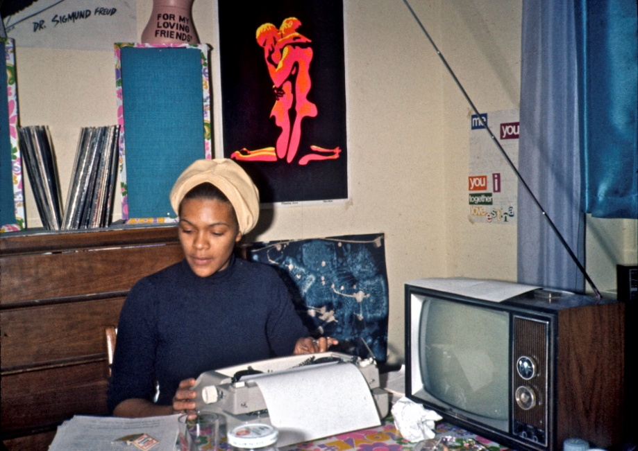
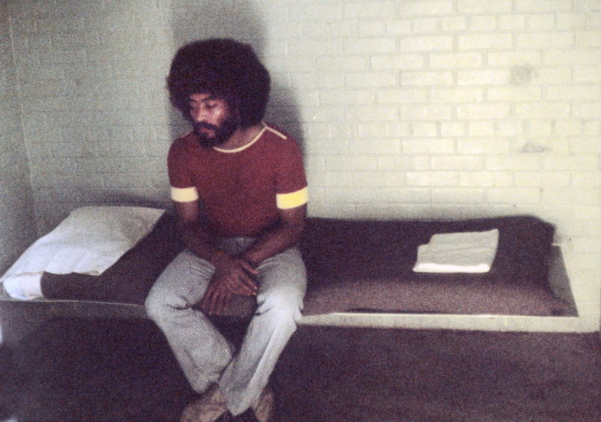
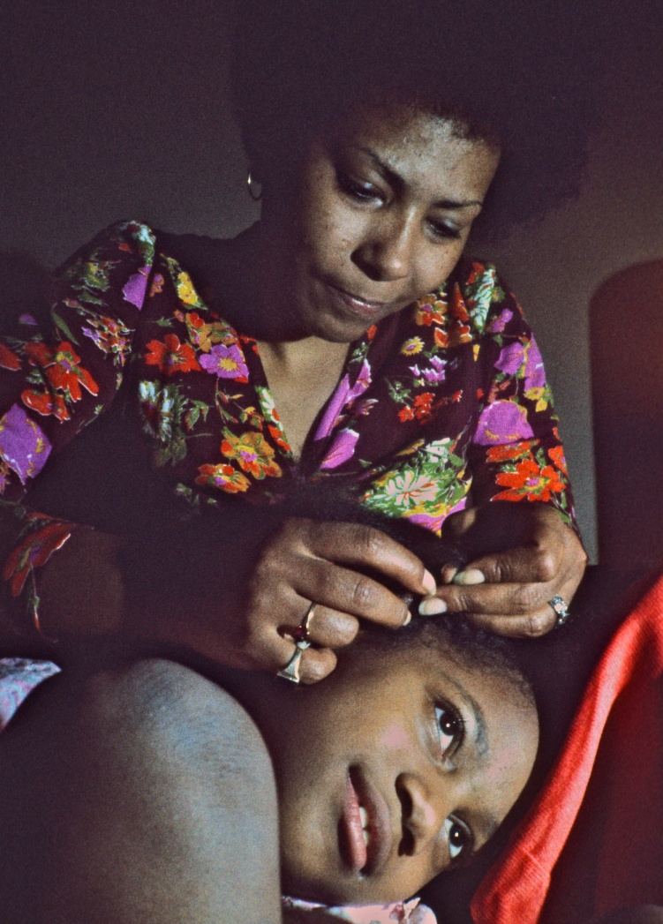
was going in the opposite direction and it was getting dark. I knew it was important to get a long ride up I85 before it got too dark. But the man seemed by now to have Angela’s mind completely in his control and in the most elaborate ways worked on the deeper anti-white feelings all educated blacks nurtured then. It was here in his house I took this photo of her during our drinks during which I could see she was more and more confused about the situation. She could no longer look at me and constantly looked away at the TV. I could see that I was losing her in this black-white power struggle during which she was totally mind fucked (as I write in my diary) by an extremely well-spoken and far more educated man than me. There was no way my poor uncertainty of the dark highways could win over his luxury in the mind of a young black woman. In the end I gave up and when he suggested that he would drive me back to Greensboro – 50 miles away – she was now sitting next him in the front and me in the back. When he let me off I could see they immediately turned around to go back to his place.
I felt totally crestfallen. When next day I helped Alfrida a whole evening write a term paper, but with no bed in Tony’s house to take my reward afterwards, I was finished with “the black bourgeoisie” for a while. And when Tony’s father at the same time was extremely worried about me continuing hanging out with the underclass in “The Grill” since the rumor was now going that I was an agent, “a bustman”, I felt I had no choice but to leave Greensboro and Tony on Dec. 4th.
Two months went by before I after hitchhiking 6500 km was back with Tony on Feb. 5th 1974.
I don’t recall if that was one of the times I arrived in the middle of the night and tried to crawl through Tony’s elevated bathroom window by climbing up on a trash can. Unfortunately I knocked some jar with cream for his hair down and smashed it so it woke him up. He came rushing out seeing me stuck high up in the tiny window, first thinking it was a burglar, “Are you crazy Jacob?
I could have shot you. This is America, don’t you know?”
I apologized and said that I didn’t want to disturb him by ringing the bell so late knowing that he was probably in bed with a girl. Then he burst out laughing – partly from joy about seeing me again and partly for seeing me being so stupid and ignorant of American habits in which it is out of the question to engage in “breaking and entering” into a house like this.
“And yes, you were right; I am in bed with a fantastic woman. And you really have to come in and see the skin of Marjorie, whom I am dating to night. It is so incredibly firm and smooth as I have never seen it before. Come in and touch her skin yourself,” he said as the first thing in the middle of night after we had not seen each other for two months. I had to admit he was right when also Marjorie burst out in laughter at the sight of such a long haired hippie standing tall above her in the bed probably at 3 am to touch her skin.
“But speaking of breaking and entering, Jacob, I am sorry to say that you have lost your bedroom, for I am again using it as a halfway house for a prisoner. I am trying to help this amazing dude Nathan Witherspoon “back in the world” after he has spent 16 years in prison convicted as a hard core addict for burglaries. Breaking and entering can be a capital crime here in North Carolina, so you are lucky Jacob that I am not right now turning you over to the police,” Tony again laughed.
“Well, sleeping up in that noisy living room in the back again seems just like capital punishment for me,” I joked. For my former bedroom next to Tony’s had been fairly quiet since it faced in toward A&T University, but apart from our small living room, which we usually used since it faced south out to Lutheran Street, there was a huge partying room in the back of the house. We never used that for anything except pot smoking since it could not be seen by police through the windows. It was dark and unbelievably noisy because of all the heavy trucks passing right outside on highway 29.
“I will introduce you to Nathan tomorrow,” Tony said. “He is a remarkable man. He was practically unable to read and write when he very young got into crime, but then taught himself and took a masters degree in social work while in prison. I have never seen such a convincing example of oppressed intelligence,” Tony said. I believe Tony was the first one to introduce me to the concept of oppressed or hurt intelligence, something we would years later go around teaching so much in our workshops on campuses and give many examples of and thus instill hope in many black students suffering from internalized racism. In the same way as I used Tony and the educated black middle class students myself to recover from the despair and to avoid the creeping racism I so easily developed by hanging out too much around the black underclass with its apparent “inferior” behavior and development. My leftist blue eyed Scandinavian ideals about how “we are all equals” could not in the long run keep me afloat in the ocean of racism I swam in. So Tony’s belief in how the underclass was suffering from oppressed intelligence was much needed ammunition for me for what I already felt intuitively, but didn’t have the right words for. As far as I remember, for Tony and I were thinking so alike although coming from different background and experience that I can to this day not remember whom of us first came up with new ideas, what came first, the chicken or the egg.
“Now Nathan stays very much to himself since he is afraid of making the wrong steps and get re-infected with the virus of defeat by hanging out with his old friends. He practically avoids blacks. So he might find it easier than the rest of us to be around you, the white devil,” Tony laughed.
“And don’t worry about sleeping in the noisy room tonight, for tomorrow I will introduce you to Marjorie’s sister, Baggie. She is so beautiful and you will like her with her big afro.” Tony was right when next day after breakfast in The Grill he drove me to the small house close by in the Morningside Heights housing project which Marjorie shared with Baggie. Baggie was incredibly beautiful with her enormous afro and I liked her calm loving radiation right away. After a wonderful day with them, during which I took the photos in my show of Marjorie breading the hair on her amazing clever daughter, Tony got up to leave. When I also got up to leave Baggie burst out with disappointment: “Oh, are you also leaving?” Then I could tell that they already had made an agreement with Tony that I should stay there. Staying with two wonderful women was definitely better than staying on some pillows in Tony’s noisy dark room. But as much as I felt attracted to Baggie it also placed me in my ongoing dilemma.
Helping Alfrida with her term paper
During Tony's work with prisoners I took this photo of himself in jail
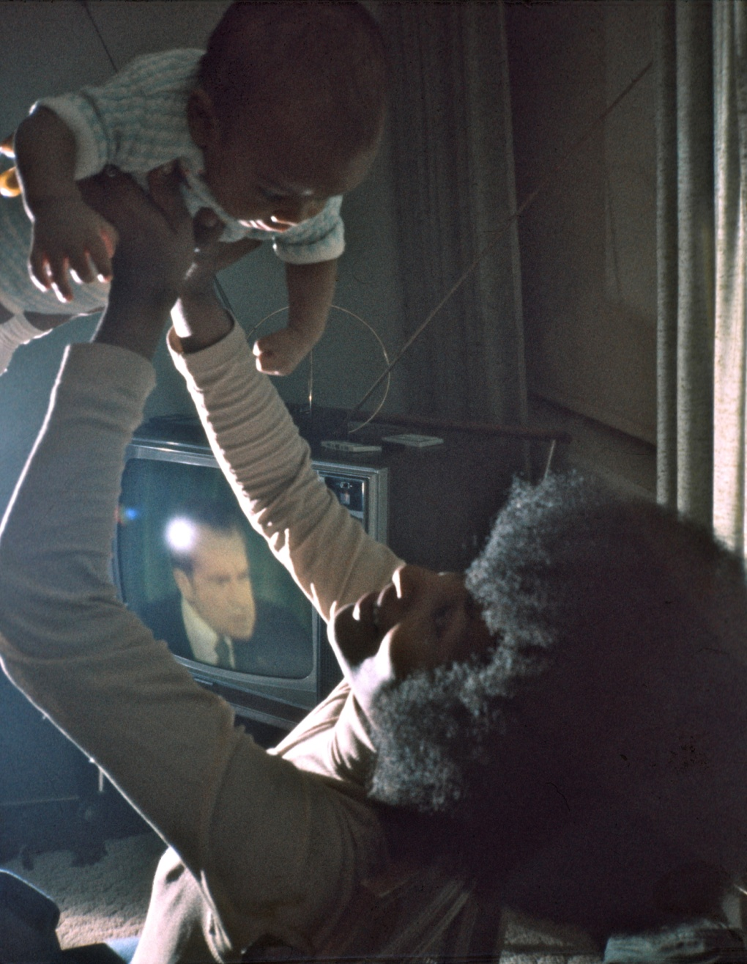
Should I enter into a relationship with her and thus give up my idea of finding a well-educated black bourgeois woman? For Baggie and her two daughters were on welfare living in the projects and just the idea of having a relationship with my work – the underclass – went against my deeper instincts at that moment. It was heartening to meet a beautiful black woman who did not seem to harbor any anti-white feelings, probably - as I often found it among poor women – this was caused by having been through some disastrous relationships with black men. Yet Baggie’s world and deep religiousness was worlds apart from mine and I feared that we would very soon run out of things to talk about and just sit watching TV with each other.
Actually that is just what we did one night when President Nixon suddenly came on TV and I took the picture of Baggie and her child next to the TV, a lucky shot which has since been declared art and exhibited in numerous museums under the title, “Beauty and the beast.” So with all my mixed feelings about being “just another in the row of white sexual exploiters” I decided to stay with Baggie for only a couple of nights, but not get into sex with her. With her religious feelings or similar confused emotions of the kind I describe on page 271 in the book about how such underclass women could not help consciously or unconsciously signaling that this was a relationship between a free and an unfree person, living together in intimacy without sex did not seem to be a problem for Baggie.
Baggie and child with Nixon on TV
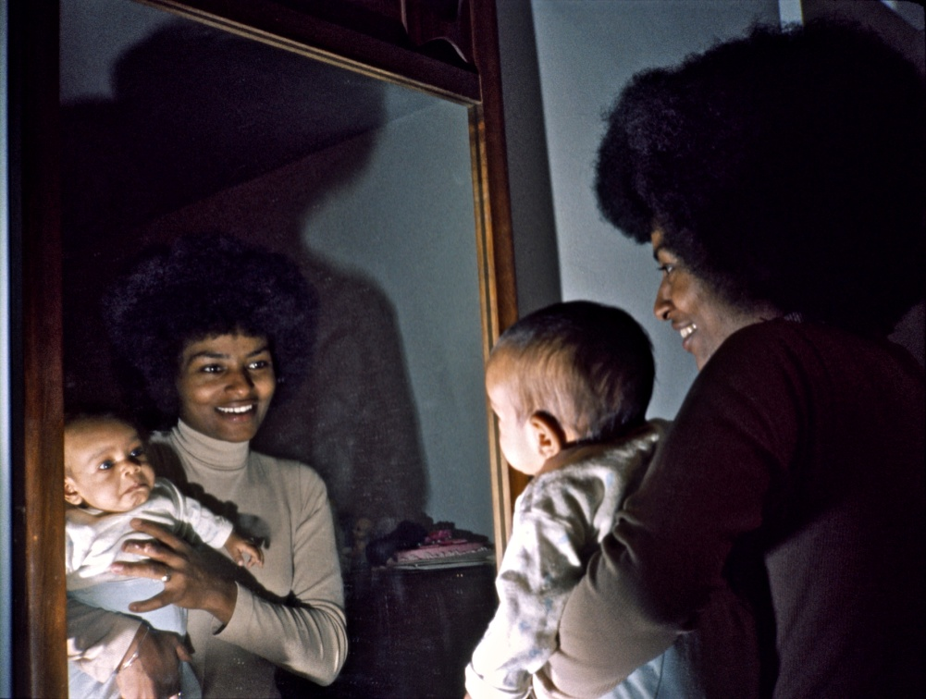
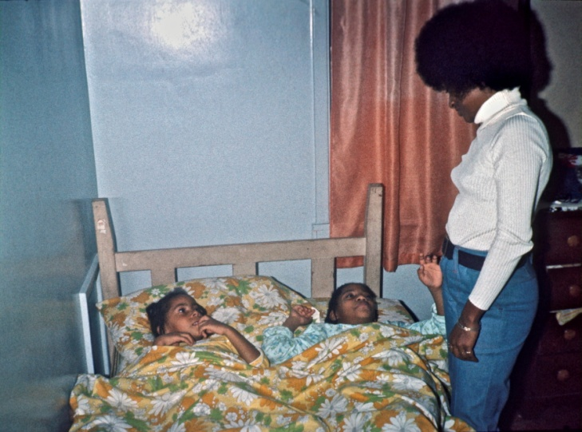
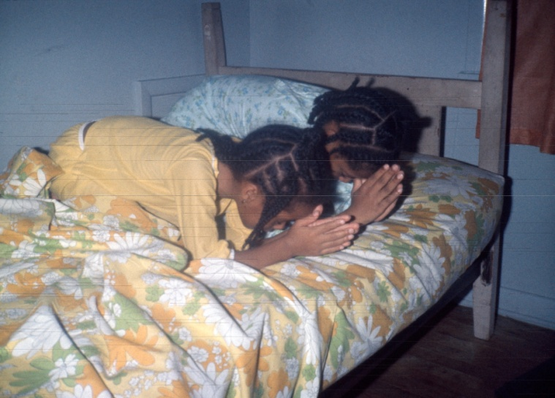
Instead I enjoyed the religious intimacy we shared when praying together with her children as shown in the photos I have since exhibited under the “republican” title; “The family who prays together stays together.” My instinctive feeling about how a deeper relationship between us would have been a mismatch – no matter how much I otherwise felt married to the underclass – was pointedly demonstrated for me less than a month later, when Baggie committed armed robbery and was sentenced to 25 years.
I lost touch with her after that – just as she did with her own children – which also prove that prayers do not solve deeper underlying social problems. Somehow living with her also had made me into typical underclass man, for to escape from the boring TV and prayers of a welfare family I started to hang out much more among the criminal types in “The Grill” which was now much closer than from Tony’s house.
Baggie was another example of how miserably I failed when Tony eagerly tried to set me up with his girlfriend’s friends and it puzzles me that in the story “Ghetto love” on page 274 I describe this as a sexist “period of conspicuous consumption of girls”. Yes, no doubt I wished it was so – and in that sense was sexist – but in hindsight I see in my diary that not a single one of all these black dates ended up in a sexual relationship.
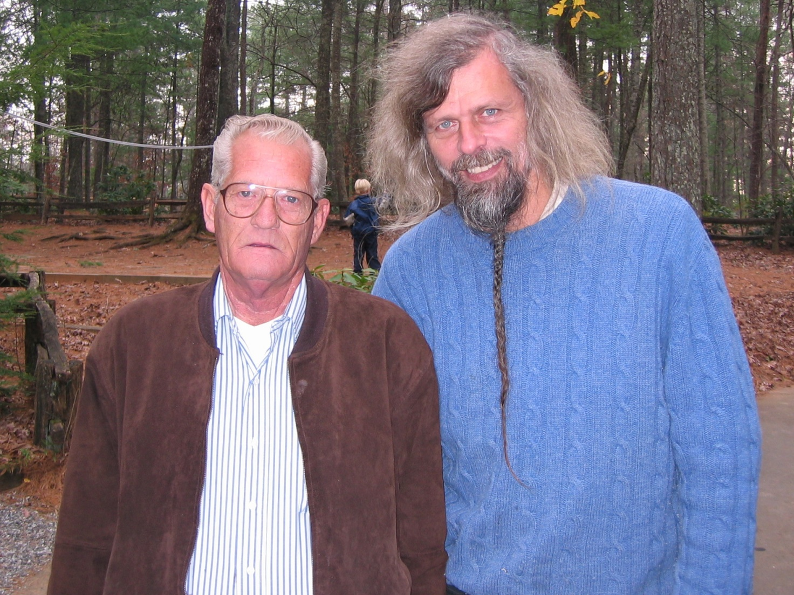
With Virgil Griffin, who masterminded the Greensboro Massacre
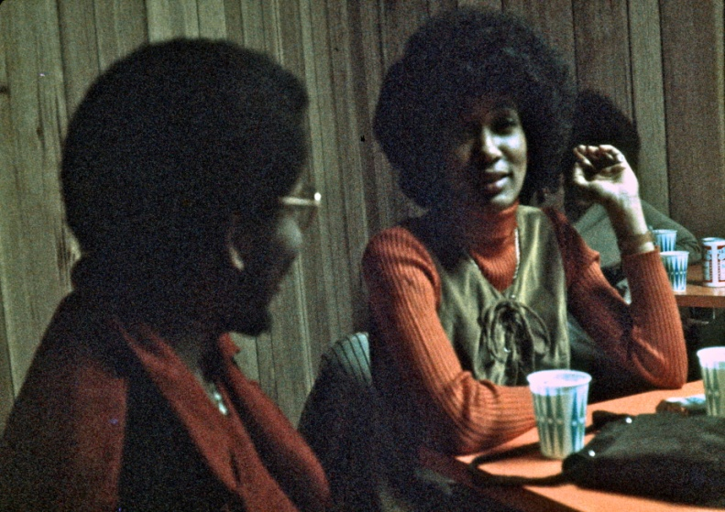
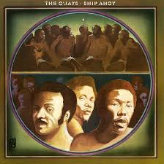
So another reason Baggie comes to mind at the time of this writing is perhaps more to illustrate Tony’s “conspicuous consumption of girls” in this period where he was practically in bed with every black woman in Greensboro. For exactly 5 years later one of Tony’s many girlfriends, Sandy Smith, was shot to death right outside Baggie’s and my door in the Morningside Heights projects along with four others in the so-called “Greensboro massacre” directed by a Ku Klux Klan leader, Virgil Griffin, who many years later became my friend and whom I helped to some degree to change. (I will write about that later). And just to illustrate just how many black women Tony in vain tried to set me up with in Greensboro I can also mention Willina Canon, whom I spent a lovely “intimate” evening with at home on 1232 S. Eugene St. She was also shot in that massacre, but survived.
So if a single Klan leader can hit so many of our girlfriend I can only conclude that Tony and I touched many black women’s lives in Greensboro, but he certainly touched them deeper than me
Women – at least white women – I could of course find much better on my own anywhere in America, so my friendship with Tony was – when all comes to all - the only reason I kept coming back to the relative boring – and in terms of my underclass project – uninteresting city, Greensboro. And in terms of home base and as a “dating helper” Tony after Feb. 12th 1974 got serious competition when Tommy Howard - the so-called playboy millionaire in my book page 130 - picked me up in his Jaguar 10 miles before Greensboro on one of my return trips to see Tony. Tommy came from a poor white trash family, but had unlike his redneck brothers worked from rags to riches and now started seeing the emptiness of affluence except as a quick tool to get girls with. So when I sat there elaborating about my life philosophy “Security is being on the road with no money,” it struck something deep in him and he asked me to come with him skiing up in Boone in the mountains, and repeated several times “And I want to make it clear to you that I am not a queer!” With my yes-philosophy I said of course right away yes and had a long, long deep talk with him that night in his motor home parked in the mountains at the skiing lot.
After taking the very important skiing photos for my “white flight” section of my show I was so bored with skiing that I next day started hitchhiking down the mountains while promising him to come see him later in his home in Greenville in eastern NC. When I later there told him about how my first ride down the mountains was with a beautiful white woman, 26 year old Joan Bates (no relation to the singer), who took me home and became my girlfriend for a few days only a mile or two from Tommy’s skiing resort where he “after spending thousands of dollars had not been able to score a single woman”, well, that again helped him to come to the decision that he “would rather be a penniless vagabond than a millionaire”.
Luckily for me that didn’t happened before I left America in late 1975 when drove his Jaguar to I95 and started hitchhiking and the next 7 years lived as a vagabond – first in Europe and Africa, since in Latin America. Often later he thanked me for changing his life with my “vagabond philosophy.” But in the meantime his luxury house in impoverished Eastern North Carolina became my home base, where he let me use his old Buick to drive around and photograph in the tobacco fields. And just as black women jumped into Tony’s in Greensboro white women jumped into Tommy’s car around Greenville. In both cases they let me have their surplus women. The difference was just that Tommy’s white women had no racial hang ups being with me. Whether or not their deeper motivation perhaps was to use my luxurious bedroom with a giant water bed as an eventual gateway into Tommy’s bedroom I cared less about. I had fewer frustrations with them than with Tony’s fringe benefits and conveniently used them and his Buick as a gateway into the impoverished East. From then on I hitchhiked endlessly east-west and west-east between my two NC homes. The happiest and freest period in my life was with these two male friends and all their female cohorts, I feel. But soon my freedom was over.
In August same year I finally got my deportation order which I had avoided for 4 years by hitchhiking to Canada or Mexico every 3 months. That is when I met a well educated yet self-taught black woman, Annie Rush in New York, and since I didn’t feel that I was finished with my project and she had just come home after 10 years in England for the funeral of her mother, who was murdered half a year after her father, she suggested that we marry. That way I could finish up in America and I could help her out of America which she hated. So for the next half year we had to live together in California after which I had a very productive swing through the Deep South. As a result I rarely saw Tony and Tommy during the time until I drove by with Annie in a drive away car to say goodbye before leaving America in December 1975.
I never thought I would return to America, so before I left I bought records which reminded me of all those people I had lived with and come to love. In Tony’s rear dark living room, which we only used for pot smoking and partying, he had one of the Automatic Stackable Turntable used everywhere in the 70’es. Yet he was too lazy to turn them upside down, so whenever he was home he usually played the same side of the same 10 records again and again. From the backroom it could be heard all over in the house. His and my favorite was the ban “The O’Jays”.
I couldn’t afford to buy all of them, but with the entire love making I had experienced in Tony’s house I wanted to remember him for the one with “Now that we found love” which I especially had loved. When I came home to Denmark either I or Annie one day flipped it over to hear what was on the other side and was immediately completely taken with the title song “Ship A’hoy” about the slaves carried over the ocean. Somehow I had never heard this song of pain and suffering it in Tony’s house and only associated Tony with romantic optimism and love, but could see right away how this was the perfect opening song of my show. So this became Tony’s ultimate musical gift for my show whose first part starts with oppression and ends with his liberating “finding love.” I have now heard these two songs 7500 times in the show and never become tired of them. And for my audiences they became instant hits which I hear them go around singing for days after – just as they usually remember and can sing “Ship A’hoy” now close to 38 years after they first heard them in my show. The only thing I regret today is that I didn’t take hardly any photos of Tony during the years he shaped so much of my life. The reason was of course that my photographic heart was with the underclass – and not the black middleclass.
Scene from "The Grill" where Tony's father and grandmother fed me night after night.
During the years as lecturer I kept bringing Danish visitors with me to "The Grill". Here it is my father with Tony's half-brother, Nathan, in 1985

