**11. November 2013  
  
  
Dear Jamie (and Steve and the other script developers)**  
  
I just had a meeting with Charlotte Omann about the contract and I hope you soon can reach a mutually satisfying agreement with her so we can get on with the project. As you know I am not that interested in money matters, but in case the movie ends up a success I will feel I have betrayed my family a bit – not least my children whom I neglected for so many years while I was working in America – in case I have not made sure they get a bit out of the success.   
  
And after all the fantastic reviews I have seen lately of “12 years a slave”, how could it not be a success? (Now I am just afraid that Steve will get a great Hollywood offer and run away from See-Saw ☺ )  
Yes, what an amazing interview with [Chiwetel Ejiofor](http://www.thedailyshow.com/watch/thu-october-24-2013/chiwetel-ejiofor) by Jon Stewart! I can already see which strong role he could play in this movie. That I don’t think you so easily can visualize from just reading the book since the book does not have many strong black male characters. However, some of the politically aware black males who helped educate me during the vagabond years I think could be very important as a counterbalance to all the women who with more or less success “put me in place”. So more on strong male figures later.   
  
Since I wrote you my last letter, the Danish documentary about my life finally secured funding from the Danish Film Institute and Danish State Radio – partly as a result of an initial short film interview with my old Jewish girlfriend Marly Sockol. In a very funny psychological portrayal of me as a young radical she really, I have to confess, nailed me or “put me in place.” So also more on that later. No doubt it helped assure the funding that the documentary with the rightwing politician “Pind and Holdt in USA” became one of the most successful TV-events of the year winning prices and incredible reviews. I can’t walk anywhere in the streets now without being thanked by all kinds of people. So now Danish TV wants to continue the series with “Pind and Holdt in Africa” since Pind worked in Africa as a former minister of development and I worked there supporting the anti-apartheid struggle.   
  
 **Ideas for your screen adaption**  
  
Over the summer I was busy with a lot of other things which gave me new ideas which could possibly be used in your movie script. Let me here run some of them down.  
  
**1. Ideas inspired by The Butler**  
A. Bloody Sunday in Selma  
B. The Klan attack on the freedom rider bus  
C. The Black Panthers  
  
**2. Ideas resulting from the 50 year anniversary of King’s speech “I have a dream”.**  
  
**3. Ideas on my relationship to black women as I talked about in my speech for my wife at our silver anniversary last week (presenting the movie with her and Marly Sockol).**   
  
**4. Ideas resulting from the “Pind and Holdt” films possibly for a sequence about apartheid, KKK, Mandela, King family, KGB.**  
  
  
1. Ideas inspired by ”The Butler”  
  
Since this film partly takes place in the era I describe in ”American Pictures” I have to tell you about some of my reactions to it. I saw it at a press showing a week before its opening in Copenhagen since I had to review it on Danish TV and was so moved in parts that I momentarily had to leave the theater in tears. For this was so much of my own life shown there – however, in much too short a movie. What an educational movie about the Civil Rights struggle it could have been for today’s school children if it had been made into, say, a 6 hour TV series, we all agreed. Yet, privately I was very pleased that it was not a 6 hour movie, for this could have killed Steve McQueen’s 6 hour project. Now Steve has the chance to present that story in a deeper way – using much of the same technique of telling it through the experiences of one person’s experiences.   
  
Of course the most dramatic parts of the civil rights struggle were over by the time I arrived in America in 1970. Yet I still found remnants of it in Jim Crow signs etc. and talking to people who had been on both sides of the struggle.   
So let me write a little about what I said in my TV-review, which you can see here <http://www.dr.dk/tv/se/filmselskabet/filmselskabet-47> (since Danish TV prevents people in other countries from seeing their programs, I will put it on my website later).   
Let me start with the end where my interviewer Maria Månson ended up giving the movie only 3 stars out of 6. I was really surprised since I felt the movie deserved a lot more and complained. And listen to what she answered off camera: “I can’t really give it more, for there are two fantastic films on similar black topics coming later this year which deserve 6 stars.” Which ones, I asked. “One is Fruitvale Station, which you have to introduce in Danish cinemas, I know, and the other one is called “12 years a slave”. Have you heard about that one?”   
To which I answered: “Oh, yes, of course, I have even talked to the filmmaker and if things go right you will hear more about us two” ….after which I refused to elaborate more ☺  
  
I started out with another surprise for her. I told her and the viewers about how I somehow had a little to do with “The Butler” becoming such a big star studded movie. “For if my old [lesbian girlfriend Sapphire Lofton](http://www.american-pictures.com/gallery/friends/Sapphire.Lofton/) had not chosen Lee Daniels to direct the movie “Precious” (nominated to 6 Oscars) based on her book “Push” (twice on the bestseller list), then he would not have made such a big name that he could get Oprah Winfrey and Jane Fonda (in whose house I had my first American show) and many other heavy weights to act in The Butler. Sapphire told me that she chose Lee Daniels because he is a homosexual like herself and because he previously had [produced a movie about incest](http://en.wikipedia.org/wiki/The_Woodsman).   
  
Let me just briefly tell you the story about Sapphire and me. When my movie “American Pictures” was running in [Film Forum in NYC in 1984](http://www.american-pictures.com/gallery/usa/pages/usa-03303.htm) I was living with 4 lesbian film makers on Ave D. One day Sapphire called me up and said she had been totally knocked out seeing my movie (although only the first part was shown in Film Forum, later she saw the whole show) and asked me to come up to see her in Harlem. I came in the early evening and we talked continually until 5 in the morning (after which I moved in with her for some years and became her hidden boyfriend). It turned out that we had completely the same ideas on everything. She had been an “outlaw” as a street walker for 10 years and I had been walking as a vagabond for 5 years. (Here I am sharing some intimate details with you, for in the media after her later fame she decided to call herself a “hippie” during those years). In order to stay free of pimps she had to study the whole “system” of male oppression just as I had studied what I called “the (master/slave) system” to stay free of it. After 10 years as a hooker she had become a fairly well known feminist and lesbian writer. My lesbian roommates on Ave D. kept begging me to introduce them to her, but Sapphire did not want anybody to know about our relationship. When we went to movies or poetry readings together she would walk on one side of the street and I on the other, totally ignoring me. Yet, after a couple of years more and more of her lesbian friends found out about our relationship and started nagging her: “How can you be with a filthy heterosexual white?” So one day she had to break up with me since I was “confusing her lesbian identity”. I understood her, and in tears we separated, promising each other not too look each other up again.   
  
But, wow, how we inspired each other’s thinking during our relationship. I don’t think she had talked to anyone about it before, but she was night after night trying to come to terms with the incest she had suffered by her military father and how she had later acted it out as a street walker. Again she has not talked about this publicly, so I hope you can keep it confidential, for our (lesbian) relationship does not make much sense unless you know this background. It was at that time I was starting to make oppression workshops in universities as a follow up to American Pictures. So day after day I was hearing similar testimonies from incest victims – especially in more impoverished white areas such as upstate New York. I can’t remember hearing many testimonies about incest in my vagabond years, so for both of us it was a new way of understanding oppressive patterns. As a result we were very much feeding each other’s ideas – mine mostly coming from the white world, hers from the black world. It was during that relationship she switched from poetry to start writing the novel “Push” and when I years later read it I could recognize so many of our neighbors in the book from our hallway where we lived on 469 Lenox Ave #52 (right next to the black museum [The Schomberg collection](http://schomburgcenter.tumblr.com/) which it was my original plan in the vagabond years to donate all my photos to).  
   
I will tell you the rest of the story about Sapphire later when you see my lecture “On saying yes to integrate with those we shun” – and how we years after reconnected as a result of “Precious”. In the fall 2012 when I was making the movie with the rightwing Danish Politician Søren Pind (whom I had had previous clashes with about ghetto youth in Denmark) I invited him to a dinner talk in my NYC apartment with Sapphire to talk about ghetto pain - “black pain” (or rather American black pain, for the West Indian experience is so different as mentioned earlier). Along with two other friends, [Terrie Williams, author of “Black Pain”](http://www.youtube.com/watch?v=dDD7foNyEV4) and one of my former students from St. Lawrence University (actually located in one of the most incest ridden and impoverished areas upstate New York where I first heard about incest from social workers), [Elinor Tatum, who is today the editor and publisher of New York’s large black newspaper and organizing former presidential candidate, rev. Al Sharpton’s weekly radio shows](http://en.wikipedia.org/wiki/Elinor_Tatum).   
You can see us all here with me sitting between Sapphire and Elinor:  
<http://www.american-pictures.com/gallery/events/Pind-tur-USA/index_8.htm> and  
<http://www.american-pictures.com/gallery/events/Pind-tur-USA/index_9.htm>   
  
And the miracle happened; these three powerful black women managed to totally keep the Danish rightwing politician’s mouth shut a whole evening – although he is known to be one of the brightest and fastest talking Danish politicians. Our talk on black pain was too long and intellectual to be used in a short documentary on the Danish TV, but I would like to show it to you later since I think you can use some of the ideas in it as inspiration for the development of Steve’s movie. In this talk I myself describe the incestuous development I saw in one NYC family, Sandra Johnson and her crack addicted sister, Caroline, from I photographed them in my book ([page 205 bottom left](http://www.american-pictures.com/gallery/usa/pages/usa-00514.htm)) (also with their father who always raped them) in 1972 ….and [to we went to see them with Søren Pind the following evening](http://www.american-pictures.com/gallery/events/Pind-tur-USA/index_10.htm). Sapphire’s next book “The kid” was very much about that pain which later devastated black neighborhoods.   
  
Well, I think Lee Daniels – after getting much critique from the black community for showing so much of that pain in “Precious” decided this time to make a real feel good movie with a happy ending which would please all blacks. In any case, through my deep relationship with Sapphire I somehow felt I had a slightly more emotional connection with “The Butler” than most people ☺  
  
Here are some of my other personal connections to the stories in The Butler:  
  
The scene where Martin Luther King’s march from Selma is stopped and brutalized at **Edmund Pettis Bridge (Bloody Sunday).**   
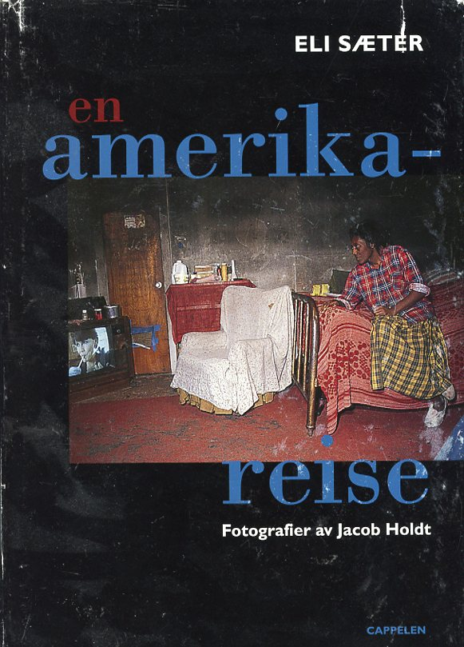  
In 1996 I had a [Norwegian woman, Eli Saeter](http://www.american-pictures.com/gallery/friends/Eli.Saeter.htm), with me on tour to visit the family of mass murderers in Louisiana, and she later wrote her bestselling Norwegian book “en amerika-reise” about our trip. When we drove through Selma she wanted to stop to get a souvenir since her best friends in Norway had named their daughter Selma, for the girl had been conceived on their vacation trip in Selma. In a souvenir shop they said, “Why don’t you go to see the mayor? He will find this an interesting story.”   
We would never have dreamed of going to the mayor of such a big city, but why not try? The mayor right away invited us into his office and when I saw that he was fairly old, I took the liberty to ask him which side he had been on during the civil rights struggle since we had just been to the museum at the famous Edmund Pettis Bridge. Without saying a word he opened a drawer and fished up an old newspaper where the whole front page showed that it was him who personally had ordered the bloody Sunday attack on King’s march. We were in total disbelief that it [was the same racist mayor who was still in office 32 years after](http://www.spokesman.com/stories/1996/aug/29/selma-segregationist-elected-mayor-again/).   
  
Then I asked him: “Wow, I can’t believe I am meeting you personally. So which side then are you on today?” Again without saying a word he fished up another newspaper, this time with a photo of himself on the front cover receiving a warm hug from Jesse Jackson. I walked away that day with a great smile on my face: “See, whenever people think that some people are bad, I can always in the end find the goodness in them. It again reaffirms my belief in people’s capacity for change.”   
(At least, when they want to get reelected year after year in a changing society ☺ )  
  
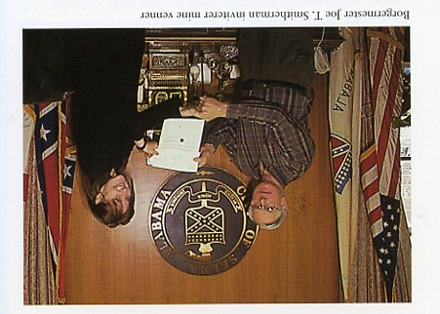  
From Eli’s book: The mayor who had ordered Bloody Sunday made an official document for Eli’s friends.  
  
  
The scene where the freedom riders are attacked by the KKK and their bus is burned ….and how a Klan leader saved my own life.  
  
The attack shown in the movie on the bus was originally carried out by some of “my” Klan friends in Anniston, Al. when the bus drove through it from Atlanta to Montgomery.   
When I years later brought America’s biggest Klan leader Jeff Berry with me around America to meet all my black friends from the book, after some days around all these black folks he wanted also to see some whites. So to cheer him up ☺ I took him to one of the old Klan members in Anniston – [now sick and poor as you can see in this series (row 2 and 3)](http://kukluxklan.info/gallery/index_12.htm).   
You can see them both in the movie here:   
<http://www.american-pictures.com/video/kkk.on.the.road/kkk-road2-us.htm>  
  
There is a deeper tragedy to this story which I knew about from his daughter Christy (seen at his side) who had brought me into Anniston’s local Klan world. Ever since she was a child she had been sexually abused by her father and several others in the family. Around 14 years old she escaped from him and – although deeply racist herself – was taken in by a black family. Over the years she acted out her pain as a crack addict and when I spent a whole night counseling her at our first meeting I noticed that she crumbled up all the time in the bed like a child in a womb as if to try to protect herself and said: “This reminds me of something, but I can’t right now remember what it is. Have you been sexually abused?” Then she started telling her childhood story and suddenly I remembered that it was the same position Jodie Foster had in her movie “Nell” about an abused woman. But this woman’s story was the most incredible I had ever heard. Details I can tell you later in my lecture “On saying yes”. As a teenage addict she became a white member of the nationwide black gang “The Bloods”, but since her Klan father was now very sick she lived part time in his poor trailer caring for him and thus lived a very dangerous double life. Since I was right now in 2005 making a movie about my own Klan leader friend Jeff Berry I got the idea to let her take him and me to her gang member friends (without them knowing that he was a Klan leader). She accepted that, but then we had a meeting with some local poor whites in which Jeff started bragging about being a Klan leader and Christy realized the rumor soon would be all over town and said: “I can’t take Jeff to the Bloods now. He will be a dead man.”

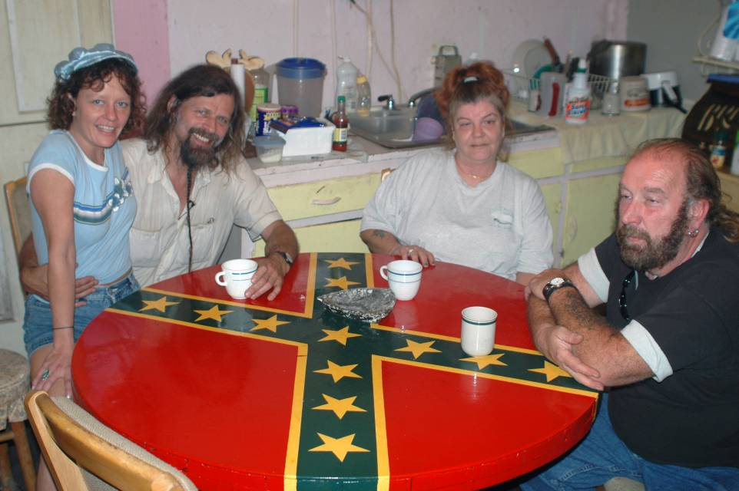With Christy on my lap visiting local Klan member who never learned to read and write. And Jeff at right.  
  
And that was also close to have been my own destiny. We checked into a cheap hooker motel that night, which Christy usually used for her prostitution to get money for her drugs. In the evening one of her drug sellers from the Bloods came around with crack for her. I was standing alone outside, so he first talked to me. But all of a sudden the gang member hidden in my sleeve saw the small microphone which we used for the filming and asked paranoid: “Are you police?” I was in a cheerful mood that day and started joking with him, “Yes,” not realizing that he was high on crack. From then on he was convinced I was a police informer no matter what Christy tried to tell him. I couldn’t afford to pay for separate rooms and had put Jeff in the same room as Christy that night while I myself as usual went to sleep in my car. At 3 in the morning I was woken up by Jeff who came out and knocked on my car door: “Jacob, can’t I have one of your books?” “What the hell do you want my book for in the middle of the night?” I asked, but he left with a copy without a word. Next morning when he came to serve me coffee in my bed in the car he said proud: “Jacob, I just saved your life from a drugged black gangster who ran around ranting about killing you all last night.” And then both he and Christy told me about how the gangster had been all night in their motel room (not of cause realizing that he shared it with a Klan leader) while they continually smoked crack from a coke can they broke open. But as the gangster got more and more paranoid and was now convinced that I was a police informer, he sat with his two pistols all the time saying that now he was going out to shoot me. No matter what they said about me they were unable to calm him down. Then late in the night the Klan leader suddenly got the idea that only my book with all the pictures of me with black people would be able to convince the gangster and came to my car to get a copy. “So Jacob, I just saved your life from a black gangster last night. Do you now see why we whites need the Klan to protect us?”   
If it had not been for Christy confirming the story and describing what a paranoid killer this gangster was, I would never have believed the truly ironic story about how America’s biggest Klan leader should one day end up saving my life ☺

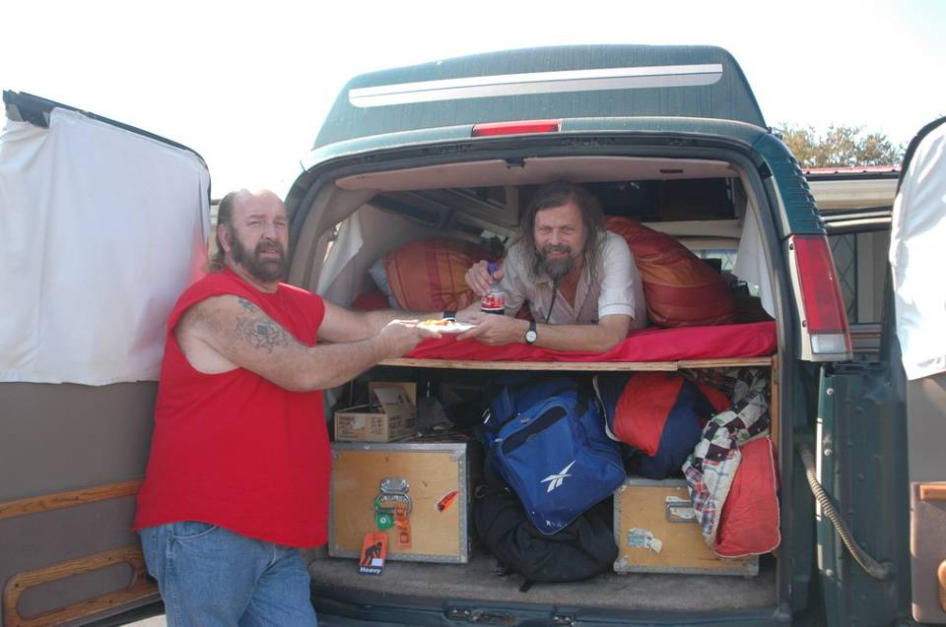  
The Klan leader proudly serving me breakfast in bed the night after he saved my life

For the idea with my friendship with him was of cause to save his life. And that I tried next day out in the woods - also to demonstrate to the spectators of the film the deeper humanity I saw in the Klan leader. Whenever I had tried to talk with Jeff about his violent mistreatment as a child, which I knew about from his wife, he had proudly fought me off and refused to talk about it, “Don’t feel sorry for me!” Now the junkie Christy (who later in life turned out as a bright honor student) agreed to let me re-enact the healing workshop I had subjected her to on our first meeting in front of the camera and Jeff in a sunny isolated place deep inside Alabama’s woods. “Jeff, please give the Klan man’s daughter all your loving attention without interrupting.” As I was holding her hands and got her to tell her story – step by step about abuse after abuse leading that wounded child attracting more and more abuse all of her childhood, she started crying as she had the first night, but now also under influence of the attention from the camera and the Klan leader. It took hours to tell her full story this time – from the sun was right above us till we were sitting in complete darkness. Gradually I saw tears in the eyes of the otherwise so tough Klan leader and in the end I suddenly turned around to him and said: “Jeff, is there anything in Christy’s story here which you can recognize from yourself?” Jeff did not say a word for a long time, then got up in silence and started walking into the dense woods. For maybe an hour we feared we would never see him again, but then suddenly he returned and started telling the painful story about his own abused childhood. It was a deep emotional experience for all of us – not least for Mads, the camera man, who had hated the Klan leader on the whole trip – and as always after such healing workshops we broke out in utter joy afterwards. I had brought plenty of beer and we ended up all four of us in a small party which ended so late that we nearly could not find our way out of the now black forest.   
That moment became a turnaround for the Klan leader, he later told me, but I am certain that I would never have been able to pull it off if I had not brought him right into this poor Klan infested territory, where the Klan had attacked the freedom riders in The Butler, and confronted him with the similar pain of one of those Klan member’s own abused daughter.   
  
The next day he was in a fantastic uplifted mood in the car when we drove to Atlanta, where I had planned for him and now felt he was finally ready to see my show “American Pictures” in a Baha’i temple along with my local black friends, one of them [Tony Harris](http://www.american-pictures.com/gallery/friends/Tony.Harris/index.htm) with whom I had conducted hundreds of such oppression workshops on American campuses. Often Tony and I had talked about how we would like to do it with the Klan one day.   
But all of a sudden Jeff changed again and refused to go inside the temple. And then suddenly things erupted and ended in our dramatic departure from each other shown in the end of the road movie. As a result I dumped him in the middle of the night in the Greyhound bus station (although it was my intention to bring him up to one of my friends from another Klan group in North Carolina, Raine. She is the only declared feminist and pro-homosexual spokesman I know in the Klan, so I had wanted her from a Klan insider perspective to work on Jeff’s homophobia).   
To our utter choc we next day discovered that Jeff in his angry departure had stolen all those tapes we had just filmed of his healing workshop in the woods – for me absolutely the most important part of the entire movie.   
I felt so bad about dumping him in a bus station full of black customers waiting for what Americans call the “ghetto busses” (Greyhound) that I drove all the way up to Indiana to make up with him and it was after a few more angry rejections of me that he finally dissolved the entire Klan group. What I had seen in him I had so often seen in [my workshops with Tony](http://www.american-pictures.com/english/show/tony.htm). Those who sit in silence we never see a deeper change in, but those who keep fighting us – we always called them “the militants” – are actually those who are on their way out of their racism and into a new way of thinking. They are the ones who later invite American Pictures back to campus to help other students go through the same workshop, the ones who years later tell us how they changed careers or try in high government positions to affect some change in society.   
For the Klan leader it made no sense to dissolve his Klan group which he had been in all his life. Without the Klan he knew he would sink back in the powerless invisible role as poor white trash. No Jerry Springer show would cultivate him as a star again, no European photographers or TV-stations would give him instant fame. But it made no sense for him any more to continue. What happened then was tragic. I was in Uganda working on [the racism of Africans against the pygmies](http://www.american-pictures.com/gallery/uganda/index_27.htm) when I suddenly in the rain forest got a mail from a Christian American Indian asking me if I could send him Jeff’s address. He had read my court defense for Jeff on my website after reading in the papers about the attempted murder on him and now wanted to “send him a truck load of Bibles and prayers for his recovery”. I was in choc when I realized what had happened to him after the change I had secretly hoped to affect in him, but never really felt would have been possible. The other Klan members including Jeff’s own son were so furious that they tried to kill him. For two months Jeff was in coma – the doctors only gave him a 50% chance of surviving. When he woke up he was blind and handicapped for life, but when I came to see him he was happy. Now he was preaching love in a church rather than hate in the woods. The rest of the (far more complex) story you can see in my “On saying yes to those we shun”. I felt extremely sad this summer when his wife send me the message about his death – after sitting rotting up ever after in front of a TV he couldn’t see. She now wants me to help her write a book about his life. Here is the brief story someone has written in Wikipedia:  
<http://en.wikipedia.org/wiki/Jeff_Berry>   
  
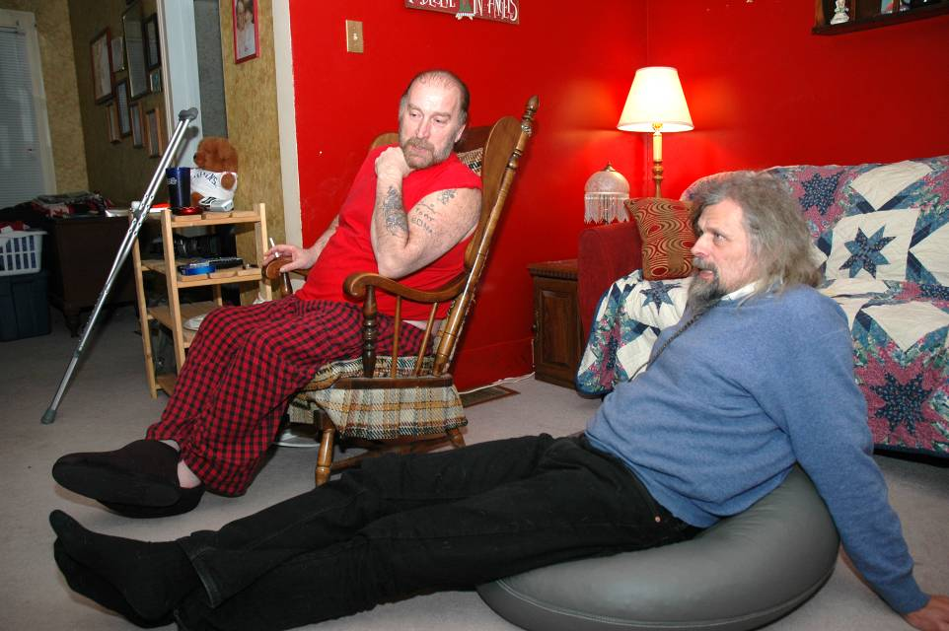  
Living with Jeff after he became blind and handicapped barely able to walk on the crutches behind him   
  
I don’t know if you can use some of this in your script writing – I suspect that you will when you see my complete (for everybody surprising and eye opening) lecture about what I found out about the Klan (and their real relationship to blacks) from the 10 years I was “a member of the two biggest Klan groups” ☺   
It was not my initial purpose, but somehow I thus had a small part in breaking up both groups by also helping to get another Klan leader to dissolve his group – one of America’s most hated Klan leaders who had among others crimes killed my best friend, Tony Harris’ girlfriend. (I know this all sounds crazy, but see it in my lecture).   
Today I really miss my Klan friends and this is probably one reason I have recently started working with the Hells Angels here in Denmark to explore the many similarities   
….and why I have to finish this chapter now since I at 5pm today am bringing some of them as surprise witnesses to a highly [academic university lecture on the childhood psychological damage of gang members](https://www.facebook.com/events/1380244922197920/?ref_dashboard_filter=upcoming) – so parallel to what I see in Klan members in the US.   
Here are some of my new Danish friends whose Christmas party I am invited to in two weeks in their well protected “rocker castle”. So even life in Denmark can be a lot of fun ☺  
  
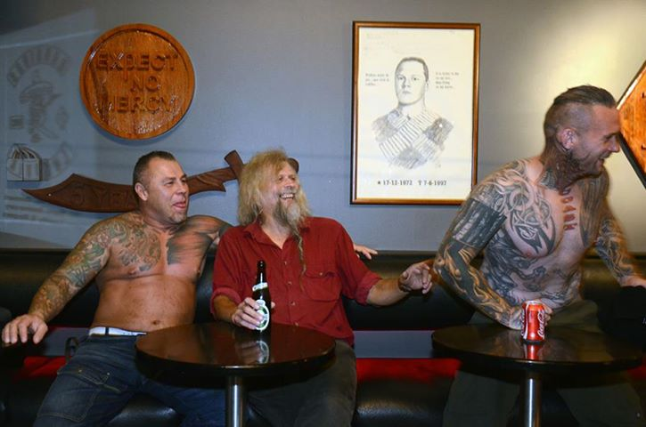

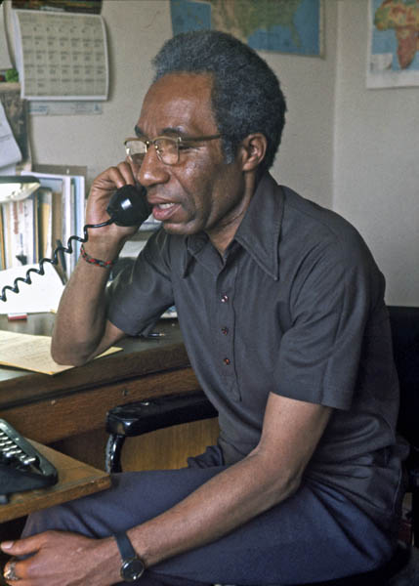The scene in The Butler with the Black Panthers  
  
Nothing in The Butler moved me as much as the scenes with Louis and Carol in their panther uniforms and proud afros. For this was exactly the moment I stepped on the American scene. In 1969 I had in Copenhagen heard stirring speeches about the Black Panthers by Jørgen Dragsdahl (the journalist who 6 years later discovered my photos and named them “American Pictures” in the media). On the entire left this new phenomenon was presented as a genuine black revolution taking place in America and I clearly had the naïve dream of joining it perhaps on my way down to Latin America to join the more violent revolution there. I can’t remember to what degree all of this was just dreaming or what. But when in Feb. 1971 I came hitchhiking from Canada to San Francisco (on my intended way to Latin America) I right away got sucked into the black struggle by getting to stay with [members of Angela Davis’ Che Lumumba Club](http://www.american-pictures.com/gallery/usa/usa-5000-16000/pages/10820.htm) in Height Ashbury. Already one of the first days I hitchhiked over to the Black Panther headquarter on 8501 East 14th street in Oakland – too poor as I was to take the bus it took me a whole day. And there I remember the chock I received when [entering the shabby building so accurately portrayed in The Butler seeing how small and poor it was](http://www.american-pictures.com/gallery/usa/usa-5000-16000/pages/09349.htm). I don’t know if I had imagined some IBM headquarters of the great American Revolution from the way the Panthers were blown up in the world media. I don’t remember much of what we talked about (I have to check my diary), but when I asked them what I as a European white solidarity worker could do for them, they said: “You have white privilege unlike us. So go into the white community and try to educate them about how their racism is crippling and oppressing ALL black people.” I remember how surprised and disappointed I was at first, for I had romanticized somehow fighting along with black people. But I kept remembering their words when I started traveling in America and increasingly – almost on a daily basis – saw myself as a messenger or bridge between blacks and whites in their totally divided society. But after my first naïve approach and somewhat disappointing rejection by the Panthers I was determined to prove to them that I really wanted to join their struggle – from the inside. So after a couple of years on the road photographing I came back in 1973 with a lot of my pictures of black oppression and said: “Can I now become a member?” The people in the headquarters were now enthusiastic and took me into the office of the editor of The Black Panther paper, [David Graham Du Bois](http://www.endarkenment.com/eap/legacy/scholars/bioduboisdavid.htm).   
Wow, I remember how amazed I was sitting here with the son of the great [W.E.B. Du Bois](http://en.wikipedia.org/wiki/W._E._B._Du_Bois), himself a great sociologist, who had just joined the Panther paper and tried to give it a more intellectual look. I immediately hooked up with David and from now on began sending the Panthers my pictures which they started publishing 4 years before they were published in a book in Europe. When I say I was a “member” it is with some reservation since the Panthers had changed since their enormous amount of members in the late 60’s after all the FBI attacks and killings. We didn’t operate with official membership any more just as I used the false name of “Mads Honst” in order not to be thrown out of the USA. But I started having meetings and hanging out with many of the famous panthers who were still alive and photograph their rallies. But for security reasons [I didn’t photograph much inside the headquarters](http://www.american-pictures.com/gallery/usa/usa-5000-16000/pages/09354.htm) which also to me photographically felt unimportant as I now felt so much at home there that it became uninteresting or too familiar. For me and for them it was my pictures of poverty in the South which were most interesting. Most often I met and worked with [Elaine Brown, one of whose powerful songs](http://www.american-pictures.com/gallery/usa/usa-5000-16000/pages/11016.htm) I still use in my show “American Pictures”. And with Ericka Huggins, a wonderful calm, but devoted activist, who after having started up the New Haven chapter had just two years earlier had a baby with her husband, who was a couple of days after killed in a shootout in L.A. Now Ericka was [starting a Black Panther school here in Oakland](http://www.erickahuggins.com/OCS.html).   
  
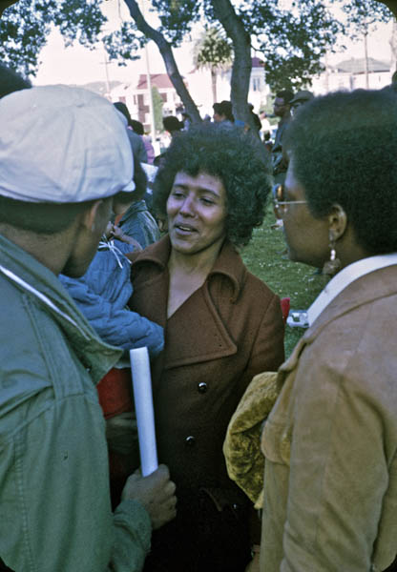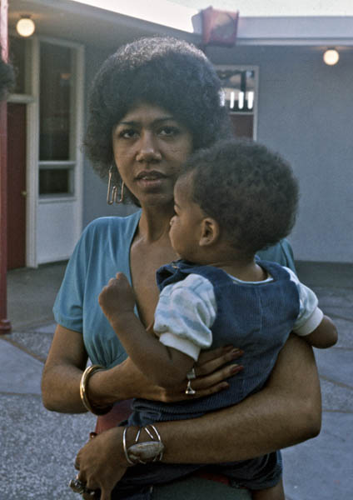

David Dubois in his office

Elaine Brown at a rally Ericka Huggins with her baby

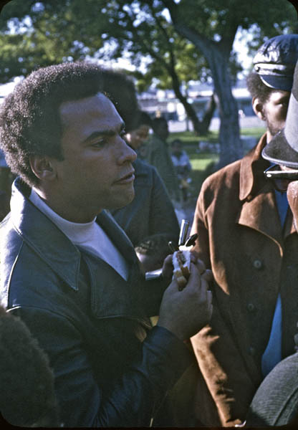In the headquarters I editorially got closest to [Emory Douglass, a soft and warm man](http://www.american-pictures.com/gallery/usa/usa-5000-16000/pages/09370.htm), who during all the years of the paper made all the cartoons in it.   
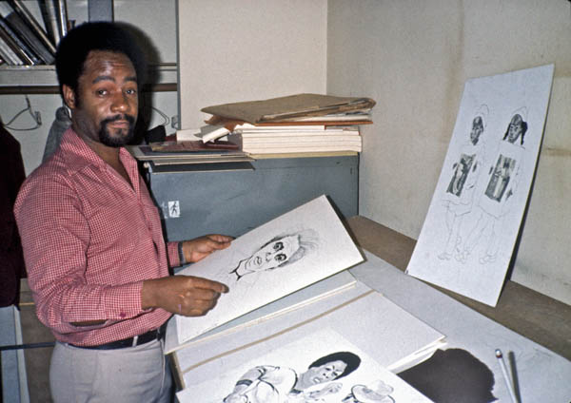

Emory Douglass working on his cartoons

[Huey Newton](http://www.american-pictures.com/gallery/usa/usa-5000-16000/pages/09352.htm) took a more aloof role living in his 10.000 dollar high security luxury apartment, but I did meet him with all his bodyguards at the rallies. There are [more Panther pictures here from number 9335-9380](http://www.american-pictures.com/gallery/usa/usa-5000-16000/index_162.htm).  
  
Before I go on with more inside stories from this part of my travels I have to confess that I have kept it hidden for so many years that I almost had forgotten all about it as I felt ashamed about it. Over the years the Panthers have been so stigmatized that I suppressed it in my mind. Therefore I broke down in guilty tears when I not only saw them in “The Butler”, but saw them presented in a positive light as an important and inevitable period of the black liberation struggle. As a result I decided for the first time to talk about this period when I had to review “The Butler” on Danish TV. In the middle of the interview I suddenly pulled up a bunch of the old Black Panther papers illustrated with my own photos and said: “Yes, I have to confess, like Louis and Carol in the movie I was myself a member of the Black Panther Party.”   
Well, you can almost see the surprise it caused in this official TV-photo: ☺  
[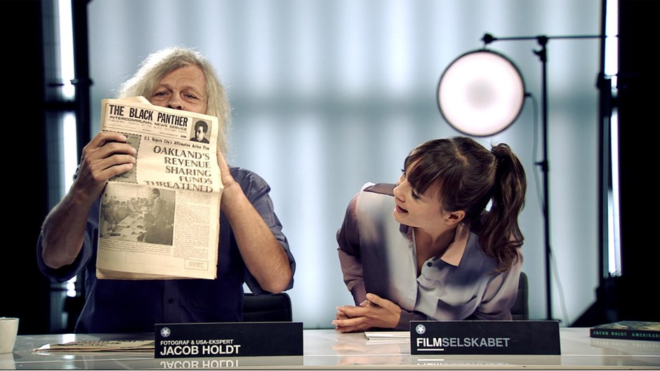](http://www.dr.dk/tv/se/filmselskabet/filmselskabet-47)  
  
Actually I had mentioned the panthers in my very first editions of the book as you see in the German edition below, but I wrote nothing personal about it and only illustrated it with my photos from our Free Breakfast for children programs – those constructive social outreach programs, which I was really glad were also presented in The Butler. By the time my American edition of the book came out in 1984 I had long ago taken the Panthers out of the book in order not to be seen as a radical and not to have it tied too closely up to a now gone era. Not a word in the book about how I myself helped serve [the free breakfast programs in Baltimore](http://www.american-pictures.com/gallery/usa/usa-5000-16000/pages/09373.htm), Washington and Milwaukee. For with my new credentials as their BPP photographer, I was soon active and trusted in local chapters all over the country.

Huey Newton

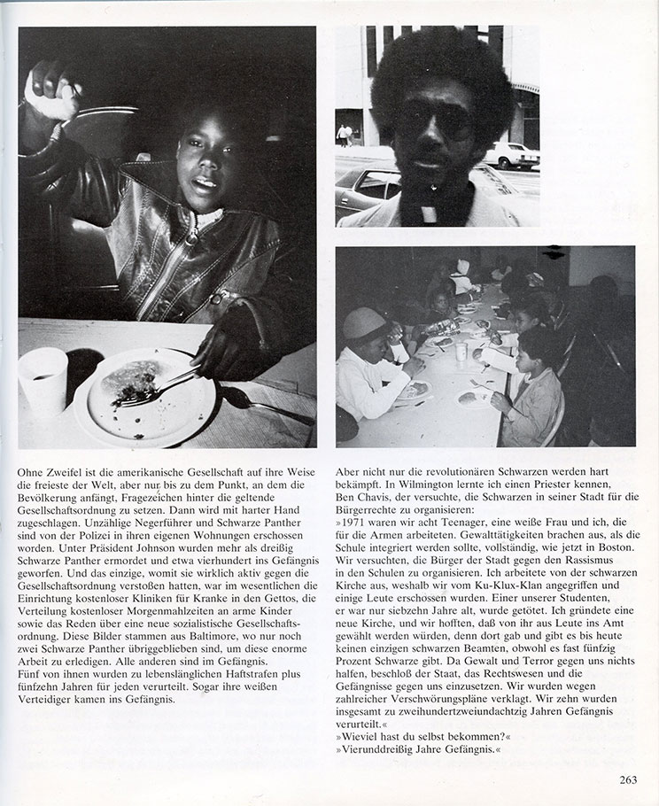

My Black Panther page in the original German book published by Fischer Verlag.

I was very much in agreement with the Panthers’ official view of catering to the “[lumpen proletariat](http://en.wikipedia.org/wiki/Lumpenproletariat)” (what I later called the black underclass) and believing like Huey Newton that “the lumpen” could and should have a progressive role in politics as a way of empowering it. I remember traveling around with their party program and giving it to highly educated friends like Marly Sockol (whom I mentioned in an earlier letter), who was very impressed by it and [started teaching it in her university classes in NYU](http://www.american-pictures.com/gallery/friends/Marly.Sockol/pages/1974-01-01.htm). I was too idealistic at first to see the danger in this philosophy; that getting all these criminal elements into the party without any psychological healing workshops eventually would become its downfall – destroying it from the inside far more than the effects of the persecution from FBI director Edgar Hoover and his [Cointelpro program](http://en.wikipedia.org/wiki/COINTELPRO) of e.g. poisoning the oranges we served for the children in the breakfast programs. All of which created further destructive paranoia within the group which would never have trusted me had it not been for my useful photos. (Actually very similar to when I years later started working with the ANC in the South African Frontline states and as a result of my photos was soon trusted to smuggle top secret messages from one guerrilla group to another despite the fact that in no cell did they know the names of more than 3 people since they were infiltrated by South African security forces).   
  
I could clearly feel over the 5 years of traveling which way it was going for the panther party and one thing which made me distance myself more and more from it was exactly that I so eagerly tried to live up to their first demand, “Go out and teach the whites about their racism”. For wherever I hitchhiked I could see how counterproductive it was when I started talking about how I was “a member of the BPP”. Often teachers picked me up and invited me to teach their university classes, but even in black universities (especially in the South) I saw the shock and discomfort all talk about Panthers created. Blacks hardly dared afterwards to hang out with me having to such a degree internalized all the white propaganda about the BPP. (This beautiful black woman, [Susan Ann Timmons](http://www.american-pictures.com/gallery/usa/usa-5000-16000/pages/10183.htm), had invited me to teach her class in [Paine College](http://www.paine.edu/) in Augusta, GA., but afterward to my great disappointment didn’t any longer dare to date me or even have me staying with her :-) *Need teaches a naked woman to spin*, so soon I had to find more effective ways of communicating the pain of “the lumpen proletariat” to the winners in society.   
  
Nevertheless, if Steve McQueen decides - like Lee Daniels - to incorporate something about the Black Panthers in his movie I can briefly give a couple of fairly cinematic stories here from my BPP work (apart from the hard and boring foot work of going around to stores to beg for free food for our [Free Breakfast for children programs](http://www.american-pictures.com/gallery/usa/pages/usa-02666.htm). I have lots of pictures of how surprisingly impoverished and hungry these children, we feed, were even in Northern cities).   
  
1. This one I told recently on Danish Tv: One of the first days after my arrival in San Francisco I met a beautiful black woman in the BPP headquarters. She had a big afro like Carols in The Butler and as it turned out also other similarities. She started telling me about how she had been in prison for shooting “two pigs” (as the Panthers and the American left called the police). I have to look in my diary to remember if one of them died and find my picture of her, but that is of less interest here than my own reaction to her story. When I heard that story I completely fell in love with her and started flirting with this “proud black woman who after centuries of oppression finally fought back”. That is how fanatic I was in my revolutionary mindset upon my first arrival in the USA. It is embarrassing to think of now, but very symptomatic for the times when it was virtually a call for many of us revolutionaries to get married to the revolution – by marrying someone from the oppressed groups we fought for, preferably a revolutionary ….or, if they were not, in our sexist mindset we were convinced we would soon make them into one ☺   
(This I actually managed to turn my first American girlfriend into – from absolutely innocent and politically unaware at first into a co-organizer with [John Kerry](http://en.wikipedia.org/wiki/John_Kerry), whom I therefore rallied with often (the later presidential candidate and today America’s Secretary of State) and finally unlike John Kerry into a bomb throwing terrorist. I can’t remember if I told you about her, Sharon Lee Holland, for the story is very interesting and cinematic and certainly not included in my later, oh so peace loving, book.)  
(Later I will also write about how this destructive mindset of cause destroyed many of my relationships with black women).   
  
2. Another good Panther story might be this one from when I briefly worked with the BPP in Milwaukee in 1972. Again I have to find my writings about it for details since I have for so long suppressed it from memory. I heard that one of their female members was in prison up north because she had been part of a group who in a shootout with the police had killed a person. The police did not know who had done it and had either locked the whole group up until one of them would testify – or locked this woman up for life because she took the blame for it. I have been through so many crime stories since that I don’t recall the details except that this BPP woman had sacrificed the rest of her life to protect the group. When I heard that I hitchhiked up to [the woman’s prison in Fond du Lac](http://en.wikipedia.org/wiki/Taycheedah_Correctional_Institution) and had a meeting with her. I immediately liked her and was impressed by her strength and I think it was already on that first meeting I discussed the idea of trying to help her escape. When I hitchhiked away from the prison I got a ride by a black family of another inmate and we were all sitting in the car drinking beer. Then the male driver all of a sudden opened his window and threw all the empty beer bottles out on the highway. I remember how disgusted I felt, but again saw it as evidence of the deep self destructive self hatred I had already seen enough of in the “lumpen proletariat”. And sure enough, right away we were stopped by the cops and the driver arrested – not only for that, but for all his crimes they now found out about. And that is very similar to how my own escape plans for the woman went down the drain. I now started with great persuasive energy to let my black friends, Waltdenia Lewis and others in Chicago, and [Jerry, Chris and Aaron in Detroit](http://www.american-pictures.com/english/book/book-10.htm), in on my plan. The plan was in short that the woman should somehow escape over the rather low fence around the prison at the time, then some of my friends should be ready with a car outside and quickly drive her to Chicago, others later to Detroit where I would have borrowed a car from my Canadian friends and drive her up to their farm near Toronto. In Canada there were so many anti-American refugees at the time (American draft dodgers) and my friends in that community would then help her to get on a flight to Denmark. In Europe the mood was such in those days that she easily could be declared a political refugee (see following story). For a while I hitchhiked back and forth between Chicago and Detroit to organize this escape attempt as I saw it as a modern version of [“the underground railroad”](http://en.wikipedia.org/wiki/Underground_Railroad) (which of cause had inspired the whole thing in my crazy mind). But soon I experienced the apathy of my black friends, who at first were very supportive and enthusiastic, but little by little I realized that I couldn’t rely on them, even Chris Booker who believed in “scientific socialism” and had been to Cuba. As the network fell apart I had to give up on my “American revolution” and it was later that summer Chris and I hitchhiked down to Guatemala to become guerillas. However, Chris only made it as far as San Diego, where he couldn’t get a ride for a whole day – then gave up and turned around going home ……and thus again betrayed our great revolution (while I was sitting waiting for him endlessly in an affluent home in Mexico City, where they kept asking anxiously “When is your Black Panther friend coming?”)   
Well, so much for my most revolutionary venture with the Black Panthers. ☺  
  
*(As an after note to this chapter I must say that I did not in those early years of my revolutionary naivety understand how much pressure there really was on my friends from merely trying to survive in the ghetto. I have followed these three students,* [*Chris Booker, Aaron Maddox and Jerry James*](http://www.american-pictures.com/gallery/usa/usa-5000-16000/pages/09916.htm) *mentioned in the book chapter “*[*Easter in Detroit*](http://www.american-pictures.com/english/book/book-10.htm)*” over the years. Jerry later became a very devoted high school teacher who really really tried with caring love to inspire his crushed, dispirited ghetto students and I often in the 80-90’s came around to do free lectures for his classes. But every year I saw conditions get worse and worse. In the 80’s I heard him say: “When I now a day see my students sit and polish their guns in class I have given up interfering any longer.” Since then more and more of his students were killed and in 2005 he gave up and fled over to me in Denmark. That was the year he had finally managed to get one of his female students accepted into Harvard, but just before her last exam gang fights broke out outside the classroom window and she was killed from stray bullets right in front of Jerry’s eyes in class. For months Jerry stayed locked up inside his room in my house in Copenhagen composing moving electronic music. When I one day said he should come out and see on Tv all the blacks who were right then drowning and dying in the hurricane Katarina in New Orleans he refused to come out and see it. He had seen enough of his own students “drown” and die. After half a year living with me he went to Turkey where he finally felt he could “breathe freedom again”. Today he has a successful musical career in Portugal where my wife and I will go and see him in two weeks. In my lecture “On saying yes” I will tell you about what later happened with many of my other friends from the book).*   
   
3. As I said, the mood in Europe was very supportive of black political refugees at the time. And that I saw when some of my later Black Panther friends Melvin and Jean McNair hijacked a plane from Detroit to Cuba and got one million dollar in ransom for their hostages. While I had been in the Bay Area we had from the headquarters in Oakland had angry split screen televised exchanges between Huey Newton there and Eldridge Cleaver in Cuba, where Melvin and Jean fled to join Eldridge and his wife, Kathleen. They were soon after given status as political refugees in France, where they since have become very productive citizens.   
So when my show “American Pictures” was introduced in Paris in 1982 it was Melvin and Jean who were organizing it. They were still very controversial at that time, so we had to have two heavily armed policemen to protect us against the bomb threats throughout the 5 hour show, [as seen in this photo](http://www.american-pictures.com/gallery/family/Jacob/pages/jacob-1981-01.htm), which made us a bit nervous since we had both Tony’s and my two year old sons inside. It was after these showings a French filmmaker for the first time wanted to make a film about my life (with [Alan Bates](http://en.wikipedia.org/wiki/Alan_Bates) playing me) on the idea of President Mitterrand’s wife, I was told. I can’t remember how that first film project stranded, but at least [since then a movie has been made about Melvin and Jean’s life](http://www.huffingtonpost.com/richard-z-chesnoff/melvin--jean_b_2077250.html?utm_hp_ref=new-york). More about that here <http://melvinandjean.com/>   
So perhaps I should have stayed closer to the spirit of my radical youth to make it into the movies ☺  
  
4. On the periphery of my BPP involvement was my simultaneous involvement in 1971 [with Angela Davis](http://www.american-pictures.com/gallery/usa/usa-5000-16000/pages/10812.htm), whom [I helped bring truck loads of letters](http://www.american-pictures.com/gallery/usa/usa-5000-16000/pages/10826.htm) from fans all over the world to her prison cell in the Main County jail ….and whom [I had a secretly taped verbal exchange with](http://www.american-pictures.com/gallery/usa/pages/usa-02659.htm) on “black self hatred” in the first edition of my show. That already then made her sister Fania mad at me, when she saw the show in GDR (East Germany). While I was working with the ANC in Africa in 1982 my black co-workers were trying to get her initial endorsement of the show and had a private presentation for her in her house in Oakland, during which she broke down crying, moved by the show. However, since then we have had opposite views on many things. And when my organizers in Californian universities ever since have come to her departments to get endorsement and financial support for the program, she to their surprise always answered them: “No, Jacob knows very well that we have a 25 year long disagreement on this.” Organizers have often tried to organize us together during black history month, but I always warn them. Well, we can’t win them all ☺  
  
  
2. Ideas inspired by my “I have a dream” talk on TV  
  
However, here is the story of another important black woman – and competitor on the campus lecture circuit – whom I did manage eventually to win over. The memories of her suddenly came back to me in late august this year around the 50 year anniversary of King’s speech “I have a dream”, when no less than three TV programs called me in to talk about it. That famous speech took place during one of my first days in Danish high school, so unlike Kennedy’s murder 3 months later I couldn’t remember how I had reacted to it as a 16 year old. Since then I have heard it about 7.500 times in my slideshow. So instead TV asked me to talk about my own later involvement with Martin Luther King’s family. In case you want something about Martin Luther King in the movie, I here briefly state what I said.  
  
I started hanging out at the social gatherings of the King family – whenever I was around Atlanta – in the last two years of my vagabonding when I had moved closer to King’s non-violent and forgiving thinking and away from the revolutionary thinking of the Panthers (and Malcolm X). I started reading his books and felt personally inspired by hanging out around his family – mostly as a shadow without any deeper involvement than occasionally helping with the coffee. [Just breathing the air 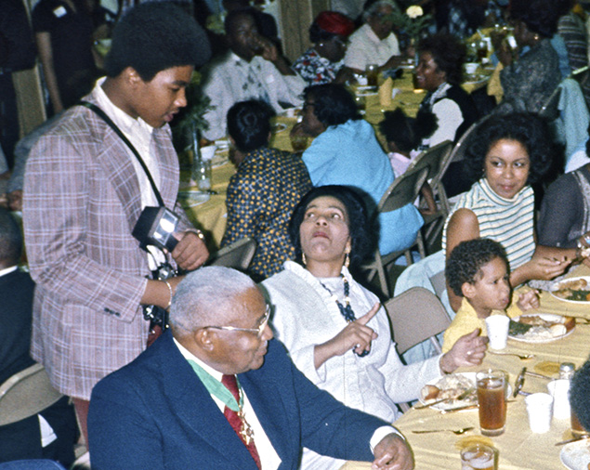around King’s grave was enough for me](http://www.american-pictures.com/gallery/usa/pages/usa-02620.htm).   
  
So on Danish TV I showed a couple of my pictures from these gatherings. They were taken shortly after King’s mother, Daddy’s wife Alberta, had been murdered in the church by a white racist in June 1974. So after all the paranoia around the Panthers I was amazed that they trusted me from the beginning, since Coretta King would have been a more likely target for a white racist.   
About 10 years later my show was becoming a success on the American lecture scene and Yolanda King soon became my strongest competitor during black history month (also Angela Davis, but unlike Yolanda and me Angela was remembered as a controversial radical). For a while we felt annoyed about stealing each other’s best universities every year, but then she approached me. Why not join each other instead of competing with each other? She was curious about how a white man could have as much success on the lecture circuit as the daughter of the very man whose struggle and birthday had inspired “black history month.” So she invited me to Atlanta to present my show for the family in the same room where I had first met the family – right on top of King’s grave which I could look out at during the entire 4 hour presentation. I am sure they were skeptical at first, but wow did the show win them over. I don’t remember who said it first, but they were in total agreement: “This slideshow MUST be seen by all young blacks today so they can understand what Martin fought and gave his life for.” They wanted it to be shown permanently in the new Center for Social Change museum being built next to King’s grave, but then I said that they would have to wait. For at the time it would require a man to stand changing slide trays ever 5 minutes all day long. So it wasn’t really useful in a permanent museum before it became *digitalized* – a word we didn’t even know in the 80’s.   
However, Yolanda from now on started using my photos in her own lectures (for unlike the old ones of her father during the civil rights struggle in black and white, my photos showing the present day oppression were in color and far more convincing for today’s youth). Especially proud I was when she with my help put together a special show for President Clinton in the Kennedy Performing Arts Center (unfortunately I was in Denmark during the performance). Shortly after there were some killings of 15 year old boys by 15 year old boys in Denmark and since shocked Danish parents now feared “American conditions” I put together a big showing of American Pictures for 2000 people in a “stop violence” campaign on Martin Luther King’s birthday. For this event Yolanda made a special speech to us which – unable to come herself – was read aloud [as you can see here](http://www.american-pictures.com/video/christiania/christiania-f.htm).   
Yolanda King graduated from one of my favorite feminist women’s universities, Smith College, and another thing which drew us together was her lesbian identity (although she never publicly dared to come out). At a time when this was deeply unpopular – not least in the black community - we were both known as outspoken pro-homosexual advocates (unlike her sister Bernice who is still an outspoken homophobic).

Daddy King, with Coretta and next to the boy, Yolanda

3. Ideas inspired by…..  
  
Well, I had planned to come with many other background stories and ideas, but can see that this letter has already become fairly long. So I will send them later. Or better, hopefully soon meet with you. Perhaps you could come here when I have to introduce “12 years a slave” in Danish cinemas. Or perhaps you could see my lecture in Holland, where <http://www.kabk.nl/> has inquired about it.   
I don’t know if you have stopped worked on the script ideas while negotiating contract. I am convinced we will soon agree on a contract and you will then need to get fired up with fresh ideas for the contract. I hope this letter helped inspire some.   
  
With love  
  
Jacob Holdt