**Story about Sharon Lee Holland**

I had been working most of 1970 on Dr. Godfrey’s farm in Canada and it was time to move on going to my ultimate destination in Latin America. However, that was a scary trip, so when the American assistant in Dr. Godfrey’s clinic in Toronto, Ann Ruffner, invited me down to spend Christmas in her home near St. Louis it sounded like a safe, comfortable start – almost halfway through the USA on my way to Mexico.   
  
On weekends I usually stayed in Dr. Godfrey’s apartment in Toronto to get away from the lonesome farm life, not least to try to find a girlfriend among the many young smart looking young people walking up and down Bloor Street on weekends. But not a single time the whole year did I have any luck even catching their attention and felt more and more frustrated. So frustrated that over the summer I had written to two former Danish girlfriends – whom I had long ago made up with and no longer had any deeper interest in – to come over to start up our relationship again. (In hindsight I am really glad they both declined). Dr. Godfrey’s daughter, Kristen, had also been one of my girlfriends in Denmark before she invited me to Canada, but shortly after my arrival she found an Argentinean revolutionary, Alonso, whom she was now living with in Toronto. She was still faithful to me and would at the same time sleep with me on her rare visits to the farm, but with my own fairly conservative outlook on such matters at that time this was not enough for me. I didn’t mind sharing – as Kristin and I had so often done with our partners in Denmark – but longed in my lonesomeness for a more intimate relationship.

One day I did succeed in inviting a local 17 year old farm girl to visit me on the farm, but on our first date I lend her my new book by [Jerry Rubin “Do it”](http://en.wikipedia.org/wiki/Jerry_Rubin) which with all its revolutionary anti-establishment yippie philosophy had deeply affected me and helped me get a bit out of my heavy ideological European leftist thinking. I never saw that girl again, for a few days later her furious father came and literally threw “that sleazy book” in my face. I had forgotten that Jerry Rubin uses the word FUCK on every page in the book, sometimes even full page.  
   
In my deep frustration over Canadian women I even went so far in my desperation as to go to a psychologist in Toronto one day to get help. I don’t recall much of what he said in the expensive session except “Why don’t you go out and chop some firewood?” My answer, “But that is what I am already doing every day!” My psychology solution is revealing in the sense that I saw the problem in myself, not in the Canadian women with their very conservative British culture. For all my distress completely changed after Christmas the minute I set foot in America.   
Already in Dr. Godfrey’s clinic Ann Ruffner had shown this enormous national difference by openly flirting with me and 3 days before Christmas she even seduced me. However, it was clearly more an ideological than a sexual attraction between us, for I soon got turned off by her long boring lectures about being an anarchist and devout follower of Russian anarchist Kropotkin. I had never heard about him before, but felt that she clung to some unrealistic past just as followers of Lenin or the approx. 30 followers of Trotsky in Toronto, who endlessly talked every Friday about “the masses”. Still Ann as an American was a fresh breeze for me in Canada. For the only people I had felt close to up here in my alienation from Canadian youth - who in my eyes were totally apolitical and only interested in looking smart parading their latest fashion in the streets - were the thousands of young American draft dodgers and deserters who had fled up here from the Vietnam War and both in politics and culture been radicalized by the war. Many of the farms around us had been taken over by them and Kristen and her brothers had sometimes taken me in the jeep to their barn balls where I was deeply fascinated by their peculiar long hair and beards and many variations of radical politics in opposition towards the war often with the same views as myself. Already up here I fell in love with young Americans – not least the hippie women among them. Yet, since they were up here with their boyfriends and were already taken, my luck with them was no greater than with the uptight Canadian women. Although I had seen the movie about the “Woodstock music festival” up here I had no idea how many millions of the same type there was on the other side of the border.   
  
In any case, I today do not see it as a coincidence that it was one of these young Americans who came up to Canada and literally took me into that America where I already could feel I belonged in and felt at home. I was invited to spend the Christmas days in Ann’s home in St. Louis, but as I write on page 4-5 in my book I was so carried away by the American youth on this my first hitchhiking trip that it took me days to get down there. The youth had frightened me with stories about police beating up hitchhikers with the result that I took the bus all the way to Springfield, Ill. When I finally dared to hitchhike from there a beautiful young white girl, Gloria Gardels, picked me up and took me home to her parents, a progressive pastor’s family. I right away hooked up with her radical longhaired brother, Nathan Gardels, who during my first American church service organized a weapon transport for the Black Panthers. He later became very famous and was the man who brought me into contact with Jane Fonda, in whose house I years later had my first presentation of my show American Pictures. During my lecturing tours in the 80-90’s I kept visiting Gloria and her later husband for years in Birmingham, Al. until the day when she and her mother got killed in a car wreck on the very same spot where she years earlier had given me my first ride in America and thus given me courage to later hitchhike 100.000 miles around. I did a memorial show and an emotional speech for her children and husband in a packed audience in University of Alabama, where he was teaching medicine, thanking her for her enormous contribution to my life.   
  
So when after a week traveling to St. Louis, when I had met all these people and had the time of my life and built up my self confidence on the American highway, I finally arrived at Ann Ruffner’s enormous home in Edwardsville, Ill. Thus I no longer had the same still undefined commitment to her as my girlfriend or ideological soul mate or whatever had brought us together. So it was a relief when her father, vice president of Southern Illinois University, showed me up into my own spacious room. Natural for him, perhaps, since I forgot to tell that Ann actually was married at the time, but had split up from her husband while working in Toronto. (They later moved together again. Last I stayed with them was after my show in U of Virginia in 1995. They lived there in Charlottesville until Ann’s death 55 years old Dec. 2nd 2004.)

|  |
| --- |
|  |

Here in Ann’s sisters room – standing untouched since her death 15 years old - I spent quite a bit of time in hiding to write my extremely detailed diary about these first days in America partly to escape from Ann’s boring lectures about Russian anarchism and partly from having to clarify in the company of her parents what our relationship really was. Therefore every conversation I here record is extremely accurate. Such as “Mr. Ruffner banged hard on my door next morning and asked: “How do you feel like a steak?” Well, my English was still not so good and in my guilt about having had an affair with his married daughter I understood it as something sexual and came with some kind of apology. In Denmark I had certainly never heard of anybody crazy enough eating t-bone steaks for breakfast. And several times during our meals I heard Ann’s equally conservative looking mother sit in these elegantly furnished rooms and say: “Yes, there certainly is a revolution going on here.” In the media around the world we had heard about various revolutionary activities going on in America. Therefore I had been somewhat disappointed not seeing any trace of revolution on my way down here, only peaceful, happy looking people. So when such statements came from even a distinguished university president’s own wife sitting in all her perfume and fancy clothes, yes, then indeed “I am in the middle of the revolution”, as I wrote home to my parents. (I didn’t see how I was myself one of the most subversive elements around, as the following account will show).   
  
Ann was not unattractive, but there is no doubt that Ann with her boring intellectual approach to life and round welfare glasses had not had too many boyfriends before her boring marriage and one of her ideas for inviting me was no doubt to use my revolutionary idealism to get a bit of attention herself from her old school friends. She succeeded so well that she lost me in the process while getting one of her old peaceful friends converted into a terrorist.

The next day was New Years Eve and Ann took me to a gigantic party with all her old friends in a huge old manor house outside Edwardsville – my first big party after a year among the boring Canadians. And to my huge surprise and relief I here in America got all the attention from women I always dreamt of in Canada. There was another reason for that. The Vietnam War had at this time made a deep impact on the youth – especially here in this farm community in the Midwest where most were not so well off or well educated that they could avoid the draft by going to higher universities or escaping to Canada. Most of them already knew many friends who had died and some had already returned from Vietnam and had now turned against the war they at first had embraced out of some misguided patriotism about “serving their country”. With all the fanatic resistance they had encountered from the nationalist Vietnamese peasants it was clear for many now that their own government had lied for them. They had come to admire their enemy, but were too ill informed to see the war in a larger perspective. Most of the youth was guided by selfishness; they naturally wanted to stop the needless killing of their own close American friends, not the Vietnamese. Close to 50.000 Americans had been killed at that moment while 4 million Vietnamese ended up losing their lives. Yes, we were drinking and trying to party, but first of all I remember this two day party as one long somber conversation between old friends sitting around desperately searching for some answers to their gloomy situation. I have never since experienced such a sad bewilderment. No later American wars such as the Iraq or Afghanistan wars touched just a fraction of the many people who were victims of this war. No other war since WW2 has so dramatically and profoundly changed the basic outlook of a whole generation throughout the world.

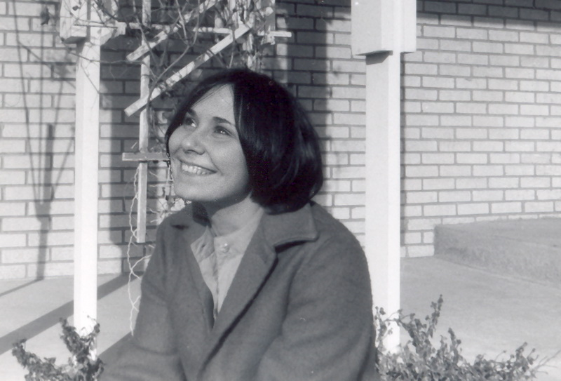It was into this confusion I stepped in with some answers for them. And never have I had such a receptive audience. During my 3 years as a Vietnam activist in Denmark I had learned my lessons – not least from academic American sources. In our attempts overseas to try to change our own government’s support of America you had to know everything about the long history of Western colonization of Vietnam, of how America had financed 80% of the French colonial warfare, had prevented the free elections promised in the Geneva talks etc. I was totally surprised seeing how completely ignorant these students were of historical facts. Not surprising, for one of their professors I met had never even heard of Karl Marx. The most receptive were those who had come home from Vietnam. I never forget when Larry Smith started telling us about his experiences. He had been one of those desperately fighting to survive in Khe Sanh during the siege and I told him how many we were overseas who had hoped that all the 6,000 Americans trapped there would be killed so it would become America's Dien Bien Phu (where the French had surrendered) and end the war. It was strange now to sit here actually talking with one of those I had wanted to be killed. But Larry said he understood. He had himself turned pretty radical after seeing what the war did to his friends and described how he had seen comrades cut eyes out on prisoners and cut stomachs up on pregnant women and tear out and kill their babies. He said that well over half of his comrades now looked at the war as he did.   
  
Ironically I some days later moved in with Larry – the guy I had wanted to be killed - for the following reason. One of those who listened most intensively to everything I had to say - literally sitting from morning to late night with open mouth and ears - was a totally naïve and politically ignorant young woman named Sharon Lee Holland. I don’t even think she knew where Vietnam - not to speak of Denmark - was on a world map. Her geographical ignorance surprised me at the time, but this is a fact I have long since gotten used to during my many years of teaching American college students. With her beautiful childlike face she kept asking me questions I perceived as naïve at first, but gradually revealing that she understood everything I said as if the pieces started falling into place for her. Behind her smiles and charm I sensed a deeper pain which perhaps also helped make me feel attracted to her. Certainly I enjoyed every moment of all the loving attention I now received from a woman after my long lonely walk though the Canadian wilderness. She tried to get closer to me by asking several times if she could see my teeth. “Why?” I asked. ”Well, I can tell even from a distance that they need to be cleaned. And I am a dentist’s assistant and will do it for you.” “But I have no money,” I replied. “Don’t worry, come to my clinic after the dentist has left and I will do it for free.” Little did I know what a sophisticated plot she already had in mind.   
  
Also I did not know until next morning about another little plot she had made behind my back. We continued to converse so late into the night that all the others had long ago found partners and rooms to sleep with them in. I dragged it out since I did not feel like going with Ann to some room after spending such a lovely evening with Sharon, but Ann was nowhere in sight. Finally there were no more possible partners or rooms to sleep in, so Sharon and I ended up crashing on some couch. I felt good about that since I would have felt guilty toward Ann whom everyone now assumed was my girlfriend about having sex with one of her old friends. So already on my first night I lived up to two of my later firm principles as a vagabond; No 1, which I will later write a story about,   
**“Never betray the hospitality a woman gives you by having affairs with some of her friends. No matter how much more beautiful, intelligent, educated and compatible they are you are faithful in your relationship with the one who first invited you home until you leave her town.”**   
No 2, **“When invited into people’s homes or parties like this one, always let the woman decide. Do not act aggressive as American men, but wait patiently to the end of night for a woman to choose you.”**The latter principle came easy for me here in America where everybody talked about how the “sexual revolution” had just started. Politically I might have been the only real revolutionary at this New Year’s party, but in social manners I felt as an absolute “counter revolutionary” when I saw all this freewheeling sex all around me during my first days in America. Already on this, the first night I spent with an American woman, I heard from Sharon the accusation I would hear again and again over the next 5 years: “Why are you so prudish?” I didn’t really have a good answer in my confusion, but mumbled something like a compliment in my self-defense: “Well, you know, I have learned that the one who waits patiently the longest will always be rewarded and end up with the best. And look, this is how I ended up with you.” I had not yet learned the sentence whites always used about blacks, that they “suffer from lower gratification threshold mentality” and therefore always were the losers. She smiled, but still couldn’t help express her irritation: “Yes, but see how we that way ended up as the losers, the only couple who didn’t find a room for ourselves in this gigantic manor house. Aren’t you aware that I want to rape you?”   
  
It was not that I didn’t have sexual desires myself, but the bluntness and suddenness of that sentence now really made me really “prudish”, a word I didn’t understand, but sensed was a negative one. So I tried to pass it off with a joke: “Well, I guess this is only your fair revenge since I have myself mind-raped you all day and most of the night.” Either Canadians or Jerry Rubin had taught me the word “mind fucking”.   
But by even just uttering that word caused me to feel guilt about the responsibility it thus gave me. If I had really mind-raped or brainwashed this otherwise innocent young girl, it would indeed amount to rape if I took advantage of her present vulnerable state of mind – also under the influence of alcohol – now to have sex with her. It was no doubt also under the influence of my own tiredness that I here on my first night with a woman in America formed **principle no. 3**, which I would follow for the next many years: **“Never to have sex on the first night with a woman whom you have just brainwashed or “let see the light.” If you don’t give her a chance to think it all over it constitutes a kind of rape which she might regret later.”** Not least when I 13 years later started my lectures in American Colleges with the enormous emotional impact the show “American Pictures” had on young students it became absolutely essential for me never to brake that principle with all the fans and groupies that gave me everywhere in America. Otherwise I would have self-destructed. But even in most of my vagabond years I was capable in most cases (I believe) to live up to it. For one good reason, as I mention in my book; namely that the guilt I got if I tried to break this rule almost always would make me sexually impotent.   
So on my first night with an American woman, Sharon Lee Holland, I for various reasons reacted against all this “sexual revolutionary activity” I saw all around me and instead engaged in the traditional old-fashioned American values of “petting” which they had themselves so eagerly practiced in the 50-60’s. And by following all these 3 new principles I was greatly rewarded the next day.  
  
When I met Ann the morning in the kitchen I felt very guilty and feared she would be mad at me for having let her down. I said something about how I had not been able to find her and having had a long political talk with Sharon had therefore ended up on the couch with her. But Ann just smiled and said she knew it would end like that. “Why?” I asked. Then Ann surprised me by saying that Sharon had already early in the day come over to her to ask her if she had anything against her spending the night with me. And being old friends Ann had said: “Of course you can. I don’t own Jacob.”   
And then Ann added to me without revealing any trace of jealousy:”But I have to warn you about Sharon. She is very, very vulnerable right now and I was mostly afraid that you would end up hurting her. Didn’t you know about the loss of her child recently? She ended up having a baby with a very cold guy. Being a Catholic she couldn’t have an abortion and her mother, whom she lives with, didn’t want her to keep it. So she was forced to give it away for adoption through a Catholic agency which she even had to pay a lot of money to. So she has been through a long period of tormenting pain and not been able to have any boyfriends. You’re the first one I have seen her open up to since, so how could I possibly say no to her. Now I am just so afraid that she will get hurt by you too.”   
“Wow,” I said, “I could see some pain in her, but now I am really glad that I didn’t take advantage of her desire to have sex with me last night. But we definitely enjoyed the intimacy with each other since we both came out of a long period without any intimacy. Me, as you know, in Canada.”   
Then I came with some generalizations about American women as opposed to Canadian from what I had already observed at the party. It irritated her, but she said that she had herself sat an analyzed their total openness the whole evening from a Canadian perspective, so she had to agree with me: “They are repressed of each other. And Sharon probably gave into that social pressure in the midst of her vulnerability.”   
Then Ann totally blew me away with her next observation (directly quoted from my diary):   
“I guess we are all vulnerable during this difficult time we go through loosing so many dear friends right now in the War. We all know that you exploit us because you don’t hide your intentions, but you do it in such a beautiful way that we like to be exploited. That is the wonderful thing.”   
As I sarcastically continue in my diary: “Her statement about me obviously made me happy and I right away came to the conclusion that my mission during this journey must be to go around to help give people the happiness of giving, let them realize that they don’t become happier by simply grabbing for themselves all the time, but that the real joy lies in giving.”  
  
After this great and very political New Year’s party I had to move back to the house of the Ruffners, but from now on Sharon came every day after work to take me on small trips. She had hoped her mother would let me stay in their house, but I write this in my diary about the first day’s reception:

Sharon Lee outside her home in Altona, IL

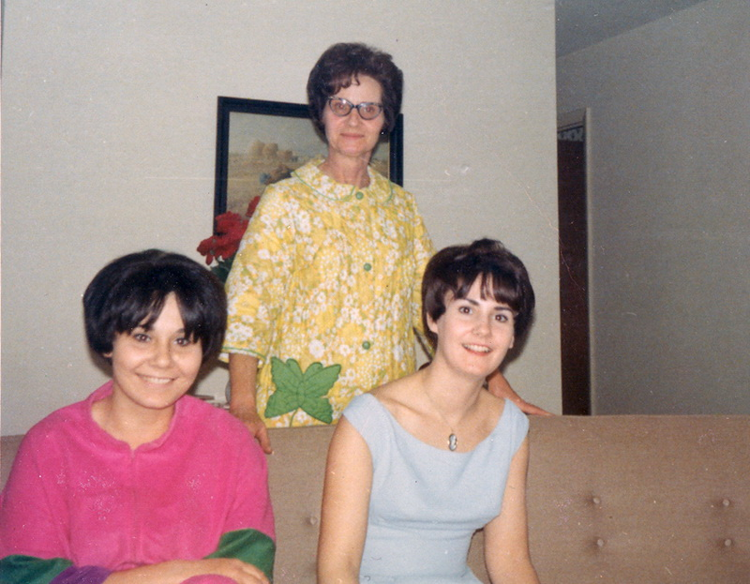“Lee was stunningly beautiful in her dentist suit with light blue shirt and white pants. We first drove up to a place, where she bought wine. She showed me a book in the car which she wanted me to read. The book was Kahlil Gibron’s The Prophet (which I since saw everywhere in the homes during these years of counterculture). She was in a good mood and was as touched as I was by the warm farewell with the Ruffners. She bought Ripple red wine which tastes terrible. On the way to her home she told me with bitterness about giving her child up for adoption and how the Catholic agency she adopted it through later demanded $ 500, which she had paid. At the same time the adoptive parents paid 500 $ and the rank and file members of the Catholic Church were constantly encouraged to make donations to "charity". She drove me past a gigantic Catholic park named ”Shrine of our lady of the snows” filled with moneyed churches, sacred caves and enormous monuments to make me understand her acrimony.  
Before taking me home to her mother, she told me about her. She had just had a cancer tumor and could not smoke any more. Moreover, she was of the fascist type who hated long hair. It turned out to be right. When we got to the place her mother would not even give me her hand. Only after I had stood with my hand outstretched for a while she took it but did not say a word. Her eyes radiated with hatred behind the typical American pointed glasses with diamonds. Her 50 year old boyfriend sat in the living room and saw Mod Squad. He got up, however, and said politely "Glad to meet you." So we escaped into the kitchen where Lee made dinner for me while another TV also there boomed with Mod Squad. I had never in Denmark seen people watching TV in each room and reacted by turning the volume down and playing my own revolutionary music from the tape recorder for Lee. She got a phone call, but still walked around the kitchen setting the table while she talked, which amused me greatly. The cord could reach even the furthest corners. (The cordless phones didn’t come until the 1980s). A small shooty barked incessantly at me because it was afraid of my boots. All of which added to the oppressive atmosphere, so after eating we left without saying goodbye. Obviously her mother would not let me stay there.”   
Today I find the scene in my diary with her racist anti-hippie mother amusing. For Mod Squad, which they were all watching, was one of the earliest attempts to deal with the counterculture. Groundbreaking in the realm of socially relevant drama, it dealt with issues such as [abortion](http://en.wikipedia.org/wiki/Abortion), [student protest](http://en.wikipedia.org/wiki/Student_protest), [child neglect](http://en.wikipedia.org/wiki/Child_neglect), the [anti-war movement](http://en.wikipedia.org/wiki/Anti-war_movement), [soldiers returning from Vietnam](http://en.wikipedia.org/wiki/Vietnam_veteran) and [racism](http://en.wikipedia.org/wiki/Racism). I ended up watching it in every home ….such as the next one.  
  
For Sharon then drove me around to some of her friends I had met at the New Year’s party to see if I could stay with some of those. We ended up going to Larry – the Vietnam veteran – and his wife Virginia. She was very open and said: “Wow, I can tell you really like Lee.” I said yes and we ended up talking politics again til late in the night when Lee left. She had hoped she could stay with me, but whether my bed in the cold attic was too small or she was too embarrassed to ask, she suddenly left with the words: “I will come tomorrow and bring you to the clinic and clean your teeth.”  
When she brought me there the dentist to my disappointment was there. She had told him so much about me that he wanted to meet me. He invited me into his office and started asking questions. He was a jovial, sex-minded redneck type, but tried to present himself as a progressive. Yet, all of a sudden he asked: “Why do you have so much animosity towards America?” I was surprised, but answered with my usual political explanations. Luckily he left for lunch so Lee could clean my teeth. I was placed in the dentist's chair and she started a small electronic needle up under the gums. She broke into laughter several times seeing my reactions, but otherwise she stared intently into my mouth with a sexy eagle eye. She was on the whole very attractive as she stood there in her white dentist dress. A couple of times I gave her a hug while flushing. When she was finished with the lower jaw she said still working "I wish I could take you home and rape you. But since I can’t……" And then she suddenly put away all her dangerous drilling needles, locked the door and climbed up in the dentist chair and raped me. Or whatever it is called when the patient just sits passively and still does everything he is being told to do. I had heard that Americans were good at having sex in the back of cars, but not that they are even great in dentist chairs. It was wonderful with a lot of laughter. Luckily we were finished when the dentist unexpectedly came back “to see if she did the cleaning right” ….. or rather if something funny was going on there, with his special sexual smile. She gave me good advice with my teeth and pulled a few sexual jokes off herself. Eventually Lee gave me lessons in brushing and gave me a brand new toothbrush. Before I left I gave her a super kiss I went out into the empty streets of Alton told to be back by 3pm.

Sharon gave me this childhood photo from 1969 which I sent home to my parents with the words: “Sharon with her sister. In the background is her mother, the racist Wallace supporter, who refused to shake hands with me. She would not even say a word to me because I am longhaired. Luckily her daughter had a certain impact on her. It was in their house there was a burglary in broad daylight while we were not home.”

The main street was not particularly exciting so I went to the Christian Science Reading Room to reflect on the event or to see if anything similar would happen there in this country of wild women. Back in the clinic the dentist again called me into his office to continue our discussion, but now he constantly used examples like "So what if you and Lee have a child, how will you bring it up?" Lee got him out of his sexual fantasies, rushing in saying that one of the patients had lost the gums or something. I wondered afterwards if Lee had gotten the whole idea of raping me in a dentist chair from listening to his sexual jokes all day. Was it a premeditated rape or a spontaneous love scene we had engaged in? Whatever it was it was not enough for Lee. She said, “There is a couple of hours to my mother gets home from work. Let’s go home in the basement and continue.” And after unusual fast driving through town that is where we ended. Here she used, not my dirty teeth, but my dirty clothes as an excuse to get me to pull it off me, “Let me wash it all for you in the washing room in there.” It was certainly more comfortable here and Lee afterwards claimed that she had had her first orgasm. I could not hear that in the noise of the washing machine next door and wrote in my diary that I doubted it, since I had never met women under the age of 26 getting orgasms, “but perhaps American women are more advanced.” While kissing she suddenly discovered that she had still not cleaned my upper mouth and said smiling, “Wonderful, we have to do it all over again tomorrow!”   
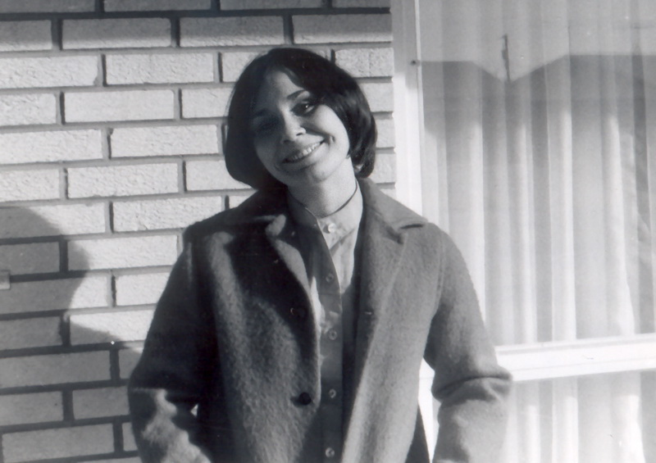“Well, I prefer just the lower parts,” I joked, not really interested in meeting her sex-fixated dentist again no matter how good ideas he had planted in Lee’s long sex-starved and pained head.   
While waiting for my clothes to dry she let me read letters by Steve, the father of her child, which struck me as extremely cold and insensitive and again made her sad. Afterwards I tried to put her in a better mood by playing revolutionary Vietnamese and Cuban songs on my tape recorder. They cheered her up so much that we ended in a gigantic naked fight in the laundry sheets in the washroom during which she claimed that I nearly choked her.   
That night Lee had the courage to ask Larry and Virginia if she could spend the night with me and of course, they had no problems with that. And as a result of this – my first girlfriend in America – I ended up staying with them for a couple of weeks. It was a wonderful time with great discussions at night with the guy I had wanted dead in Khe Sanh and Lee and all their friends. In the daytime I would go to classes in Southern Illinois University with Larry and wrote a lot of my observations in the diary about the American college system I had no idea then I would end up spending the rest of my life in. I was not impressed and came with a lot of sweeping generalizations so typical of the new tourist totally ignorant of the ranking order of American universities and that SIU is in the lowest category as “lesser competitive”. “With such ignorant teachers and students how can I blame them for all their war crimes in Vietnam?” I wrote.   
It didn’t matter anyway since my mind was still set on continuing through the southern USA down to Guatemala to fight “this monster” along with the guerrilla movement there. Therefore it was a great opportunity when Larry and Lee one evening took me over to visit some of their Guatemalan friends, two sisters who lived in an astonishingly affluent apartment decorated with expensive Maya art. Their rich father owned a large latifundia in Guatemala and let them fly home every holyday. They had just come back from there and told us that there was a curfew now all night because of all the killings. “If only those terrible guerrillas would stop,” they kept saying. I had said nothing about my sympathies, but said I would like to go there and I several times asked for their home address. They declined several times to give me their address, not least when I asked them if I could hitchhike around there and they said: “Oh, no, no, dangereuse, dangereuse!” We talked a bit about the new president and when I mentioned his name and those of all the previous presidents, it astonished everyone present. They had never met any American who knew their names. (When I later hitchhiked to Guatemala I realized that everybody there associated long hair like mine with guerrillas, so then I understood their reluctance to give me their address).  
  
Next day, January 11th, it was my intention to continue hitchhiking through the south towards Mexico and Guatemala, but now it was Lee and all her friends who said I was crazy. “It is too dangerous going through the South. They shoot hitchhikers and hippies down there.” They were influenced by the recent counterculture movie “Easy Rider”. Today I see how ironic it was that they could so easily frighten me from going through a relative peaceful democratic country like America when they knew I wanted to go down fighting with the guerrillas against a bloody dictatorship. However, I was easy to persuade by all their loving warnings. Not least those of Lee. Love or revolution I soon found to be my constant choice. “Stay a bit longer with me, and then I will drive you all the way to Washington. Then we can march together in the big anti-war demonstrations before you go south.” Lee had started changing politically and said she would really like to join me going to Latin America. Luckily, next day the roads were so icy when she drove me out to the highway that nobody could neither drive nor hitchhike. I was relieved as I really would much rather stay with Lee than go into the scary unknown “to fight.” Finally, on January 14 I left going north. Partly my one-month visa was soon running out and partly they had frightened me so much that I decided to hitchhike back up to Canada to get it renewed in the American embassy after which I would hitchhike across Canada and then go down the safer route to Central America via California. That journey ended up taking me more than a year because of many other “Love or revolution” detractions.   
  
It does not show in my diary how sincere I was in my promise to Lee meet up with her again. Yet Lee was definitely one reason why I after having joined Angela Davis’ “Che-Lumumba Club” in San Francisco suddenly decided to postpone my “Che Guevara-journey” towards Latin America and instead 4 months later hitchhiked all the way across America to join Lee in the big antiwar demonstrations in Washington. However, now we had already both changed. Here I had ended up in another romance living with a woman, Helen White, while Lee had been further radicalized and came driving to DC with all the “Vietnam Veterans Against the War” from St. Louis. We had hardly time to see each other, but at least were standing next to each other on April 23rd during the emotional two hours when John Kerry and almost 1000 other highly decorated veterans in anger tossed their medals, ribbons, hats, jackets, and military papers over the fence up against Congress. It was the day after Kerry became the first Vietnam veteran to testify before Congress about the war.  
  
What happened over the next two years has astonished me ever since. Lee would often contact me and ask me to come to the rallies she organized in various cities for the VVAW of which she had become a traveling spokesperson. It was clearly not “to rape” me any longer, for she was now so devoted to the cause that I do not recall us having sex at our later reunions. Also I somehow did not now feel as sexually attracted to the radical monster I had helped turned her into. Now she was completely devoted to the leader of the VVAW, John Kerry, whom I therefore often chatted with at the various rallies. Offhand I recall hitchhiking to see Lee speak in Milwaukee, in St. Louis and in 1972, when I gave up my revolution in the mountains of Guatemala and hitchhiked 8000 km from there through Mexico and the Deep South to join her in the demonstrations against Nixon’s reelection in Miami.   
But as I write on page 7 in my book I was here too busy staying with a republican woman on the 12th floor of Nixon’s headquarter “The Fontainebleau” to sleep outside in the parks with Lee and “the thousands of demonstrators, dirty hippies and lazy bums” below our windows.   
  
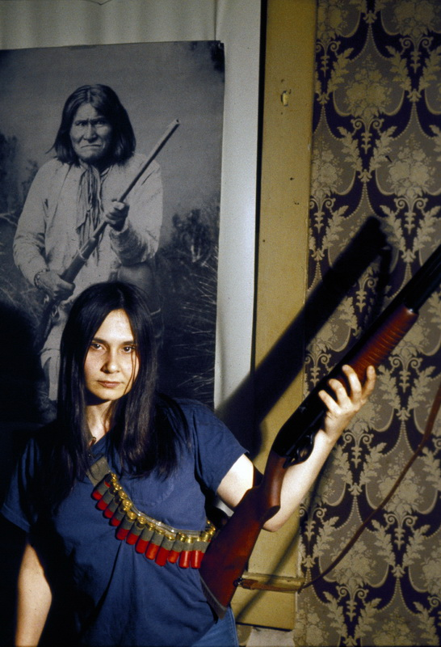After Nixon’s disappointing re-election – in which both Lee and I had actively worked for the peace candidate McGovern – our ways really separated. I had had enough of revolution and her longtime ally John Kerry now took his fight from the streets by running for a seat in Congress.   
The last time I saw Lee in 1972 or 1973 she called me out to a secret place in the woods of Missouri. Here she was now living with her boyfriend, John (I will not reveal his surname because of his position today), who was another member of the VVAW. They had both become so disillusioned with the killings in Vietnam and the way the country was “moving towards fascism” that they were now collecting bombs and firearms to start a war against the government.   
On the photos I took of her here, the sad bitterness I had first detected in her now came out in the open. She posed as the angry armed radical woman with a rifle in front of a poster of her inspiration, the Indian chief Geronimo, who had previously fought against the American government. She wanted me to meet her boyfriend because she had told him so much about how I was the one who had made her aware of the oppression behind “the system”. In an interview, I have googled in a local paper (see below) I can tell that they already in the summer of 1972 talked like that. They were "not only concerned with ending the war but changing the domestic social, political, and economic institutions that have caused and permitted the continuance of war." I remember Lee begging me to join them to “fight the monster from within, as Che Guevara said”, but I was after my disillusion in Guatemala clearly on a different path now. When we departed in tears, she said something like “I know that this is probably the last time we see each other.”   
I was very much at the time in doubt whether I should feel proud or bad about my role in her change. I had talked so persuasively about revolution and social justice when I first met her as an innocent young woman in a vulnerable stage of her life that I had in less than two years changed her into a terrorist (as we would call it today). She was not alone. Thousands of others also went underground at that time. However, she was the only one I was somehow responsible for, “My Fair Lady” whom I had turned into a dark Indian fighter.   
  
She was right about not seeing me again. I never could find any trace of her since. However, many years after the end of the divisive Vietnam War a Danish journalist sometime in the 1990s was doing research on the Navaho Indian reservation in Arizona. There he interviewed a woman who afterwards asked him if he had ever met a Danish man called Jacob Holdt. “Oh, yes, he is very famous in Denmark,” he replied. Then she said, “He was my boyfriend once and he is the reason I am working here to help improve the condition for the Indians now. Please send him all my love.”   
Yet Lee forgot to give him her address. I have often googled her, but never found her since.

On the back of this – my first American photo – I wrote to my parents: ”Sharon Lee Holland, the dentist girl I stayed with after I moved from president Ruffner in St. Louis. She fixed my teeth for free one day in the clinic. That would otherwise have cost me 150 kr. And she offered to drive me most of the way to Washington DC until I suddenly changed plans and went to Chicago instead. I met her at a party in a huge manor house outside St. Louis 1st and 2nd New Years Day.

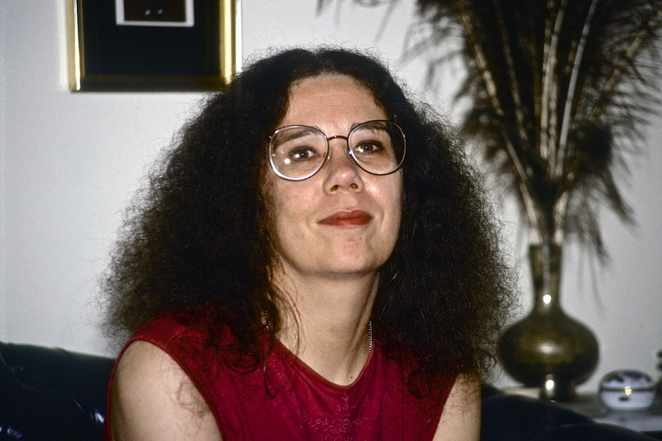

Ann Ruffner Jellen. After our brief Christmas fling in 1970 she shortly after went back   
to her husband. They later settled in Charlottesville, VA, where I often stayed with them   
during my lectures in U. of Virginia. I believe this photo is from my last   
lecture there on Nov. 6th 1995. Ann died in on Dec. 2nd 2004, 55 years old.   
I will forever be grateful to her for introducing me both to the boring Russian anarchist  
and the more fun American social revolution – and (without jealousy) to Sharon Lee Holland.

**Sharon Lee’s later impact on my life**One of the first days in America I borrowed Ann’s cheap camera to take some pictures of Sharon Lee in order to remember her in my joy. I sent them home to my parents in Denmark along with endless detailed letters describing in almost photographic detail everything I experienced (in addition to the even longer diaries). Already before I after two weeks left the St. Louis area my father sent me a letter back to the Ruffners. He said that perhaps it would be a good idea if instead of such long letters I sent them some more photos home. That way it would be a lot easier to remember all the people I met. So my parents had decided for my upcoming birthday to send me a camera which I could pick up at the Godfrey family in Canada. When my father had told his local photo store that I travelled with very little money, the manager advised him to get a cheap half-frame camera so I could take 72 pictures on a normal roll of film. That was another reason for me to go back to Canada instead of Guatemala. And so, In that way my love for my first American girlfriend which I just wanted to record and share with my parents led to my future career as a photographer. I could never have imagined at the time how much Sharon Lee would change my entire future life. The impact of our meeting had made her pick up the gun and made me pick up the camera.  
  
Unable to see her again while she went underground I over the years formed strong emotional ties to John Kerry by supporting his more peaceful path to peace. Yet, whenever I saw John Kerry in the media I was always thinking of Lee whom I had lost. In 1984 I supported John Kerry’s run for the senate in my home state Massachusetts against Reagan’s belligerent policies. When he ran for president in 2004 also on a peace platform against the warmongering George H. Bush I again stood on his side and made on my own an huge online campaign against Bush – again to try to wake Americans up: [**http://holdt.us/from/election/disaster**](http://holdt.us/from/election/disaster). (Not all embedded links and embedded flash films in it work today). Ever since then I have received John Kerry’s daily campaign letters.   
  
Somehow Sharon Lee is still affecting my life in strange ways. A couple of months ago I wrote to Steve McQueen’s film company that I would spend the spring writing background stories for his screen adaption of American Pictures. Then I received an invitation from two young Danish women asking me to come with them to Palestine to help set up and run the [**Palestine Marathon**](http://palestinemarathon.com/).   
As 15-16 year old students they saw my slideshow “American Pictures” and were so affected by it that they decided to take a university education in development work “to help change the world”. Since then they worked for the Red Cross in Palestine, but were so frustrated by the Israeli occupation that they wanted to help the Palestinians build up their smashed economy. Since they were both marathon runners they came up with the idea of creating this as a tourist event in Palestine. From the beginning the Israelis tried to harass them and prevent Palestinians from Gaza and Israelis from participating. So soon the Marathon became a protest against the Wall named [**“Right to movement”**](http://www.righttomovement.org/) marathon.   
  
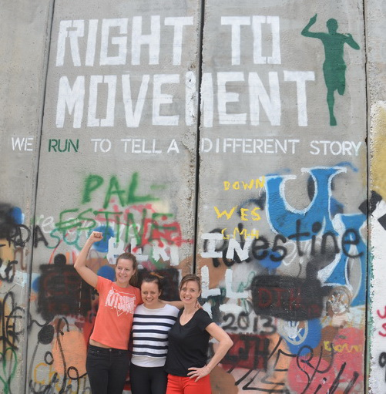They begged me to come “since your name will mean a lot for the success of the marathon”, but I said at first no. I was too busy writing in Denmark and had already run 11 marathons and sworn to myself I would never run another one. What changed me? Suddenly I realized that the aim of these two Danish women was to support John Kerry’s peace talks which were right then going on and had a deadline on my 67th year birthday coinciding with the Palestine Marathon. I so desperately wanted the peace talks to succeed and again - going back to my long history of supporting John Kerry’s peace efforts - I suddenly felt I couldn’t let him down.   
And so I decided to run my 12th marathon and help the women make this “Right to movement” a success. In the process I crossed back and forth the apartheid wall to do peace lectures for both Israelis and Palestinians while writing these long accounts on Facebook to get the whole world to support John Kerry’s latest peace process:  
[**http://www.american-pictures.com/english/racism/Israel-Palestine-tour-2014.htm**](http://www.american-pictures.com/english/racism/Israel-Palestine-tour-2014.htm)

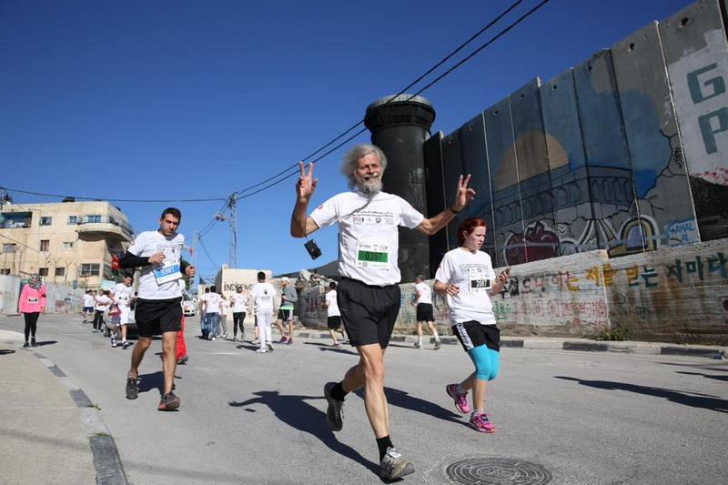It was the hardest run of my life in 25-30 degrees heat up and down the steep hills in Bethlehem because the Israelis would not let us get a more flat stretch. But when I ran through the refugee camp Aida, where we were teargas bombed and shot at when setting up the route the day before and a Palestinian mother was killed trying to protect her children the next day, I thought of Sharon Lee Holland. In some way she was the one who had sent me here by bringing me in contact with John Kerry and in some way I was now protesting against her bombs and violence by showing that there is another and better way to work or “run for peace.”   
I am still trying to find Sharon Lee. For after hearing about her work among the Indians I know that we are today on the same peaceful side of the struggle for peace and justice. Until I find her this will be the end of this story about my impact on her life and her impact on my life.  
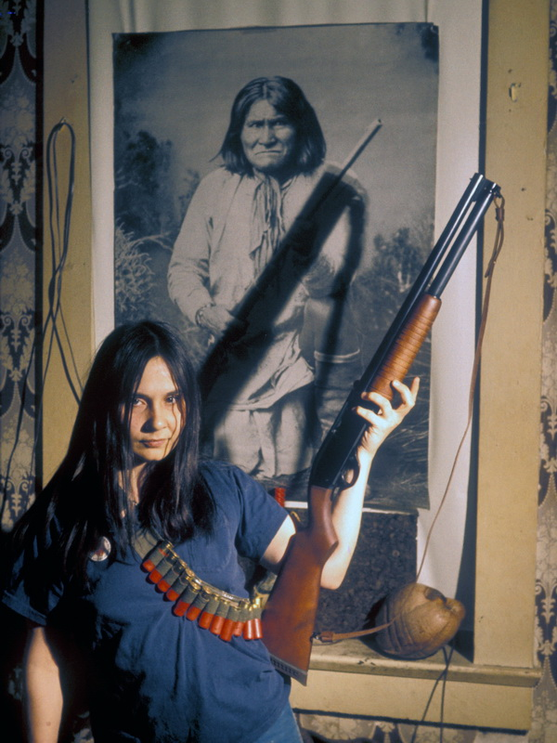 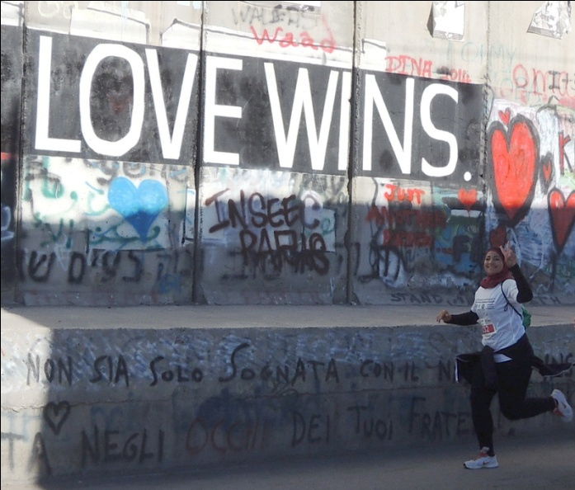  
 From Sharon’s violent and bitter approach to social justice…. ….to today’s head covered Palestinian women’s more loving run for it.  
   
***With all my love for Sharon,  
Jacob Holdt***

Photo taken just as I run through the Aida refugee camp past one of the Israeli guard towers. It is blackened by smoke from Palestinian children, who try to burn it down all the time.

[Alton Evening Telegraph](http://www.newspapers.com/browsemore/hzCeh9OTO_1/) › [1972](http://www.newspapers.com/browsemore/hzCeh9OTOTsFZj9Zy_1/) › [June](http://www.newspapers.com/browsemore/hzCeh9OTOTsFZj9ZyyDn5s2Cc_1/) › [1 June 1972](http://www.newspapers.com/browsemore/hzCeh9OTOTsFZj9ZyyDn5s2CcuT3ZpBI9_1/) › Page 26

Antiwar unit organized at L & C college A chapter of Vietnam Veterans Against the War has been started at Lewis & Clark Community College. A group of 10-12 Vietnam and other military veterans recently received recognition by the college as an official club. They are now trying to recruit other veterans in the area to join in their activities opposing the Indochina war. Other activities of the group include taking food, clothing and medical supplies Saturday to the United Front rally in Cairo. The local chapter and the national Vietnam Veterans Against the War states that it is not only concerned with ending the war "but changing the domestic social, political, and economic institutions that have caused and permitted the continuance of war." The group also plans to work with a coffeehouse at the Veterans Hospital at Jefferson Barracks. It also plans to do draft counseling — the chapter favors full amnesty for those refusing to be drafted. Another planned activity is research on local industries manufacturing war goods. One of the leaders of the group, Bill Felkey, said his year in Vietnam showed him "the North is, so much more oriented towards war that (the U.S.) could stay there another 10 years and it wouldn't change anything." A female veteran in the new chapter against the war, Sharon Holland, said her experience as a medic "seeing the end results" of the Indochina war confirmed her opposition to it. Another leader of the group, Paul Owens, said simply that his experience at Cam Ranh Bay and Saigon showed "it was none of my business being there." The group is hoping to recruit more members when summer school begins at Lewis & Clark. There are an estimated 300 Vietnam veterans attending the junior college. The chapter's headquarters presently is at 1027 6th St., Alton.